# ## ABSTRACT

Behavioral flexibility, the ability to change behavior when circumstances change based on learning from previous experience, is thought to play an important role in a species' ability to successfully adapt to new environments and expand its geographic range. However, behavioral flexibility is rarely directly tested at the individual level. This limits our ability to determine how it relates to other traits, such as exploration or persistence, that might also influence individual responses to novel circumstances. Without this information, we lack the power to predict which traits facilitate a species' ability to adapt behavior to new environments. We use great-tailed grackles (a bird species; hereafter “grackles”) as a model to investigate this question because they have rapidly expanded their range into North America over the past 140 years. We evaluated whether grackle behavioral flexibility (measured as color reversal learning) correlated with individual differences in the exploration of new environments and novel objects, boldness towards known and novel threats, as well as persistence and motor diversity in accessing a novel food source. We determined that exploration of a novel environment across two time points and persistence when interacting with several different novel apparatuses was repeatable in individual grackles. There was no relationship between exploration or persistence and the two components of flexibility - the rate of learning to prefer a color option in the reversal learning task, and the rate of deviating from a preferred option. However, grackles that underwent serial reversal training to experimentally increase behavioral flexibility were more exploratory in that they spent more time in close proximity to the novel environment relative to control individuals. This indicates that, the more an individual investigated a novel apparatus, the more it was able to potentially learn and update its knowledge of current reward contingencies to adapt behavior accordingly. Our findings improve our understanding of the traits that are linked with flexibility in a highly adaptable species. We highlight the importance of using multiple different methods for measuring boldness and exploration to evaluate consistency of performance and therefore the methodological validity. We also show a link between exploration and behavioral flexibility that could facilitate adaptation to novel environmental changes.

# ## KEYWORDS

Behavioral flexibility, personality, anthropogenic change, repeatability

### [Video summary](https://youtu.be/Xd_nYV9Lj7E) [https://youtu.be/Xd_nYV9Lj7E](https://youtu.be/Xd_nYV9Lj7E)

# ## INTRODUCTION

Humans are altering all ecosystems on the planet too rapidly for most species to evolve adaptations to survive and reproduce [@hendry2008human; @sih2013understanding]. Among other consequences, anthropogenic change can lead to a proliferation of novel habitats, foods, and predators [@sih2011evolution]. Across short timescales, individuals must adapt to this novelty through changes in behavior. Behavioral flexibility (hereafter “flexibility”) is defined as the ability to use learning to functionally change behavior when circumstances change [@mikhalevich_is_2017]. As such, flexibility is thought to facilitate species resilience to anthropogenic change [@sol2013behavioural] and species invasions into novel areas [@sol2002behavioural; @wright2010behavioral].

The relationship between flexibility and adaptation to anthropogenic change is rarely directly tested at the individual level. Research studying the impact of flexibility on the success of species invasions most often uses proxies of flexibility such as species brain size, or presence of the theoretical outcomes of flexible behavior like the number of foraging innovations [@sol2002behavioural]. The few studies that have directly related environmental adaptation to flexibility through measures of reversal learning show that flexible behavior can be closely linked with the current environmental niche. For example, mountain chickadees that live in harsh, high elevation environments perform worse on reversal learning tasks relative to lower elevation, milder climate individuals [@croston2017predictably]. This suggests that individuals that have a wider range of food options and a reduced reliance on cached food in milder climates require more flexibility to switch between food types. Additionally, new evidence from great-tailed grackles shows that the more flexible individuals also demonstrate greater foraging diversity in the wild [@logan2024flexfor], and were better able to innovate solutions on a novel foraging apparatus [@logan2023flexmanippcj]. Consequently, flexibility may show variation within, as well as among, species and may affect diverse aspects of individual behavioral interactions with the environment. To better understand how flexibility might facilitate responses to novelty and resilience to anthropogenic change, it is important to directly test flexibility and relate it to other ecological and behavioral traits at the individual level.

Although flexibility has been the trait that much research has focused on to understand how behavior can impact adaptation to anthropogenic environmental changes, individual differences in other traits like exploratory tendency, boldness, persistence, or motor diversity could also play a role and correlate with behavioral flexibility [@logan2016behavioral; @sol2002behavioural]. To distinguish whether observed behavior in the wild or performance on behavioral trait assays are motivated by one or more distinct traits, it is important to measure multiple traits in the same individuals [@carter2013animal]. However, evaluation of the relationship between flexibility and other behavioral traits has produced inconsistent results [@dougherty2018linking; @logan2016behaivoral]. In one well studied avian group, the Paridae, flexibility is related to exploration, which increases the likelihood of encountering fitness-enhancing resources in novel environments [@canestrelli2016bolder; @griffin2016invading]. This might imply that they are not two distinct traits, but the direction of the relationship is inconsistent across species [positive: @herborn2014personality, @rojas2020exploration; negative: @amy2012worms]. Individuals approaching a potentially threatening aspect of the environment require a certain degree of boldness [@mccune2018evidence]. However, the relationship between boldness and flexibility can be positive [@titulaer2012personality], negative [@bensky2022behavioral; @bebus2016associative], or neutral [@guenther2014learning; @de2022bold]. Theoretically, persistence should inhibit flexibility because it results in perseverating on a previously rewarded behavior rather than changing to a more productive behavior for a given circumstance [@morand2022cognitive]. In contrast to persistence, motor diversity is theoretically positively correlated with flexibility because it implies that the individual has a repertoire of different behaviors it is able to choose from to match each circumstance [@diquelou2016role]. Research in squirrels supports this prediction [@chow2016practice], where the more flexible individuals were less persistent and more likely to use diverse motor behaviors. Whereas, an earlier study in great-tailed grackles using different behavioral assays found no relationship between flexibility and any other behavioral traits, including persistence and motor diversity [@logan2016behavioral].

The lack of consistent support for which behavioral traits are related (or not) to flexibility could stem from what has been called a “jingle-jangle fallacy” [@carter2013animal]. This term describes the mismatch between a trait label (like exploration) and what the method (novel environment) actually measures (could be exploration, activity, or boldness). A mismatch can occur when researchers use a single trait label for what are actually multiple distinct inherent traits (“jingle fallacy”), or if using two or more distinct labels for what is actually the same inherent trait (“jangle fallacy”). One step towards avoiding this issue is to use multiple experimental methods, as in a test battery, to measure a variety of behaviors, then assess the relationships among performance to identify which aspects of the behaviors that are measured might be driven by the same underlying trait [@shaw2017cognitive; @perlas2017revisiting].

To determine whether behavior labels represent the same underlying trait, it is also important to ensure that measured performance on behavioral assays is consistent within individuals across time and context (i.e., repeatable). Inter-individual differences in performance could result from short-term variation in the external environment like social interactions or food availability or variation in internal states like hunger or stress. This plasticity is distinct from consistent individual differences in behavior across contexts stemming from genetic or developmental effects [i.e., animal personality; @duckworth2010evolution; @fidler2007drd4]. If behavioral traits are heritable, multiple traits can become linked through natural selection such that individuals that show high values on one trait (e.g, flexibility), will consistently display high values on a linked trait (e.g., exploration) [@reale2007integrating; @rowe2014measuring]. It is important to know whether traits are linked because such linkage could result in limited behavioral plasticity that may alter the ability or mode of adapting to rapid environmental changes [@sih2004behavioral]. Indeed, inconsistency in the direction of the relationship between flexibility and behavioral traits in previous studies could stem from a lack of repeatability in performance on behavioral trait assays. To address whether flexibility is related to other behavioral traits, we must first assess whether our methods produce performance that is repeatable [@dingemanse2013quantifying] to validate that it is more likely to represent variation in a heritable trait.

In a previous study with a smaller sample size [@logan2016behavioral], we found no evidence for significant correlations between flexibility and the behavioral traits exploration, boldness, persistence, and motor diversity. However, this result could stem from the small sample size and lack of power to detect a relationship with a small effect size, or methods that do not result in repeatable performance. Based on this preliminary evidence, in the present study we increased our power to detect a relationship by training some individuals to be more flexible before measuring the other behavioral traits. Additionally, we tested whether performance on measures of exploration, boldness, persistence, and motor diversity are repeatable across time and contexts and therefore likely represents distinct personality traits. Behavior is considered repeatable if the variance in performance on the task is smaller within individuals compared to the variance among individuals. If there is no repeatability of these behaviors within individuals, then performance is likely state dependent (i.e., it depends on fluctuating motivation, stress, hunger levels, etc.) and/or reliant on the current context of the tasks, and therefore less likely to consistently correlate with flexibility [@griffin2015cognition]. Then we assessed whether the repeatable traits were related to performance on a flexibility task. We focus on great-tailed grackles (*Quiscalus mexicanus*; hereafter “grackles”) because they are likely to have experienced selection for behavioral adaptations to rapid environmental change. Grackles have rapidly expanded their range into novel areas in North America over the past 140 years [@wehtje2003range, @summers2023xpop] and our previous research on this species has demonstrated that grackles are flexible [@logan2016flexibilityproblem], and that flexibility is a distinct trait on which grackles show individual variation [@mccune2023flexmanippeerj]. Thus, this species is ideal for assessing whether flexibility is part of a suite of behaviors that facilitate adaptation to novel environments.

## ## Preregistered hypotheses and predictions summary

\**We preregistered several additional predictions pertaining to alternative measures of behavioral flexibility that we are not using here. The preregistration details the criteria that determined which variables to use, and is available as Supplementary Material 3. This article also attempted to test Hypothesis 2 and its associated predictions, which are reported in Supplementary Material 2. The prediction numbers listed here maintain the original order from the preregistration to help readers track consistency across Stage 1 and Stage 2.*\*

#### **Hypothesis 1:** Behavioral flexibility is correlated with the exploration of new environments and novel objects, but not with boldness, persistence, or motor diversity.

**Predictions 1-5:** Behaviorally flexible individuals will be more exploratory of novel environments (P1) and novel objects (P2) than less flexible individuals, but there will be no difference in persistence (P3), boldness (P4), or motor diversity (P5) [as found in @logan2016behavioral] related to flexibility.

**P1 alternative 4:** There is no correlation between exploration and behavioral flexibility because our novel object and novel environment methods are inappropriate for measuring exploratory tendency. These measures of exploration both incorporate novelty and thus may measure boldness rather than exploration. This is supported by a positive correlation between behavioral responses to our exploration and boldness assays.

**P3 alternative 1:** There is a positive correlation between persistence and the number of incorrect choices in reversal learning before making the first correct choice. This indicates that individuals that are persistent in one context are also persistent in another context.

**P3 alternative 2:** There is no correlation between persistence and the number of incorrect choices in reversal learning before making the first correct choice. This indicates that flexibility is an independent trait.

# ## METHODS

## ### Preregistration details

The hypotheses, methods, and analysis plan are described in detail in the peer-reviewed preregistration, in Supplementary Material 3. We summarize these methods here, with any changes from the preregistration noted in the \**Changes after the study began*\* section. The preregistration was written and submitted to Peer Community In (PCI) Ecology for peer review (Sep 2018) before collecting any data. After data collection began (and before any data analysis was conducted), we received peer reviews from PCI Ecology, revised and resubmitted the preregistration (Feb 2019). It received an in principle recommendation in Mar 2019.

## 

## ### Subjects

Grackles were caught in the wild in Tempe, Arizona USA using mist nets, walk-in traps and bow nets. Trapping could occur at any time of day where grackles were active. While some trapping methods can select for subjects with certain traits (e.g., boldness: @biro2008sampling; but see @brehm2018mind), mist nets are not visible to birds and no habituation is required, decreasing the probability of a selection bias for individuals that are more bold, food motivated, etc. Grackles were then individually housed in an aviary (each 244 cm long by 122 cm wide by 213 cm tall) where they had \**ad lib*\* access to water. We aimed for a balanced sample of adult males and females, but because grackles in this population were difficult to catch, we ultimately ended up with only 4 females (15 males) and 2 juveniles (17 adults). Grackles were held in captivity until they completed the test battery, or 6 months had passed. All grackles were then released back into the wild and subsequently observed exhibiting normal behavior.

## ### Test battery

During testing (except exploration, see below) we food deprived grackles for up to four hours per day, but they had the opportunity to receive high value food items by participating in the assays. They had access to a maintenance diet at all other times. Individuals were given three to four days to habituate to the aviaries before their test battery began. Birds were then tested 6 days per week. On each testing day, we conducted multiple testing sessions where the duration of the session depended on the grackle’s motivation to participate or the task design (see below).

We use data from a recent investigation [@logan2024flexmanippcj; @lukas2024flexmanip] on the flexibility of 19 grackles, and here we additionally measured exploration and boldness in these same individuals. We also measured persistence and motor diversity through performance on two multiaccess boxes (MABs) in 17 of these grackles. The research described here is part of a larger project where the main goal was to better understand the impact of flexibility on diverse cognitive, behavioral, and physiological traits. Consequently, for all grackles we first assayed flexibility and implemented a flexibility training where half of the grackles underwent serial reversal learning and the other half received only one reversal and then control trials, described below. The training resulted in grackles more quickly changing their behavior when reward contingencies changed, relative to control grackles [@logan2024flexmanippcj]. By experimentally increasing the difference in behavioral flexibility between control and trained grackles, we increased our power to detect relationships between flexibility and other traits. After grackles passed the flexibility training, they received the subsequent behavioral trait assays in a randomized order. Grackles were assayed twice for exploration and boldness, and given sessions with the MABs until they passed criterion. Because there were two MABs, we also have two measures of persistence and motor diversity for each individual.

## ### Behavioral flexibility

We used the reversal learning paradigm to measure flexibility as the ability to change behavior when circumstances change. In the first phase of reversal learning, subjects learn an initial association between a stimulus (here, color) and food. The reversal phase then occurs where the food is switched to the other color and the measure of flexibility is how quickly the subject learns the new food-color association. The methods for the initial association and the reversal trials are identical, where, on each trial, grackles could choose to look inside one of two colored containers for food (Fig. 1a). After they make a choice, the experimenter removes both containers, refills the food if necessary, then replaces the containers for the next trial. The side that the rewarded container was on was pseudorandomized to never be on the same side more than twice in a row to inhibit grackles from forming a side bias. When grackles showed a significant preference for the rewarded color in the initial association phase, demonstrated by choosing correctly on 17 out of the most recent 20 trials, we switched the location of the food to the other color container (a “reversal”). We measured baseline flexibility as the number of trials it took grackles to choose correctly on 17 out of the most recent 20 trials in this first reversal to demonstrate a change in preference to the second colored container. The flexibility training consisted of a randomized subset of grackles (n = 8) that received serial reversals where we switched the location of the food in multiple reversals after the grackle passed criterion in each reversal. Serial reversals continued until grackles were switching their preference in each reversal quickly enough to meet our experiment’s passing criterion of two consecutive reversals in 50 trials or fewer. We chose a criterion of 50 trials based on an earlier study of grackle reversal learning performance [@logan2016behavioral] where 50 represented an approximately 30% increase in the speed that grackles switched their preference in the first reversal [@logan2023flexmanippcj]. Grackles needed 6-8 reversals to pass this serial reversal training. Instead of serial reversals, control grackles (n = 11) received equal testing experience with two identically colored containers, both containing a food item.

From the performance of each individual on reversal learning, we used Bayesian reinforcement learning models to create the Flexibility Comprehensive variables by modeling all of the choices that individuals made during the serial reversal learning experiment, and the uncertainty around these choices. Because we include the sequence of all correct and incorrect choices individuals made during reversal learning, these variables more effectively represent flexibility compared to more commonly used variables such as the number of trials to reverse a preference. The details of this model and the validation of it as a measure of flexibility are described elsewhere [@lukas2024flexmanip; @blaisdell2021more]. The Flexibility Comprehensive variables consist of two components: $\phi$ (the Greek letter phi) as the rate of learning to be attracted to a color option and $\lambda$ (the Greek letter lambda) as the rate of deviating from learned attractions that were previously rewarded. Thus, our two measures of flexibility, that we subsequently included as covariates explaining behavioral trait performance, were the Flexibility Comprehensive continuous variables or the dichotomous variable describing whether the grackle was in the flexibility trained or control group. There was one measure per individual for each of these variables.

All measures of the behavioral traits exploration, boldness, motor diversity, and persistence were collected after the serial reversal learning training was complete. By experimentally increasing the difference in flexibility performance between the trained and control grackles, we increased our ability to detect a relationship, if it exists, between this trait and the other traits under investigation in this study.

## ### Behavioral traits

### #### Boldness

We define boldness as an individual’s response to a potential threat [@reale2007integrating]. We measured boldness with two different threatening objects, a known threat (taxidermied Cooper’s hawk) and a novel threat (purple cat halloween decoration). We also included a known non-threat (taxidermied pigeon) as a control condition (Fig. 1d). Each individual was assayed with all three objects, presented in randomized order, across three days. Exposure to each object was limited to 15 minute trials, and a food item was placed next to the object. Boldness assays occurred while the grackle was food deprived to elicit approach behaviors. We conducted each of these assays twice to measure the repeatability of performance on this task to verify that the experimental designs elicited behaviors indicative of an inherent personality trait (as opposed to a passing motivational state). During boldness trials we measured multiple behaviors and, as preregistered, statistically analyzed the variable for which we ultimately had the most data, “Duration on the Ground”, encompassing the total time grackles spent within 100cm of the object.

### #### Exploration

We defined exploration as an individual’s response to novelty [@reale2007integrating] to gather information that does not satisfy immediate needs [@mettke2002significance]. We used two different assays to measure exploratory tendency: novel environment (a small tent) and novel object (a pink fuzzy shape) exploration (Fig. 1b & 1c). We also conducted control conditions where we measured the grackle’s behavior in its familiar environment (the aviary) and with a familiar object (an empty water dish). Exploration tests occurred when the grackle was not food deprived to ensure that any approach to the novel object was for information gathering rather than food. Each trial was 45 minutes long and we always conducted the familiar condition trial immediately before the novel condition trial. We also conducted each of these assays twice to measure repeatability. As in boldness trials, we measured multiple behaviors during exploration trials and statistically analyzed the variable for which we ultimately had the most data. In the exploration of the novel environment condition we had the most data for two variables, “Duration near” (within 20cm) and “Latency to first land on the ground” within 100cm of the object, so we conducted one model for each variable. For the exploration of the novel object condition, we had the most data for “Latency to first land on the ground”.

### #### Motor diversity and persistence

We defined motor diversity as the number of different motor actions used to solve novel problems on either of two multiaccess boxes (MABs; Fig. 1e & 1f). We used an ethogram (Table 1) to define and distinguish each interaction with the MABs. For each grackle, we summed the number of distinct motor actions they used while interacting with each MAB, resulting in two values for each grackle. We quantified persistence as the number of touches to a novel apparatus per trial time [@logan2016behavioral; @griffin2015innovative], where the novel apparatuses included the novel environment and novel object from the exploration assays, the potentially threatening boldness objects, as well as the two MABs. We summed the number of touches grackles made to each apparatus, resulting in a value of persistence for each test apparatus, if the grackle received that test (e.g., two grackles did not participate in the MAB tests). We further distinguished touches to the MABs based on whether they were functional (touches to the doors or loci that could result in getting the food item) or nonfunctional (touches to the side of the box that would never result in food). Motor diversity and persistence were coded from videos of grackles interacting with the two different MAB apparatuses for a separate experiment on problem solving ability [@logan2024flexmanippcj], as well as the novel apparatuses from the exploration and boldness assays.

## ### Statistical analyses

\**General analysis plan*\* - For all analyses, we used the MCMCglmm function in the MCMCglmm R package [@hadfield2010mcmc]. Our preregistered analysis plan was to use a Poisson distribution and log link for both the repeatability analyses and analyses testing the correlation of behavioral traits with flexibility. However, we used the DHARMa package [@hartig2019dharma] to verify that the data for each analysis met the assumptions for Poisson regression and modified the model family accordingly (see below in *Changes after the study began*). We started each model with 13,000 iterations, a thinning interval of 10, a burnin of 3,000, and minimal priors (V=1, nu=0). We checked that the GLMM showed acceptable convergence [i.e., lag time autocorrelation values <0.01; @hadfield2010mcmc], and adjusted the number of iterations, thinning and burnin if necessary. Due to our unbalanced sample of sex and age we checked whether these variables significantly impacted the response. We found that these covariates did not have a significant effect on any of the models (described below), so we omitted them from the final models (see Changes after the study began section).

*\*Repeatability* -* We obtained repeatability estimates that account for the observed and latent scales. The repeatability estimate indicates how much of the total variance, after accounting for fixed and random effects, is explained by individual differences. For each behavioral trait, we included fixed effects to control for variation in the response not attributable to individual differences and consequently we report the adjusted repeatability estimates. All models included a covariate describing whether the grackle was flexibility trained or in the control group. Our boldness model additionally included a covariate for threat condition (hawk or cat). For persistence, we additionally included a covariate for assay type and one for the total time the grackle had access to an assay to control for opportunity to make functional or non-functional touches. The motor diversity model included an additional covariate for assay type. Marginal and conditional R-squared values are reported in Table S1 of Supplementary Material 2 to illustrate the impact of fixed effects on repeatability estimates.

From the posterior distribution of the MCMCglmm model for each behavioral trait, we extracted the Bird ID random effect variance to calculate the ratio of variance accounted for by individual differences relative to total variance [@nakagawa2010repeatability]. We used the mean value of this ratio across all iterations for a given behavioral trait as our measure of repeatability. We used the HPDinterval function from the coda package [@plummer2020coda] to calculate credible intervals around our repeatability estimate. We used permutation tests that randomized data among individuals to test the significance of the repeatability value.

\**Relationship with flexibility\** - If performance was repeatable across two time points in the behavioral trait assays, we used the average value per bird per assay in Bayesian multivariate models to investigate whether performance was related to the Flexibility Comprehensive variables ($\phi$ and $\lambda$). As such, the performance variables from each behavioral trait assay were the dependent variables and $\phi$ and $\lambda$ were the independent variables. We assessed the relationship between flexibility and the behavioral trait by interpreting the parameter estimates from these models. Similarly, we used Bayesian bivariate models to analyze whether there was a difference in performance on the behavioral trait assays between grackles that underwent serial reversal learning flexibility training relative to grackles in the control group.

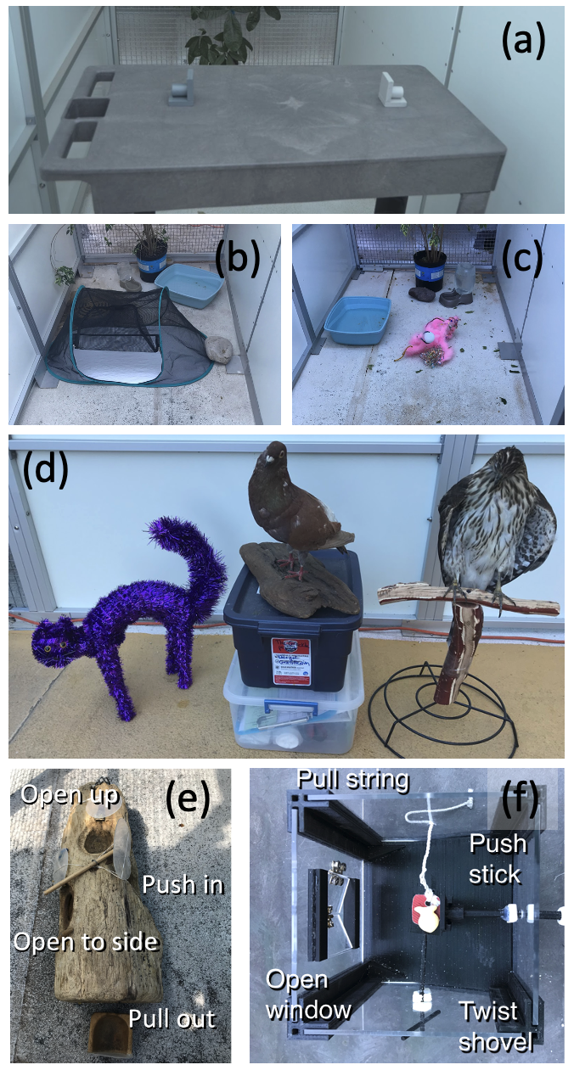

Figure 1: This experiment assessed the relationship between multiple different behavioral tests and contexts. We quantified and increased behavioral flexibility with serial reversal learning of a color preference: a light gray and a dark gray tube (a), we determined individual differences in exploration of a novel environment: a tent (b), exploration of a novel object: a homemade pink fuzzy shape (c), boldness towards threatening objects (purple halloween cat and Cooper’s hawk) compared to a known non-threat (pigeon) (d), we cataloged motor diversity when interacting with novel foraging problems on the two multiaccess boxes (e-f), and we measured persistence by we counting the number of touches to all novel apparatuses (b, c, d, e, and f).

Table 1. Motor action ethogram for the two multiaccess box experiments. Any of the four modifiers can be added to any of the six motor actions. However, Stand only goes with the On top modifier, resulting in a total of 21 unique motor actions. For example, Vertical Peck is a peck to a vertical surface, and Gape Upside Down is a gape with the head being held upside down. Note that one interaction can be coded in multiple categories (e.g., if a bird pulls the string first horizontally and then vertically).

| **Body part** | **Motor action** | **Description** |
| --- | --- | --- |
| Bill | Peck | Pecks the apparatus or its pieces, usually a short duration (e.g., 1s). A peck is with the bill closed or open, but just the tip of the bill touches the apparatus. |
| Push | Pushes a piece of the apparatus or its pieces, usually of a longer duration than a peck. |
| Pull | Pulls a piece of the apparatus or its pieces, usually of a longer duration than a peck. |
| Grab | Grabs a piece of the apparatus or its pieces, usually of a longer duration  than a peck. The bill will be open in this case and the part of the bill touching the apparatus will be the inside of the mandibles. |
| Gape | The closed bill is placed under the edge, in an opening, or on a surface of the apparatus or its pieces and then the bill is opened. Usually of a longer duration than a peck. |
| Feet | Stand | Stands on top of the apparatus. |
|  | ***Modifiers*** | ***These can apply to any of the above actions*** |
|  | **Vertical**  (e.g., head vertical to the ground) | Performs an **action directed vertically**, often toward the horizontal (oriented parallel to the ground) edges of the apparatus (e.g., the lid of the box), or moves a piece of the apparatus up. |
|  | **Horizontal**  (e.g., head parallel to the ground) | Performs an **action directed horizontally**, often toward the vertical (oriented upright to the ground) edges of the apparatus (e.g., the walls), or moves a piece of the apparatus horizontally. |
|  | **Upside down** | Performs an action with its head upside down. |
|  | **On top** | While standing on top of the apparatus. |

## ### Changes after the study began

**After data collection began and before data analysis:**

1) We added an \**unregistered analysis\** to assess interobserver reliability for the response variables to determine how repeatable our data collection was by having the videos coded by multiple coders. This unregistered analysis is described, and results reported, in the Supplementary Material 1.

**After data collection and during data analysis:**

1) We conducted an \**unregistered analysis*\* to compare the grackles’ responses to the familiar item with responses to the novel/threatening items in the exploration and boldness assays. The definition for boldness relates to the behavioral response to threat, so we would expect a decrease in interactions with the novel/threatening items relative to the control item. To test that this occurred, and the grackles perceived the items as threatening, we used MCMCglmm to model the effect of condition (novel or familiar item trial) on the latency to approach and the duration spent in proximity to the items in the exploration assays. We used a gaussian distribution for latency to approach and Poisson distribution for the duration spent in proximity. We included a covariate that identified whether the bird was in the flexibility trained or control group and a random effect for bird ID. The boldness data were overdispersed and zero-inflated so we used a zero-inflated negative binomial mixed model with the R package NBZIMM [@zhang2020nbzimm]. In this model, we also included a covariate for the flexibility trained group and a random effect for bird ID.

2) For the repeatability analyses, we preregistered that we would calculate repeatability from the ratio of variance components extracted from MCMCglmm models. We also obtained credible intervals from the posterior distribution of these models. However, repeatability is a ratio so values can never be less than zero. As such, we are not able to ascertain the significance of our repeatability values by determining whether the credible interval overlaps with zero. We conducted an \**unregistered analysis*\* to obtain p-values indicating whether performance was significantly more repeatable than random by utilizing the built in permutation tests in the rptR package [@stoffel2017rptr]. This also ensured that repeatability values and credible intervals were consistent with the preregistered MCMCglmm methods to validate that our non-informative priors were appropriate.

3) The boldness data were zero-inflated (69% of the data were zeros) and overdispersed, such that the appropriate model for this kind of count data is a zero-inflated negative binomial model. As stated above, we used this model type in the \**unregistered analysis*\* to compare the responses between the threatening and non-threatening contexts. To assess repeatability of performance on the boldness assays, we preregistered that we would use a MCMCglmm model with a Poisson distribution. The boldness data were not appropriate for Poisson and we do not know of a method for obtaining the variance components for the repeatability calculation from a zero-inflated negative binomial model. Consequently, for the repeatability analysis we used a logistic regression, where the response was 0 (the grackle never approached the object during boldness trials) or 1 (the grackle approached the object during boldness trials).

4) For repeatability analyses of the exploration and persistence data, we originally planned to conduct a model with a Poisson distribution. However, the data checking process detected significant zero-inflation and heteroscedasticity in the Poisson models. We log-transformed the latency to approach (for exploration) and number of touches (for persistence) for the gaussian model, which was normally distributed and not heteroscedastic, therefore we used a gaussian distribution instead.

5) When we originally submitted this preregistration, we anticipated measuring motor diversity on only one multiaccess box (MAB). However, as part of a different experiment within our overall project, we added a second, but distinct MAB. Consequently, we did not preregister a repeatability analysis for motor diversity because there would have been only one measure per bird. We added an \**unregistered analysis*\* to assess motor diversity repeatability. We used a Poisson regression and included a covariate for whether the grackle was flexibility trained or not. We also included an offset for the total trial time with the MABs to control for variation in the opportunity to express motor behaviors.

6) During the exploration environment assays, very few grackles stepped inside the tent (n = 4), so we did not have enough data to use the following preregistered variables in the analysis relating exploration and behavioral flexibility: Latency to enter a novel environment inside a familiar environment, Time spent in each of the different sections inside a novel environment or the corresponding areas on the floor when the novel environment is not present (familiar environment) as an interaction with the Environment Condition: activity in novel environment vs. activity in familiar environment, Time spent per section of a novel environment or in the corresponding areas on the floor when the novel environment is not present (familiar environment) as an interaction with the Environment Condition: time spent in novel environment vs. time spent in familiar environment.

7) We also realized that, because we experimentally increased reversal learning speed through serial reversal learning [@logan2024flexmanippcj], behavioral flexibility should be the independent rather than dependent variable.

8) We found [@blaisdell2021more; @lukas2024flexmanip] that the "Flexibility Comprehensive" variables were much more effective at representing flexibility than the other variables we preregistered (e.g., Trials to reverse in the last reversal). Additionally, we found that solution switching on the MAB is correlated with reversal performance and including this as an additional variable describing flexibility will not significantly add to the variance explained. Because the individual’s serial reversal learning training condition (control or trained) is accounted for in the Flexibility Comprehensive variables, we did not include condition as an additional independent variable in these models. Note that we still conducted the preregistered analyses testing the relationship between performance on the behavioral trait assays and whether the individual was in the control or flexibility trained group.

9) We preregistered that we would include “Age” as a covariate in our models relating performance on the behavioral trait assays to flexibility, if we tested juveniles as well as adults, though our plan was to only test adults. Our sample ultimately included two juveniles because the grackles were more difficult to catch than expected and we struggled to meet our minimum sample size. Similarly, it is possible that Sex could influence performance, but we only tested 4 females because they were more difficult to trap than males. We did not find that including a covariate for Age and Sex changed any of our results (repeatability or relationship with flexibility). Therefore, to maintain greater statistical power, we decided not to include Age or Sex as covariates in the final models.

10) We added an additional persistence repeatability analysis to test whether nonfunctional touches were consistent across the two different MABs. We preregistered that we would separately evaluate the relationship between flexibility and functional or nonfunctional touches, but, because flexibility was originally the dependent variable, we did not preregister this repeatability analysis.

11) We made two modifications to the analysis testing the relationship between persistence and flexibility. We preregistered that we would use all of the data, including the repeated measures, with a random effect for individual ID in a Poisson model. However, the full data set was zero-inflated. Because persistence was repeatable across assays, we took the average for each individual to use as the dependent variable in our model. Consequently, there was no potential for within-individual clustering in the data and we did not include the random effect for individual ID. Secondly, we were interested in the number of touches to novel objects per time. As such, we used a Poisson model as preregistered, but with an added offset term for trial time.

12) We preregistered that we would compare performance on the boldness and exploration assays between grackles in the aviaries and those tested in the wild. However, we were unable to collect a large enough sample size to quantitatively test this hypothesis, therefore we present what we have in Supplementary Material 2.

# ## RESULTS

## ### Repeatability

Our first goal was to assess the repeatability of grackle boldness, exploration, persistence and motor diversity behaviors across time and different contexts. We collected boldness and exploration data on 19 individuals, but 2 of these individuals did not participate in the MAB tasks and so our sample size was 17 for the repeatability of persistence and motor diversity.

### #### Boldness

We first conducted an \**unregistered analysis\** to evaluate whether grackles perceived the objects presented to them during boldness trials as threatening. Relative to the pigeon control condition (the known non-threat), we found that grackles spent 55% less time on the ground within 100cm of the cat (\**p\** = 0.00) and 61% less time on the ground in the presence of the hawk (\**p\** = 0.00). There was a nonsignificant 9.5% decrease in duration on the ground in the hawk condition relative to the cat condition (\**p\** = 0.71). Consequently, there is evidence that the grackles perceived the cat and hawk as more threatening than the pigeon, and we only use data from the cat and hawk assays in all subsequent analyses including boldness. Despite the perceived threat, 12 out of 19 grackles spent time on the ground in the presence of the hawk and 7 out of 19 grackles spent time on the ground with the cat at some point during the 15-minute boldness trials.

Next we assessed whether grackles reacted consistently towards each threatening object across two time periods (temporal repeatability). Because the repeatability analysis was not possible with a zero-inflated negative binomial model, we instead used a binomial model where our dependent variable represented whether the duration grackles spent within 100cm of the threatening object was greater than 0 seconds (1) or not (0). We found no evidence for repeatability of performance in either the cat (\**Repeatability\** = 0.18, CI = 0.00-0.96, \**p\** = 0.22) or hawk (\**R\** = 0.00, CI = 0.00-0.44, \**p\** = 0.48) assays (Fig. 2). Similarly, when we considered grackle performance across the two different threatening contexts (contextual repeatability) there was also no consistency in behavioral response (\**R\** = 0.04, CI = 0.00-0.28, \**p\** = 0.22).

It is possible that the lack of repeatability is because habituation to the potentially threatening object occurs after the first exposure[@greggor2015neophobia; @takola2021novelty]. We conducted an *unregistered analysis* and found that grackles did spend significantly longer on the ground during the second cat, hawk and novel object (which the grackles considered threatening, see below) trials, relative to the first trials (Poisson model: *ß* = 0.85, p < 0.01). To check whether this explains the lack of contextual repeatability in this behavioral trait, we conducted a second *unregistered analysis*\** evaluating repeatability of performance in only the first trial in response to the potentially threatening contexts. We still found no evidence that response to the potentially threatening objects was repeatable across these contexts (\**R\** = 0.00, CI = 0.00-0.17, \**p\** = 1; Fig. S3).

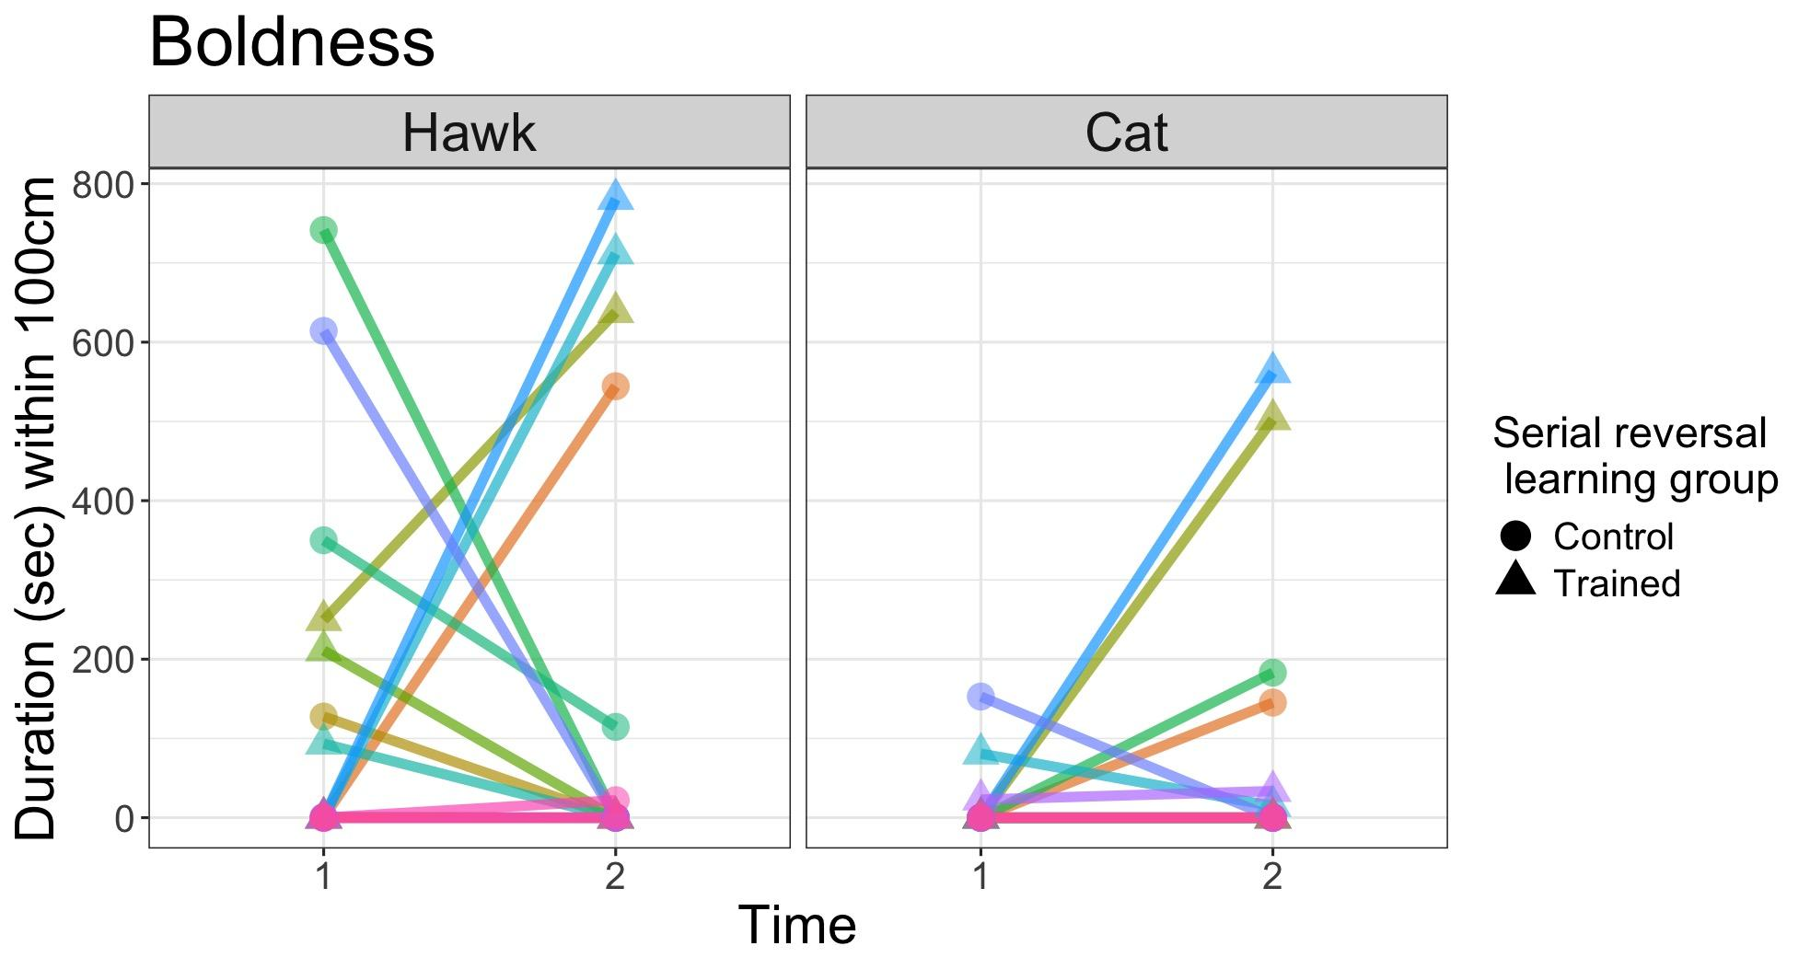

Figure 2: The grackles did not respond consistently to the threatening objects across the two time points. Each line color represents an individual and the points show the number of seconds individuals spent on the ground within 100cm of the threatening object during each of the two 15-minute trials (Time 1 and Time 2). The shape of the point is based on whether the grackle was part of the control (circle) or trained (triangle) group in the serial reversal learning experiment. The two time periods were separated by an average of 33 days (range: 11-49 days). If performance is repeatable we would expect the line connecting the two points to be at or close to horizontal, and the lines of different individuals to be approximately parallel.

### #### Exploration

Similar to boldness, we assessed the repeatability of exploratory behavior across two time points and across two different contexts: a novel object and a novel environment. Because novel items might elicit a response based on the boldness personality trait rather than an exploratory response [our P1 alternative 4 described above; @carter2013animal], we also compared the novel environment and novel object responses to control conditions with a familiar environment and a familiar object to determine whether grackles perceived the novelty as threatening (this is an \**unregistered analysis*\*). We found no difference in the latency of individuals to approach the novel compared to the familiar environment (\**ß\** = 0.29, CI = -0.24-0.81, \**p\** = 0.27), or the duration they spent near the novel and familiar environments (\**ß\** = -0.61, CI = -1.47-0.20, \**p\** = 0.14). In contrast, grackles took significantly longer to approach the novel object relative to the familiar object (\**ß\** = 2.11, CI = 1.22-2.89, \**p\** < 0.01), indicating the novel object may have been perceived as threatening.

We found that the latency to approach the novel environment across time points 1 and 2 was highly repeatable (\**R\** = 0.72, CI = 0.42-0.88, \**p\** < 0.01). Similarly, the duration spent near the novel environment was also highly repeatable (\**R\** = 0.85, CI = 0.67-0.98, \**p\** < 0.01). However, the latency to approach the novel object was not repeatable (\**R\** = 0.05, CI = 0-0.5, \**p\** = 1; Fig. 3). When we assessed performance across the novel environment and novel object tasks, we found that latency to approach was repeatable across the two different contexts, but this result was driven by the very high between-individual variance in the environment assay (\**R\** = 0.49, CI = 0.21-0.69, \**p\** = 0; Fig. S1).

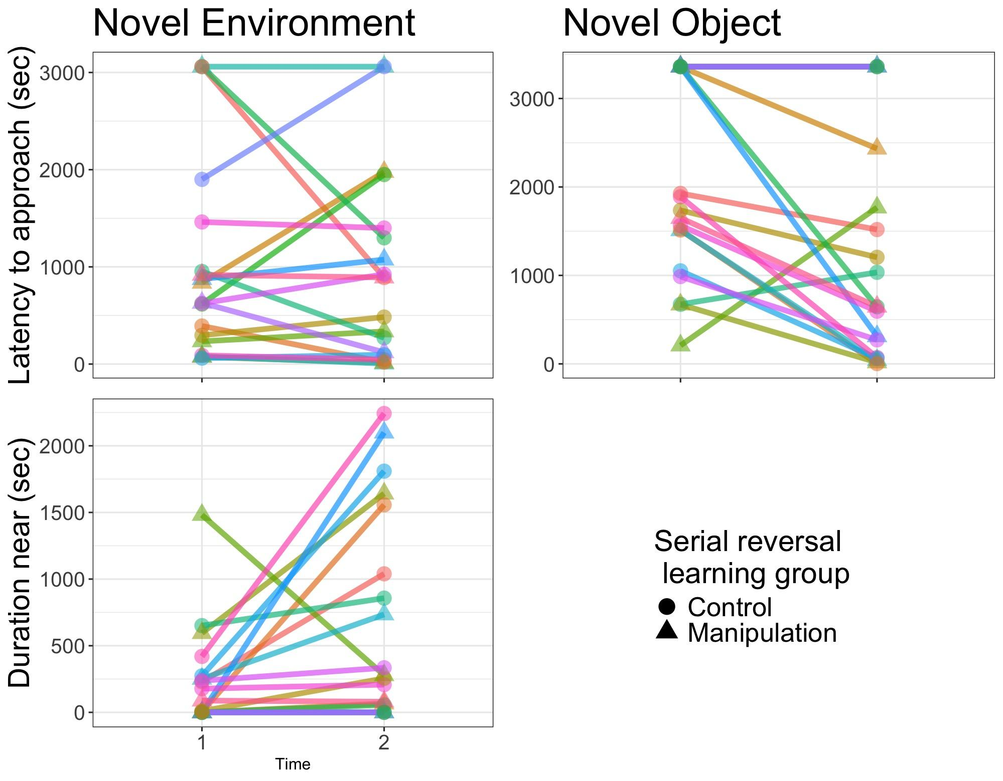

Figure 3: The latency to approach and the duration spent near the novel environment test were significantly repeatable across time, whereas performance was not repeatable for novel object exploration. Each line color represents an individual and the points show the amount of time before individuals approached to within 100cm (Latency to approach) or amount of time individuals spent within 20cm (Duration near) of the novel item during each of the two 45-minute trials. The shape of the point is based on whether the grackle was part of the control (circle) or trained (triangle) group in the serial reversal learning experiment. The two time periods were separated by 34 days on average (range: 11-49). If performance is repeatable within a test we would expect the line connecting the two points to be at or close to horizontal, and the lines of different individuals to be approximately parallel.

### #### Persistence

We tested whether individuals (n = 17) were repeatable in the number of touches per trial time that they made across multiple novel test apparatuses (Fig. 1b-f): boldness objects, exploration environment and object, as well as the two different MABs. We found that persistence in interacting with these diverse objects was repeatable (\**R\** = 0.28, CI = 0.07-0.46, *\*p\** < 0.01; Fig. 4). However, touches to the MABs that were nonfunctional (i.e., applied to the parts of the apparatus that could never result in obtaining the food) were not repeatable (*R* = 0.08, CI = 0.00 - 0.58, *p* = 1).

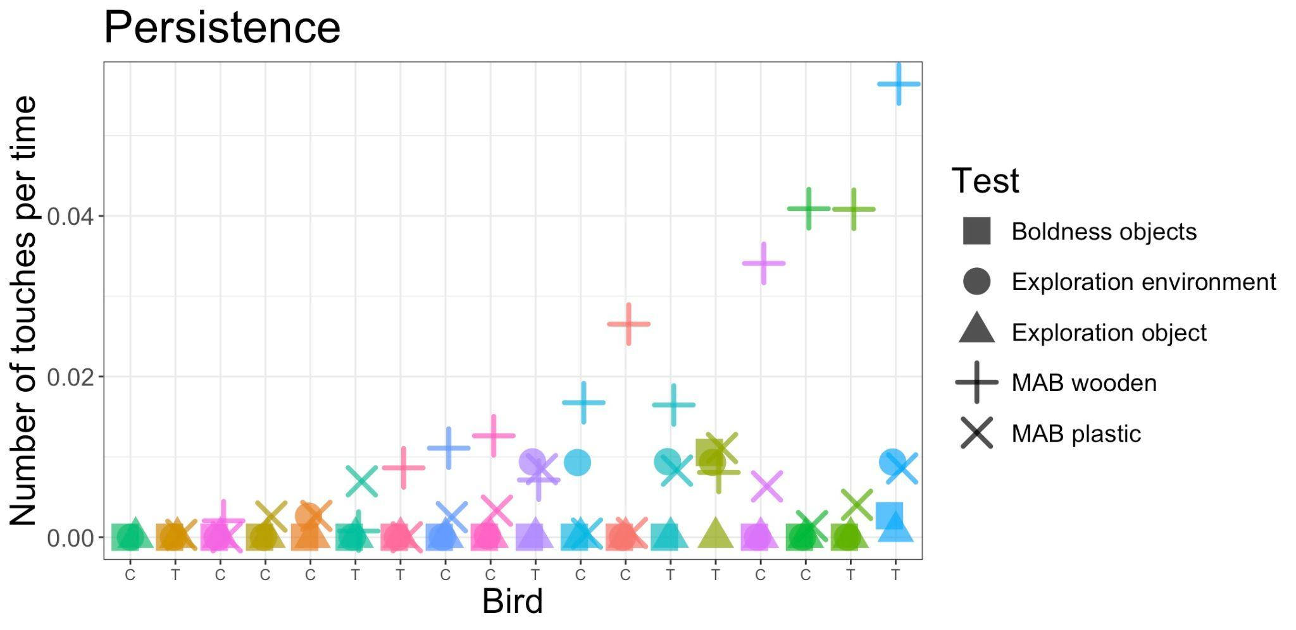

Figure 4: Persistence (the number of touches per time) was repeatable across multiple diverse test apparatuses. The x-axis shows each individual bird, also identified by unique colors and labeled with a “C” or a “T” to distinguish whether they were part of the control or trained group, respectively, in the serial reversal learning experiment. Birds are sorted on the x-axis according to the maximum number of touches per time. Test apparatuses are distinguished by shape and we abbreviated multiaccess box as “MAB” in the figure legend.

#### Motor Diversity

We quantified the number of different motor behaviors used while interacting with two distinct MABs in 17 grackles. Grackles were not consistent in the number of motor behaviors used across the two MABs and so repeatability was very low and not statistically significant (\**R\** = 0.06, CI = 0.00-0.45, \**p\** = 0.50).

## ### Hypothesis 1: Relationships among measures

The repeatability analyses informed which of our methods measured consistent individual differences in behavior. Our next goal was to investigate the relationships among only the repeatable measures (exploration of a novel environment and persistence) and the Flexibility Comprehensive variables and whether the grackle was in the flexibility trained or control group.

### #### Relationship between flexibility and exploration

We first analyzed the relationship between the Flexibility Comprehensive measures that quantify the rate of learning to be attracted to a color option in the serial reversal learning task, $\phi$, and the rate of deviating from learned associations, $\lambda$ [@lukas2024flexmanip; @blaisdell2021more], and two variables describing novel environment exploration: Duration near (within 20cm) the outside of the tent, and the latency to first come to the ground from the aviary perches to approach the tent. We found no relationship between either measure of novel environment exploration and $\phi$ or $\lambda$ (Table 2).

We next investigated if performance varied as a function of whether individuals went through serial reversal learning to increase flexibility (trained group, n=8) or not (control group, n=11). Grackles that underwent the flexibility training were more exploratory in that they spent more time within 20cm of the outside of the novel environment relative to control individuals (Table 3; \**ß\** = 3.92, \**p\** = 0.04). However, there was no difference between trained and control individuals in latency to come to the ground within 100cm of the novel environment (\**ß\** = -0.43, \**p\** = 0.54).

### #### Relationship between flexibility and persistence

We found no support for a relationship between persistence, measured as functional touches to all test apparatuses, and either $\phi$ (n=19, *ß* = 0.42, *p* = 0.11) or $\lambda$ (*ß* = 0.08, *p* =0.77). We then looked at whether the number of incorrect choices in the reversal learning task (i.e., how much the grackle is perseverating on a previously rewarded color option before exploring the other option), which is considered a measure of persistence, was related to the average number of functional or nonfunctional touches per time to the novel apparatuses (see P3 alternative 2, above). We found no evidence of a relationship between these two potential measures of persistence because the intercept-only model was supported over the model containing the number of touches variable (Table S2). This is evidence that the number of touches is not related to perseverating on an option in a way that inhibits flexible learning.

Lastly, in contrast to the exploration results, we found no evidence of a relationship between persistence and whether or not the grackle underwent the flexibility training. The number of functional touches to the novel apparatuses did not differ between control and trained grackles (Table 3; *ß* = 0.81, *p* = 0.09).

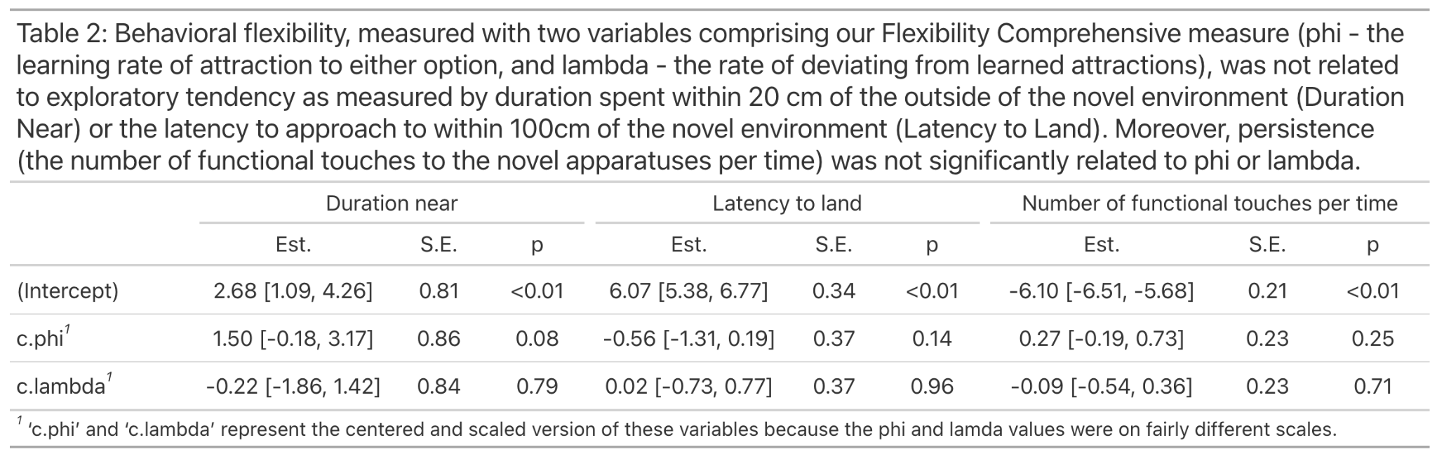

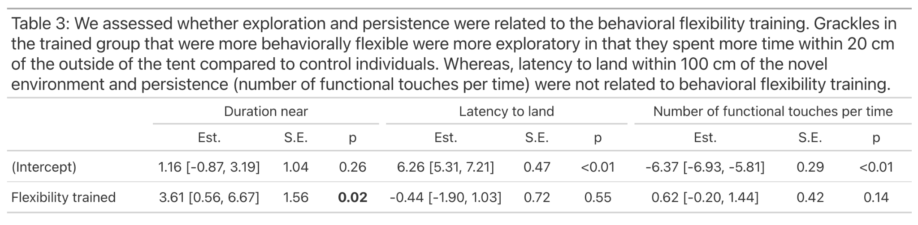

# ## DISCUSSION

Rapid human-induced environmental change leads to novel challenges for wildlife, where individual and species ability to survive is most often possible through behavioral change [@wright2010behaivoral]. Although several behavioral traits are implicated in successful adaptation to human modified environments [@chapple2012can], it is uncommon to directly test for multiple traits in the same individuals. Here, we used multiple novel and threatening stimuli to assess the validity of methods measuring various behavioral traits, and the relationships among traits, in great-tailed grackles, a species that has adapted to many human-induced changes to its environment during a rapid range expansion. We found that only some of our methods for measuring behavioral traits in captivity produced repeatable performance and in support of our main hypothesis, we did find a relationship between behavioral flexibility and exploration.

Personality traits like boldness, exploration, and persistence are not directly observable. To validate that the experimental method used likely elicited performance reflective of the inherent personality trait, performance must be repeatable across time and contexts [@carter2013what]. We found that the number of touches that grackles made to multiple different novel apparatuses was repeatable, indicating that this is likely a valid method for measuring the trait persistence. Despite using multiple assays and stimuli to quantify exploration, boldness, and motor diversity, we found that only one method produced repeatable performance: the novel environment exploration assay. The other methods, exploration of a novel object, boldness towards two different novel threats, and the number of distinct motor behaviors used to interact with the two different MABs (Fig. 1) did not produce repeatable performance across sampling periods. However, we provide in Supplementary Material 2 a plot of the raw boldness and exploration data so readers can visually compare performance among tests (Fig. S2).

A key aspect distinguishing boldness from exploration is that boldness reflects a response to potentially threatening objects, novel or familiar [@carter2013animal; @greggor2015neophobia]. Consequently, we compared performance between the novel or threatening objects and the familiar objects in the exploration and boldness assays. The novel environment was the only object the grackles did not perceive as a threat. Although the novel object for the exploration assay was not meant to be threatening (e.g., it was smaller than the threatening objects, it did not have eyes), grackles still spent significantly less time near it than their familiar object. Consequently, grackles did not perform consistently on these assays where the object was perceived as threatening. This highlights the relevance of the jingle-jangle fallacy, which describes the mismatch between a trait label and what the method actually measures [@carter2013animal]. Although we expected the novel object to measure the trait exploration, by incorporating control conditions and multiple other novel and threatening objects, it was clear that the novel object was eliciting performance that was likely more reflective of boldness.

It is possible that grackles, in general, do not produce repeatable responses when faced with a threat in captivity. In the wild, grackles are a gregarious species that probably rarely encounters threats while alone [@johnson2001great]. For several reasons, we did not house more than one grackle in each aviary. Therefore, the lack of repeatability in performance could stem from the relatively contrived situation of experiencing a threat when visually isolated from conspecifics. This preliminary evidence is congruent with other research on social species encountering novelty. For example, zebra finches were more likely to approach a novel object for food [@coleman1994neophobia] and investigate a novel environment [@schuett2009sex] when in a social group compared to when alone. However, Carib grackles were slower to approach novel foraging opportunities when in a social group compared to when alone [@morand2009innovation]. Because the majority of research on animal personality traits is conducted on individuals in captivity regardless of their sociality, more research is needed to understand when social behavior may affect the consistency of performance on personality assays.

We assessed the relationship between our repeatable behavioral traits (exploration and persistence) and the two measures of behavioral flexibility (Flexibility Comprehensive and flexibility trained versus control groups). Our Flexibility Comprehensive measure reflects two aspects of performance during serial reversal learning, the rate of learning to be attracted to a color option, $\phi$, and the rate of deviating from learned associations, $\lambda$ [@lukas2024flexmanip; @blaisdell2021more]. We predicted that exploration would be positively related to flexibility, and in particular we assumed $\lambda$would best reflect exploratory behavior during the reversal learning task [@lukas2024flexmanip]. We found no relationship between the Flexibility Comprehensive variables and novel environment exploration. This is contrary to previous literature that found that flexibility is theoretically [@griffin2016invading] and experimentally [@rojas2020exploration] linked with this behavioral trait. However, in support of previous literature, we found that grackles that underwent the serial reversal learning training to experimentally increase flexibility were more exploratory towards the novel environment compared to grackles that were in the control group. This potentially explains how great-tailed grackles are successful at adapting to rapid anthropogenic change. The individuals in the population that are willing to seek out novel foraging or nesting opportunities are also able to change their behavior to switch to using these novel resources when they are encountered.

The inconsistent results for the relationship of exploration with either of the two different measures of flexibility likely reflects that individuals trained to be more flexible through serial reversal learning ended up with different strategies for how to reverse quickly [@lukas2024flexmanip]. Trained individuals had a higher $\phi$ and lower $\lambda$ relative to grackles in the control group. As such, trained individuals were good at reacting to changes in the environment either because they kept on exploring alternative options (high lambda) or because they placed high importance on new information (high phi). With either strategy, we could expect trained individuals to also be better at exploration. In addition, we found that, even though all grackles improved during the training, individual differences persisted [@mccune2023flexmanippeerj]. These individual differences might be linked to their persistence, which would explain why the training did not influence the relationship between flexibility and persistence.

In addition, with a sample size of 19, we potentially lacked the power to detect a subtle relationship between flexibility and exploration or persistence. We conducted a power analysis a priori that indicated that a sample size of 32 would permit detections of large effect sizes. We did not meet this sample size goal, due to the difficulty in catching grackles and the large time commitment for serial reversal learning, and so it is possible we failed to detect some relationships. However, the power analysis included many more predictor variables than we ended up using (see Changes after the study began) and was conducted before we determined that the serial reversal learning trained grackles to be significantly more flexible than control grackles [@logan2023flexmanippcj]. Thus, the increased difference in flexibility between control and trained grackles, also reflected in the $\phi$ and $\lambda$ values, should increase our power to detect a relationship between these behavioral traits and flexibility, if it exists. Nevertheless, future research should evaluate these relationships with larger sample sizes.

By assessing multiple behavioral traits in the same individuals of a highly adaptable species, we were able to identify correlations among certain repeatable traits that can inform our understanding of the ability to adapt to environmental change. Overall, we found that the time spent exploring near a novel environment was related to flexibility. Our results support previous hypotheses about traits that are related to flexible behavior, and therefore might be important for increasing survival and fitness in the face of human-induced environmental change. However, additional research is needed to further validate methods for measuring individual differences in boldness and motor diversity in this species, and to disentangle the mechanisms driving the mixed results for the relationship between persistence, exploration, and the two ways of measuring behavioral flexibility.

## Ethics

The research on the great-tailed grackles followed established ethical guidelines for the involvement and treatment of animals in experiments and received institutional approval prior to conducting the study (US Fish and Wildlife Service scientific collecting permit number MB76700A-0,1,2; US Geological Survey Bird Banding Laboratory federal bird banding permit number 23872; Arizona Game and Fish Department scientific collecting license number SP594338 [2017], SP606267 [2018], and SP639866 [2019]; Institutional Animal Care and Use Committee at Arizona State University protocol number 17-1594R; University of Cambridge ethical review process non-regulated use of animals in scientific procedures: zoo4/17 [2017]).

# ## ACKNOWLEDGEMENTS

We thank Jeremy Van Cleve and two anonymous reviewers for their feedback on the preregistration. Julia Cissewski for tirelessly solving problems involving financial transactions and contracts; Sophie Kaube for logistical support; and Richard McElreath for project support.

Ben Trumble for providing us with a wet lab at Arizona State University; Melissa Wilson Sayres for sponsoring our affiliations at Arizona State University and lending lab equipment; Kristine Johnson for technical advice on great-tailed grackles; Jay Taylor for grackle scouting at Arizona State University; Arizona State University School of Life Sciences Department Animal Care and Technologies for providing space for our aviaries and for their excellent support of our daily activities; and our research assistants who helped habituate, trap, weigh, and train grackles to participate in tests: Nancy Rodriguez, Aelin Mayer, Sofija Savic, Brianna Thomas, Aldora Messinger, Elysia Mamola, Michael Guillen, Rita Barakat, Adrianna Boderash, Olateju Ojekunle, August Sevchick, and Justin Huynh. We thank Melissa Folsom and Luisa Bergeron for their exceptional assistance with logistical planning and data collection in the field.

# ## SUPPLEMENTARY MATERIAL 1: Interobserver reliability

### Unregistered analysis: interobserver reliability of dependent variables

To determine whether the experimenter coded the dependent variables from the video recordings of each trial in a repeatable way, hypothesis-blind video coders were first trained in video coding the dependent variable, and then they coded 26% of the videos in the exploration and boldness experiments. We randomly chose four (Tomatillo, Queso, Mole, and Habanero) of the 19 birds (21%) who participated in these experiments using random.org. Video coders then analyzed all videos from these four birds. The experimenter's data was compared with video coder data using the intra-class correlation coefficient (ICC) to determine the degree of bias in the regression slope (@hutcheon2010random, using the irr package in R: @gamer2012package).

#### Interobserver reliability training

To pass \*\***interobserver reliability (IOR) training**\*\*, video coders needed an ICC score of 0.90 or greater to ensure the instructions were clear and that there was a high degree of agreement across coders (see R code comments for details).

\*\***Sierra Planck (discussed with Logan):**\*\* Persistence (total number of touches to apparatus) and motor diversity (presence or absence of a behavior from the ethogram). Planck was the first to code videos for these variables so there was not an already established training process or someone to compare her to. Planck and Logan worked together to agree on coding decisions using one video, and then Planck proceeded to code videos independently after that.

\*\***Alexis Breen**\*\*

- \*\***Persistence (compared with Logan):**\*\* total number of functional touches to apparatus unweighted Cohen's kappa = 1.00 (confidence boundaries=1.00-1.00, n=21 data points)

- \*\***Persistence (compared with Logan):**\*\* total number of non-functional touches to apparatus unweighted Cohen's kappa = 0.00 (confidence boundaries=0.00-0.00, n=19 data points). Note: Breen was previously unclear about when to count non-functional touches, however, a discussion eliminated confusion and we proceeded with allowing her to video code independently because the functional touches, which she scored perfectly on, are the more difficult touches to code and thus indicative of her ability to code non-functional touches after clarity on the instructions.

- \*\***Motor diversity (compared with Planck):**\*\* presence or absence of a behavior from the ethogram unweighted Cohen's kappa = 0.70 (confidence boundaries=0.39-1.00, n=21 data points). Note: Breen joined the project after Planck and had extensive experience with video coding bird behaviors. Because of this, and because she became Kiepsch's supervisor for exploration, boldness, persistence, and motor diversity, we decided to use Breen as the baseline for persistence and motor diversity and match future coders to her rather than to Plank. Therefore, we moved Breen into the primary video coder position (coding more of the videos than the others). To prepare for Kiepsch's training, Breen clarified the motor diversity ethogram to make it more repeatable. However, we did not require Planck to redo training because she was already so far through the videos. As such, we realize that Planck's data from 21% of the videos may not match Breen's as closely as if Plank was matched to Breen during training.

\*\***Vincent Kiepsch (compared with Breen)**\*\*:

- \*\***Exploration**\*\* order of the latency-distance categories ICC = 0.96 (confidence boundaries=0.92-1.00, n=141 data points)

- \*\***Boldness**\*\* order of the latency-distance categories ICC=1.00 (confidence boundaries=1.00-1.00, n=11 data points). Note that, for exploration and boldness, the ordered categories were aligned based on similar latencies between coders to prevent disagreements near the top of the data sheet from misaligning all subsequent entries.

- \*\***Persistence**\*\* number of touches to the apparatus ICC = 0.999 (confidence boundaries=0.996-1.00, n=5 data points).

- \*\***Motor diversity**\*\*: the training score for the presence or absence of a behavior from the ethogram required additional training than originally planned, resulting in a final Cohen's kappa = 0.93 (confidence boundaries=0.80-1.00, n=42 data points).

#### Interobserver reliability scores were as follows (4/19 birds; 21% of the videos):

\*\***Vincent Kiepsch (compared with Breen)**\*\*:

- \*\***Exploration object:**\*\* closest distance category to apparatus Cohen's unweighted kappa = 0.86 (confidence boundaries=0.71-1.00, n=32 data points)

- \*\***Exploration environment:**\*\* first latency to enter tent ICC = 0.997 (confidence boundaries=0.99-0.999, n=10 data points)

- \*\***Boldness:**\*\* closest distance to apparatus Cohen's unweighted kappa = 0.86 (confidence boundaries=0.68-1.00, n=24 data points)

\*\***Exploration and boldness in the WILD (comparison between McCune video coding and transcribing field notes for 20% of the grackles in the wild sample in March 2021 and again on the same data in May 2021)**\*\*:

\**Exploration and boldness data collected in the wild were combined because there was not much data for either and because the variables were the same for both assays*\*

- \*\***Exploration and boldness:**\*\* closest distance category to apparatus Cohen's unweighted kappa = 1.00 (confidence boundaries=1.00-1.00, n=12 data points)

- \*\***Exploration and boldness:**\*\* latency to first landing in a distance category ICC = 0.999 (confidence boundaries=0.994-1.000, n=8 data points)

\*\***Persistence and Motor Diversity (comparisons between Breen, Kiepsch, and Planck)**\*\*:

- \*\***Persistence:**\*\*

- total number of FUNCTIONAL touches to apparatus ICC = 0.77 (confidence boundaries=0.48-0.90, n=18 data points)

- total number of NON-FUNCTIONAL touches to apparatus ICC = 0.68 (confidence boundaries=-0.06-0.95, n=6 data points)

- **Motor diversity:** presence or absence of a behavior from the ethogram unweighted Kappa = 0.77 (confidence boundaries=0.70-0.84, n=380 data points)

These scores indicate that the dependent variables are repeatable to a moderate (persistence and motor diversity) or a high to very high (exploration and boldness) degree given our instructions and training.

# ## SUPPLEMENTARY MATERIAL 2: Additional behavioral trait results

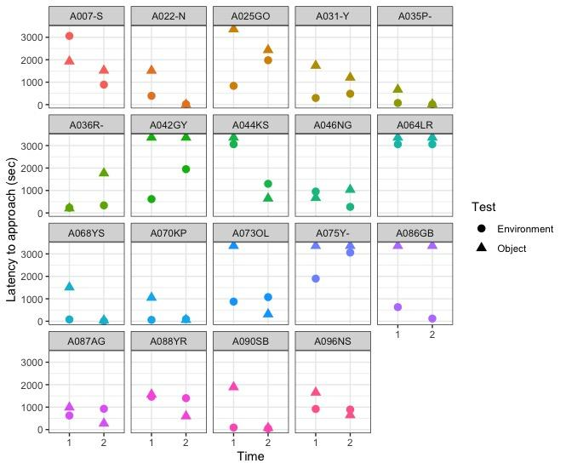

Figure S1 (repeatability of exploration): Grackles performed consistently across the two \*\***exploration\*\*** contexts. Circles represent performance on the novel environment test and triangles represent performance on the novel object test. If performance across contexts is repeatable we would expect to see the circle and triangle at each time point to be near one another.

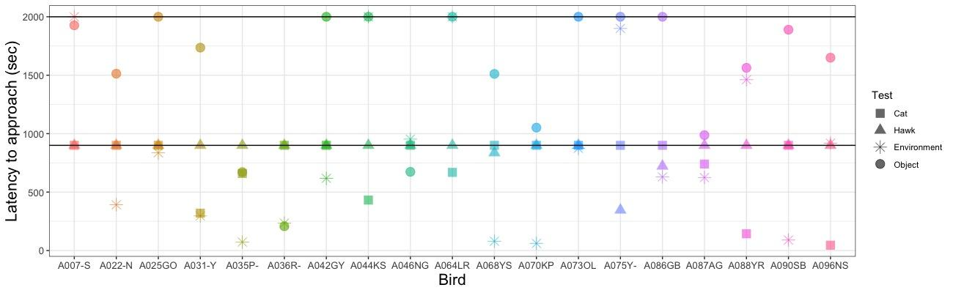

Figure S2: Performance of each grackle on the \*\***boldness\*\*** cat (square), boldness hawk (triangle), \*\***explore\*\*** environment (star) and explore object (circle) assays. Note that explore environment (star) was the only assay that resulted in repeatable performance across time. Here we present data only from time point one. The black horizontal lines at 900 and 2000 seconds represent the ceiling values (i.e. the trial end times) for the boldness and exploration assays, respectively.

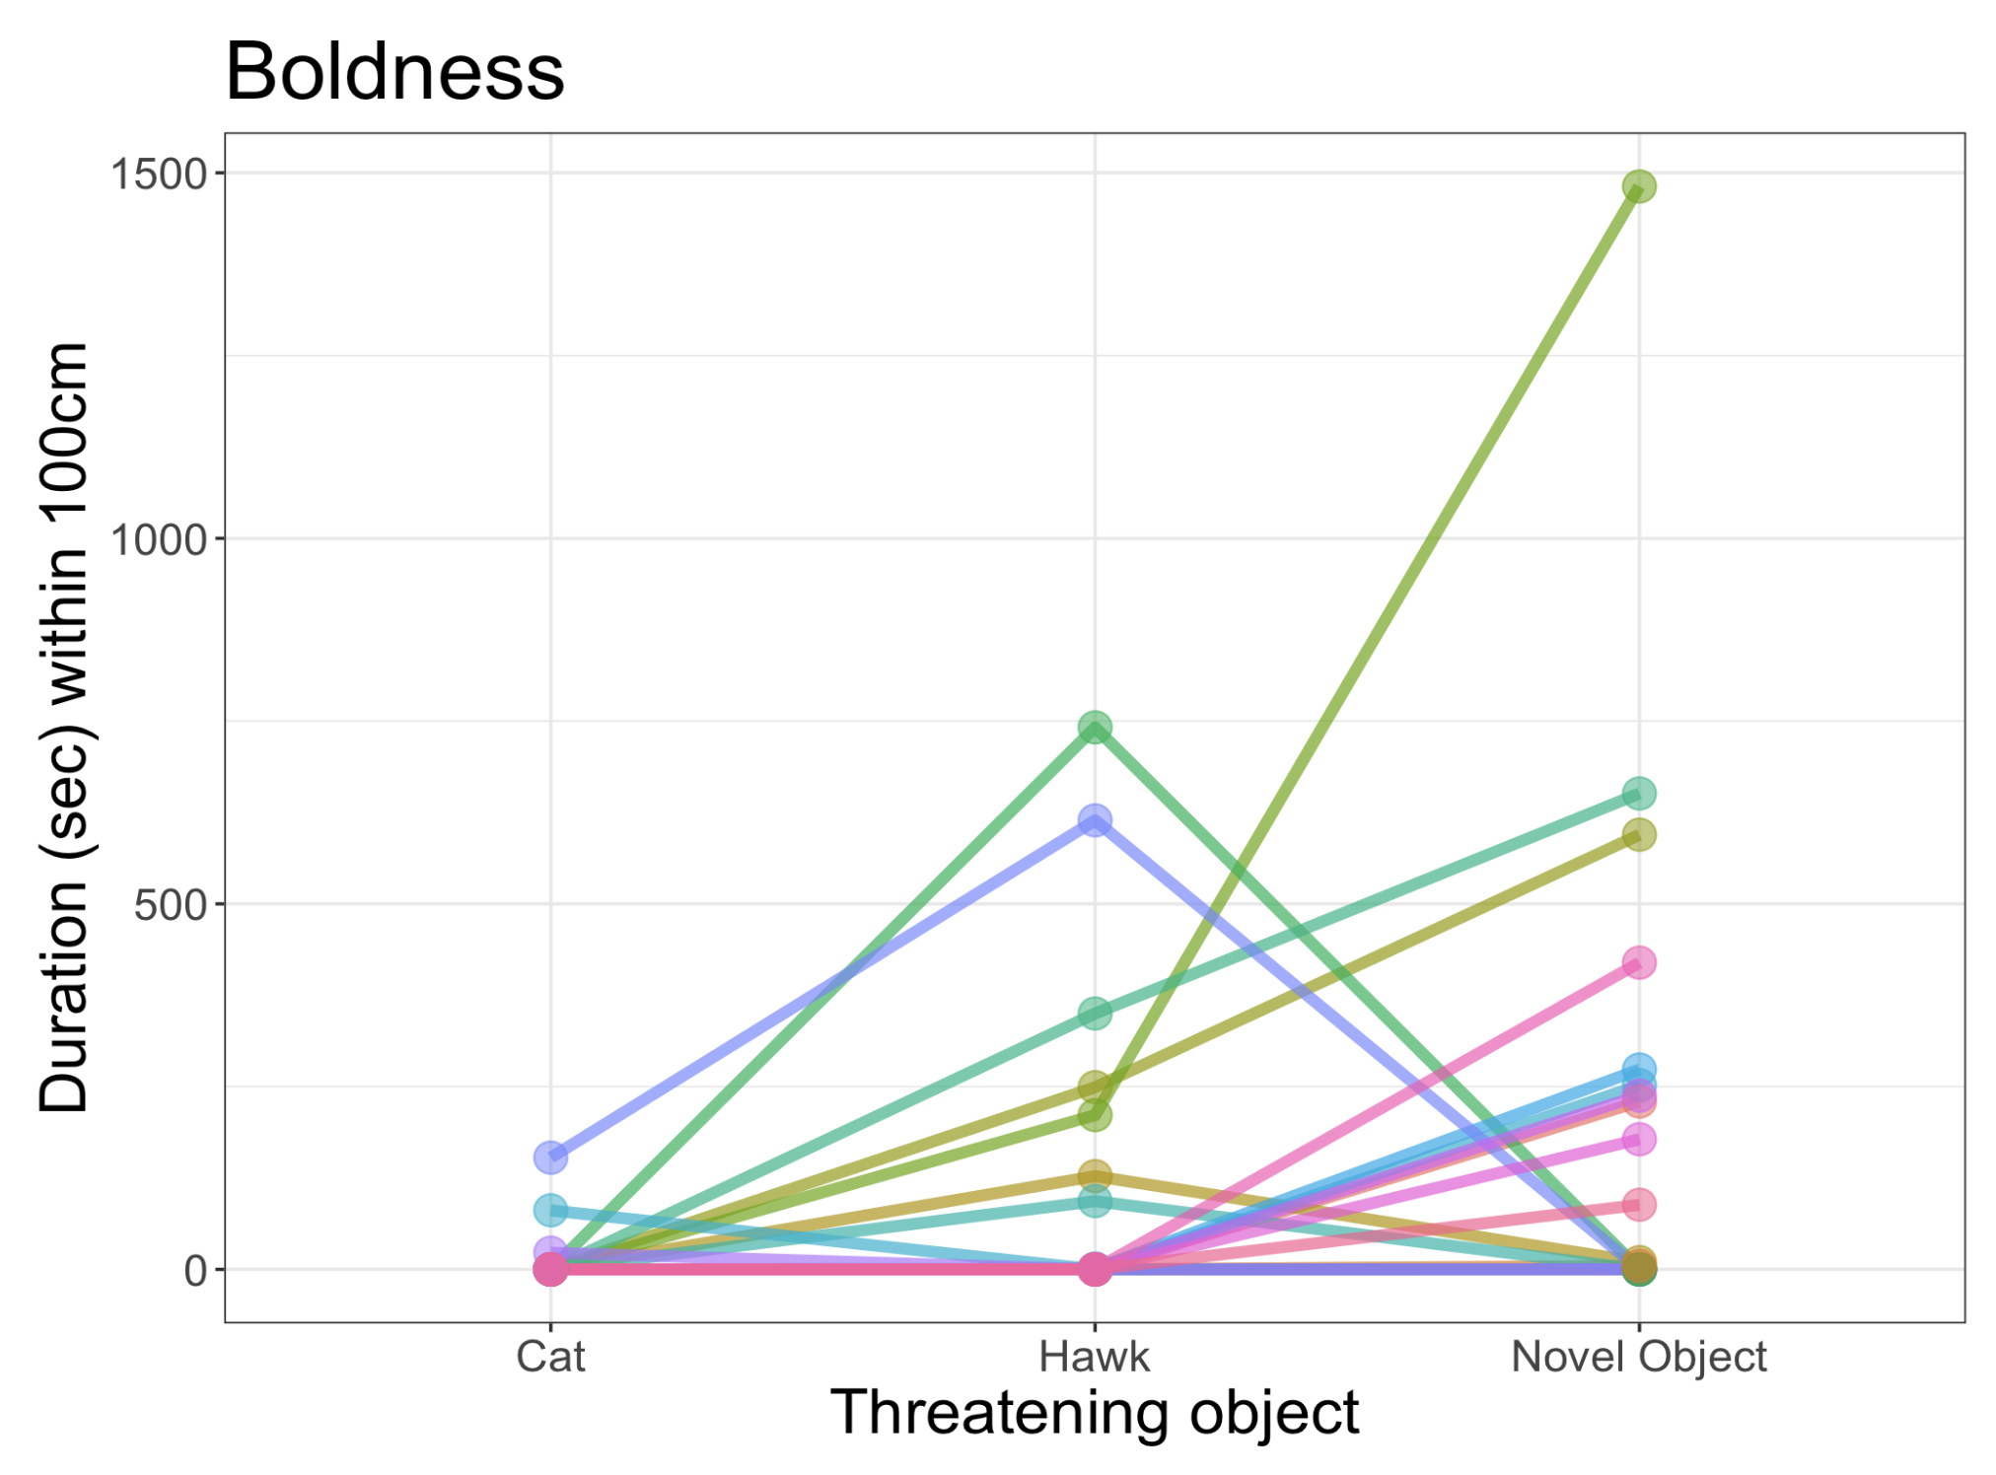

Figure S3: Habituation to the potentially threatening objects did not affect the repeatability of a grackle’s response. We still found no significant repeatability in performance when only evaluating the first trial for each object. Each line color represents an individual and the dots show the number of seconds individuals spent on the ground (within 100cm) in the presence of the threatening object during Time 1’s 15-minute trial.

Table S1: We evaluated the marginal and conditional R-squared values for the fixed effects in our repeatability models. This illustrates the amount of variance in the model that fixed effects explain to inform how much variance is leftover that the random effect of bird ID can account for.

| Trait | Model | Marginal R2 | Conditional R2 | Adjusted Repeatability |
| --- | --- | --- | --- | --- |
| Environment Exploration | Duration near ~ FlexGroup | 0.19 | 0.89 | 0.85 |
| Environment Exploration | Latency to approach ~ FlexGroup | 0.05 | 0.71 | 0.72 |
| Object Exploration | Latency to approach ~ FlexGroup | 0.10 | 0.11 | 0.05 |
| Boldness | Approached ~ FlexGroup + Condition | 0.07 | 0.14 | 0.04 |
| Persistence | Sum touches ~ FlexGroup + Test + Time | 0.57 | 0.69 | 0.28 |
| Motor diversity | Motor actions ~ FlexGroup + Test | 0.06 | 0.08 | 0.06 |

Table S2 (hypothesis 1, prediction 3 alternative 2): Model selection output from the linear mixed model relating the number of incorrect choices on the last reversal to the average number of touches to the novel apparatuses per time. The intercept-only model (Model 1) was a better fit to the data than a model (Model 2) that included the number of touches.

| **Model** | **(Intercept)** | **Average touches** | **df** | **logLik** | **AICc** | **delta** | **weight** |
| --- | --- | --- | --- | --- | --- | --- | --- |
| 1 | 1.66 | NA | 3 | -23.78 | 55.16 | 0.00 | 0.91 |
| 2 | 1.66 | 0.02 | 4 | -24.46 | 59.79 | 4.63 | 0.09 |

# 

## ### Hypothesis 2: Comparing performance in captivity and in the wild

We originally planned to compare performance of grackles on the boldness and exploration tasks assayed in captivity and in the wild. However, we were unable to collect a large enough sample size to quantitatively test this hypothesis. We present here the preregistered hypothesis and methods for this question, as well as the description of the data we were able to collect.

#### Hypothesis 2: Captive and wild individuals may respond differently to assays measuring exploration and boldness.

Prediction 6: Individuals assayed while in captivity are less exploratory and bold than when they are again assayed in the wild, and as compared to separate individuals assayed in the wild, potentially because captivity is an unfamiliar situation.

P6 alternative 1: Individuals in captivity are more exploratory and bold than wild individuals (testing sessions matched for season), and captive individuals show more exploratory and bold behaviors than when they are subsequently tested in the wild, potentially because the captive environment decreases the influence of predation, social interactions and competition.

P6 alternative 2: There is no difference in exploration and boldness between individuals in captivity and individuals in the wild (matched for season), potentially because in both contexts our data is biased by sampling only the types of individuals that were most likely to get caught in traps.

P6 alternative 3: Captive individuals, when tested again after being released, show no difference in exploratory and bold behaviors because our methods assess inherent personality traits that are consistent across the captive and wild contexts in this taxa.

#### Results

Participation of free-flying color-tagged grackles in our exploration and boldness assays in the wild was very low. Of the 19 grackles that experienced the personality assessments in the aviaries, we were only able to measure the corresponding performance in the wild for 2 in the exploration object assay and 2 in the boldness cat assay (3 individuals total). Therefore, we cannot statistically analyze the consistency of performance within individuals across aviary and wild contexts. Qualitatively, in all 4 assays in the wild, grackles approached the item more quickly in the wild compared to aviary assays (Fig. S4).

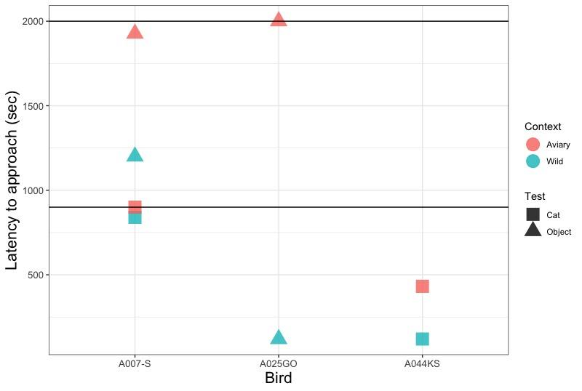

Figure S4: We were only able to measure performance on our boldness and exploration tasks on 3 individuals in both the aviaries (orange symbols) and in the wild (blue symbols). In all cases, grackles were faster to approach to within 20m of the item in the wild compared to the aviaries. The boldness cat assay is indicated with a square symbol and the exploration object assay is indicated with a triangle symbol. Note that neither of these assays produced repeatable performance across time from grackles in the aviaries. This, coupled with the small sample size means these results should be interpreted and generalized with caution. The black horizontal lines at 900 and 2000 seconds represent the ceiling values (i.e. the trial end times) for the boldness and exploration assays, respectively.

We also compared general performance on the exploration environment task (the only repeatable exploration or boldness task) of all grackles in the aviaries compared to all grackles that participated in the wild tests (i.e., many of the color-banded grackles that participated in the wild were never brought into the aviaries). We had no data from the same birds for the exploration environment test in both the aviary and wild contexts and our sample size for wild individuals was small (n=3 wild grackles, n=19 aviary grackles). From this small sample, we found no difference in the latency to approach the novel environment between the aviary or wild context (*ß* = -0.39, CI = -1.83-1.46, *p* = 0.63).

#### Discussion

While we attempted to compare performance on these personality assays between individuals in the aviaries and individuals in the wild, it was difficult to ensure participation of wild grackles. From the small sample of participating grackles, including those we also measured in the aviaries, preliminary evidence supports this explanation because wild grackles were faster to approach compared to grackles tested in the aviary. It is possible that, compared to the aviary performance, the faster approach of wild grackles could be explained by habituation to the threatening objects. If the assays in the wild occurred after grackles were released from the aviaries, it would be the third time they were exposed to the object. However, it is unlikely that this is the case because one (of three total) grackles tested in both the aviaries and the wild was actually given the novel object exploration assay and the novel threat boldness assay first in the wild, then subsequently was caught again and tested in the aviaries. This individual (A007-S) still approached the objects faster while in the wild (Fig. S4).

# 

# ## SUPPLEMENTARY MATERIAL 3: Detailed Methods (preregistration)

**Below is the preregistration that passed pre-study peer review.**

### Preregistration ABSTRACT

This is one of the first studies planned for our long-term research on the role of behavioral flexibility in rapid geographic range expansions. **Project background:** Behavioral flexibility, the ability to change behavior when circumstances change based on learning from previous experience (@mikhalevich_is_2017), is thought to play an important role in a species' ability to successfully adapt to new environments and expand its geographic range (e.g., [@lefebvre1997feeding], [@griffin2014innovation], [@chow2016practice], [@sol2000behavioural], [@sol2002behavioural], [@sol2005big]). However, behavioral flexibility is rarely directly tested at the individual level, thus limiting our ability to determine how it relates to other traits, which limits the power of predictions about a species' ability to adapt behavior to new environments. We use great-tailed grackles (a bird species) as a model to investigate this question because they have rapidly expanded their range into North America over the past 140 years ([@wehtje2003range], [@peer2011invasion]) (see an overview of the [5-year project timeline](https://github.com/corinalogan/grackles/blob/master/README.md)). **This investigation**: In this piece of the long-term project, we aim to understand whether grackle behavioral flexibility (color tube reversal learning - described in a separate [preregistration](https://github.com/corinalogan/grackles/blob/master/EasyToReadFiles/g_flexmanip.md)) correlates (or not) with individual differences in the exploration of new environments and novel objects, boldness, persistence, and motor diversity (and whether the flexibility manipulation made such correlations more detectable). Results will indicate whether consistent individual differences in these traits might interact with measures of flexibility (reversal learning and solution switching). This will improve our understanding of which variables are linked with flexibility and how they are related, thus putting us in an excellent position to further investigate the mechanisms behind these links in future research.

### A. STATE OF THE DATA

NOTE: all parts of the preregistration are included in this one manuscript.

**Prior to collecting any data:** This preregistration was written and submitted to PCI Ecology for peer review (Sep 2018).

**After data collection had begun (and before any data analysis was conducted):** This preregistration was peer reviewed at PCI Ecology, revised, and resubmitted (Feb 2019), and passed pre-study peer review (Mar 2019). See the [peer review history](https://ecology.peercommunityin.org/public/rec?id=29&reviews=True). Interobserver reliability analyses were added (Feb 2021).

### B. PARTITIONING THE RESULTS

We may decide to present the results from different hypotheses in separate papers.

### C. HYPOTHESES

#### H1: [Behavioral flexibility](https://github.com/corinalogan/grackles/blob/master/EasyToReadFiles/g_flexmanip.md) (indicated by individuals that are faster at functionally changing their behavior when circumstances change; measured by reversal learning and switching between options on a multi-access box) is positively correlated with the exploration of new environments and novel objects, but not with other behaviors (i.e., boldness, persistence, or motor diversity) (see @mikhalevich_is_2017 for theoretical background about our flexibility definition).

We will first verify that our measures of exploration, boldness and persistence represent repeatable, inherent individual differences in behavior (i.e., personality). Individuals show consistent individual differences in behavior if the variance in latency to approach the task is smaller within individuals compared to variance in latency among individuals (for exploration and boldness assays). The same definition applies to persistence with the number of touches as the measured variable. If there is no repeatibility of these behaviors within individuals, then performance is likely state dependent (e.g., it depends on their fluctuating motivation, hunger levels, etc.) and/or reliant on the current context of the tasks.

**Predictions 1-5:** Individuals in the experimental group where flexibility (as measured by reversal learning and on a multi-access box) was manipulated (such that individuals in the manipulated group became faster at switching) will be more exploratory of new environments (P1; methods similar to free-entry open field test as in @mettke2009spatial) and novel objects (P2; methods as in @mettke2009spatial) than individuals in the control group where flexibility was not increased, and there will be no difference between the groups in persistence (P3), boldness (P4; methods as in @logan2016behavioral), or motor diversity (P5) (as found in @logan2016behavioral). We do not expect the flexibility manipulation to causally change the nature of the relationship between flexibility and any of the other measured variables. Instead, we expect the manipulation to potentially enhance individual variation, thus making it easier for us to detect a correlation if one exists.

**P1-P5 alternative:** If the flexibility manipulation does not work in that those individuals in the experimental condition are not more flexible than control individuals, then we will analyze the individuals from both conditions as one group. In this case, we will assume that we were not able to influence their flexibility and that whatever level of flexibility they had coming into the experiment reflects the general individual variation in the population. This experiment will then elucidate whether general individual variation in flexibility relates to exploratory behaviors. The predictions are the same as above. The following alternatives apply to both cases: if the manipulation works (in which case we expect stronger effects for the manipulated group), and if the manipulation doesn't work (in which case we expect individuals to vary across all of the measured variables and for these variables to potentially interact).

**P1 alternative 1:** There is a positive correlation between exploration and both dependent variables in reversal learning (one accounts for exploration in reversal learning [the ratio] and the other does not). This suggests that flexibility is not independent of exploration and could indicate that another trait is present that could be explaining individual variation in flexibility as well as in exploration. This other trait or traits could be something such as boldness or persistence.

**P1 alternative 2a:** There is a positive correlation between exploration and the dependent variable that does not account for exploration (number of trials to reverse), but not the flexibility ratio, which suggests that performance overall in reversal learning is partially explained by variation in exploration, but that flexibility and exploration are separate traits because using a measure that accounts for exploration still shows variation in flexibility.

**P1 alternative 2b:** There is a negative correlation between exploration and the flexibility ratio that accounts for exploration, but not with the number of trials to reverse. This could be an artifact of accounting for exploration in both variables.

**P1 alternative 3:** There is no correlation between exploration and either dependent variable in reversal learning. This indicates that both dependent variables measure traits that are independent of exploration.

**P1 alternative 4:** There is no correlation between exploration and either dependent variable in reversal learning because our novel object and novel environment methods are inappropriate for measuring exploratory tendency. These measures of exploration both incorporate novelty and thus may measure boldness rather than exploration. This is supported by a positive correlation between behavioral responses to our exploration and boldness assays.

**P3 alternative 1:** There is a positive correlation between persistence and the number of incorrect choices in reversal learning before making the first correct choice. This indicates that individuals that are persistent in one context are also persistent in another context.

**P3 alternative 2:** There is no correlation between persistence and the number of incorrect choices in reversal learning before making the first correct choice. This indicates that flexibility is an independent trait.

![Figure 1.](g_exploreFig1.png)

***Figure 1.*** An overview of the study design and a selection of the variables we will measure for each assay. Exploration will be measured by comparing individual behavior within a familiar environment to behavior towards a novel environment, as well as response to a familiar object vs. a novel object within the familiar environment that contains their regular food. Boldness will be measured as the willingness to eat next to a threatening object (familiar, novel oject, or a taxidermic predator) in their familiar environment. Persistence will be measured as the number of touches to the novel environment and novel object in the Exploration assay, the objects in the Boldness assay, and the multi-access box in a separate [preregistration](https://github.com/corinalogan/grackles/blob/master/EasyToReadFiles/g_flexmanip.md). Motor diversity will be measured using the multi-access box in a separate [preregistration](https://github.com/corinalogan/grackles/blob/master/EasyToReadFiles/g_flexmanip.md). After the flexibility manipulation occurs, assays will be conducted at least twice (e.g., Time 1, Time 2) and differences (if any) between the control and manipulated groups in the behavioral flexibility [preregistration](https://github.com/corinalogan/grackles/blob/master/EasyToReadFiles/g_flexmanip.md) will be compared across time and, with persistence, across tests (e.g., Test 1, Test 2) because persistence is measured in four different assays.

#### H2: Captive and wild individuals may respond differently to assays measuring exploration and boldness.

**P6:** Individuals assayed while in captivity are less exploratory and bold than when they are again assayed in the wild, and as compared to separate individuals assayed in the wild, potentially because captivity is an unfamiliar situation.

**P6 alternative 1:** Individuals in captivity are more exploratory and bold than wild individuals (testing sessions matched for season), and captive individuals show more exploratory and bold behaviors than when they are subsequently tested in the wild, potentially because the captive environment decreases the influence of predation, social interactions and competition.

**P6 alternative 2:** There is no difference in exploration and boldness between individuals in captivity and individuals in the wild (matched for season), potentially because in both contexts our data is biased by sampling only the types of individuals that were most likely to get caught in traps.

**P6 alternative 3:** Captive individuals, when tested again after being released, show no difference in exploratory and bold behaviors because our methods assess inherent personality traits that are consistent across the captive and wild contexts in this taxa.

### D. METHODS

**Planned Sample**

Great-tailed grackles are caught in the wild in Tempe, Arizona USA for individual identification (colored leg bands in unique combinations). Some individuals (~32) are brought temporarily into aviaries for testing, and then they will be released back to the wild. Grackles are individually housed in an aviary (each 244cm long by 122cm wide by 213cm tall) at Arizona State University for a maximum of three months where they have ad lib access to water at all times and are fed Mazuri Small Bird maintenance diet ad lib during non-testing hours (minimum 20h per day), and various other food items (e.g., peanuts, grapes, bread) during testing (up to 3h per day per bird). Individuals are given three to four days to habituate to the aviaries and then their test battery begins on the fourth or fifth day (birds are usually tested six days per week, therefore if their fourth day in the aviaries occurs on a day off, then they are tested on the fifth day instead). For hypothesis 2 we will attempt to test all grackles in the wild that are color-banded.

**Sample size rationale**

We will test as many birds as we can in the approximately three years at this field site given that the birds only participate in tests in aviaries during the non-breeding season (approximately September through March). The minimum sample size for captive subjects will be 16, however we expect to be able to test up to 32 grackles in captivity. We catch grackles with a variety of methods, some of which decrease the likelihood of a selection bias for exploratory and bold individuals because grackles cannot see the traps (i.e. mist nets). In sampling all banded birds in the wild, we will therefore have a better idea of the variation in exploration and boldness behaviors in this population.

**Data collection stopping rule**

We will stop testing birds once we have completed two full aviary seasons (likely in March 2020) if the sample size is above the minimum suggested boundary based on model simulations (see section "Ability to detect actual effects" below). If the minimum sample size is not met by this point, we will continue testing birds at our next field site (which we move to in the summer of 2020) until we meet the minimum sample size.

#### **Open materials**

[Testing protocols](https://docs.google.com/document/d/1sEMc5z2fw6S9C-wVfc2zV331CRPpu3NuA7IhSFUZJpE/edit?usp=sharing) for exploration of new environments and objects, boldness, persistence, and motor diversity.

#### **Open data**

When the study is complete, the data will be published in the Knowledge Network for Biocomplexity's data repository.

#### **Randomization and counterbalancing**

There is no randomizing. The order of the three tasks will be counterbalanced across birds (using https://www.random.org to randomly assign individuals to one of three experimental orders).

1/3 of the individuals will experience:

1. Exploration environment

2. Exploration object

3. Boldness

1/3 of the individuals will experience:

1. Exploration object

2. Boldness

3. Exploration environment

1/3 of the individuals will experience:

1. Boldness

2. Exploration environment

3. Exploration object

#### **Blinding of conditions during analysis**

No blinding is involved in this study. NOTE Feb 2021: interobserver reliability analyses were conducted with hypothesis-blind video coders.

#### **Variables included in analyses 1-5**

NOTE: to view a list of these variables in a table format, please see our Google [sheet](https://docs.google.com/spreadsheets/d/1nhFkqTFWeAeWli8FU8n7mDiWGBuCeduzf8tWN3wPQeE/edit?usp=sharing), which describes whether they are a dependent variable (DV), independent variable (IV), or random effect (RE). Note: when there is more than one DV per model, all models will be run once per DV.

**ANALYSIS 1** - *REPEATABILITY of boldness, persistence and exploration*

**Dependent variables**

1) Boldness: Latency to land on the table - OR - Latency to eat the food - OR - Latency to touch a threatening object next to food (we will choose the variable with the most data)

2) Persistence: Number of touches to an apparatus per time (multi-access box in the behavioral flexibility [preregistration](https://github.com/corinalogan/grackles/blob/master/EasyToReadFiles/g_flexmanip.md), novel environment in P1, and objects in P2 and P4)

3) Exploration of novel environment: Latency to enter a novel environment set inside a familiar environment

4) Exploration of novel object: Latency to land on the table next to an object (novel, familiar) (that does not contain food) in a familiar environment (that contains maintenance diet away from the object) - OR - latency to touch an object (novel, familiar) (choose the variable with the most data)

**Independent variables**

1) [Condition](https://github.com/corinalogan/grackles/blob/master/EasyToReadFiles/g_flexmanip.md): control, flexibility manipulation

2) ID (random effect because multiple measures per individual)

**ANALYSIS 2** - *H1: P1-P5: flexibility correlates with exploratory behaviors*

**Dependent variables**

1) The **number of trials to reverse** a preference in the last reversal that individual participated in (an individual is considered to have a preference if it chose the rewarded option at least 17 out of the most recent 20 trials (with a minimum of 8 or 9 correct choices out of 10 on the two most recent sets of 10 trials)). See behavioral flexibility [preregistration](https://github.com/corinalogan/grackles/blob/master/EasyToReadFiles/g_flexmanip.md) for details.

2) If the number of trials to reverse a preference does not positively correlate with the number of trials to attempt or solve new loci on the multi-access box (an additional measure of behavioral flexibility), then the **average number of trials to solve** and the **average number of trials to attempt** a new option on the multi-access box will be additional dependent variables. See behavioral flexibility [preregistration](https://github.com/corinalogan/grackles/blob/master/EasyToReadFiles/g_flexmanip.md).

3) **Flexibility comprehensive**: This measure is currently being developed and is intended be a more accurate representation of all of the choices an individual made, as well as accounting for the degree of uncertainty exhibited by individuals as preferences change. If this measure more effectively represents flexibility (determined using a modeled dataset and not the actual data), we may decide to solely rely on this measure and not use independent variables 1-3. If this ends up being the case, we will modify the code in the analysis plan below to reflect this change before conducting analyses of the data in this preregistration.

All models will be run once per dependent variable.

**Independent variables**

1) P1: Latency to enter a novel environment inside a familiar environment

2) P1: Time spent in each of the different sections inside a novel environment or the corresponding areas on the floor when the novel environment is not present (familiar environment) as an interaction with the Environment Condition: activity in novel environment vs. activity in familiar environment

3) P1: Time spent per section of a novel environment or in the corresponding areas on othe floor when the novel environment is not present (familiar environment) as an interaction with the Environment Condition: time spent in novel environment vs. time spent in familiar environment

4) P1: Time spent exploring the outside of the novel environment (within 20cm) before entering it

5) P2: Latency to land on the table next to an object (novel, familiar) (that does not contain food) in a familiar environment (that contains maintenance diet away from the object) - OR - latency to touch an object (novel, familiar) (choose the variable with the most data)

6) P3: Number of touches to the functional part of an apparatus per time (multi-access box, novel environment in P1, novel objects in P2 and P4)

7) P3: Number of touches to the non-functional part of an apparatus per time ([multi-access box](https://github.com/corinalogan/grackles/blob/master/EasyToReadFiles/g_flexmanip.md))

8) P4: Latency to land on the table - OR - Latency to eat the food - OR - Latency to touch a threatening object next to food (choose the variable with the most data)

9) P5: Number of different motor actions used when attempting to solve the [multi-access box](https://github.com/corinalogan/grackles/blob/master/EasyToReadFiles/g_flexmanip.md)

10) Age (adult: after hatch year, juvenile: hatch year). NOTE: this variable will be removed if only adults are tested (and we are planning to test only adults).

11) ID (random effect because multiple measures per individual)

12) [Condition](https://github.com/corinalogan/grackles/blob/master/EasyToReadFiles/g_flexmanip.md): control, flexibility manipulation

**ANALYSIS 3** - *H1: P1 alternative 4: correlation between boldness and exploration*

Dependent variable: Boldness: Latency to land on the table - OR - Latency to eat the food - OR - Latency to touch a threatening object next to food (we will choose the variable with the most data)

Independent variables:

1) Time spent exploring the outside of the novel environment (within 20cm) before entering it

2) Latency to land on the table next to an object (novel, familiar) (that does not contain food) in a familiar environment (that contains maintenance diet away from the object) - OR - latency to touch an object (novel, familiar) (choose the variable with the most data)

**ANALYSIS 4** - *H1: P3: does persistence correlate with reversal persistence?*

Dependent variable: The number of incorrect choices in the final reversal before making the first correct choice

Independent variables:

1) Average number of touches to the functional part of an apparatus per time ([multi-access box](https://github.com/corinalogan/grackles/blob/master/EasyToReadFiles/g_flexmanip.md), novel environment in P1, novel objects in P2 and P4)

2) Condition: control, flexibility manipulation

**ANALYSIS 5** - *H2: P6: captive vs wild*

**Dependent variables**

1) Boldness: In captivity we will measure boldness as the latency to land on the table - OR - Latency to eat the food - OR - Latency to touch a threatening object that is next to food (we will choose the variable with the most data); In the wild the dependent variable will be the latency to come within 2m - OR - Latency to eat the food - OR - Latency to touch a threatening object that is next to food (we will choose the variable with the most data).

2) Persistence: Number of touches to an apparatus per time (multi-access box in the behavioral flexibility [preregistration](https://github.com/corinalogan/grackles/blob/master/EasyToReadFiles/g_flexmanip.md), novel environment in P1, objects in P2 and P4)

3) Exploration of novel environment: Latency to enter a novel sub-environment inside a familiar environment

4) Exploration of novel object: Latency to land next to an object (novel, familiar) (that does not contain food) in a familiar environment (that contains maintenance diet away from the object) - OR - latency to touch an object (novel, familiar) (choose the variable with the most data)

*Note: if 3 and 4 are consistent within individuals, and correlate, we will combine these variables into one exploration propensity score.*

**Independent variables**

1) Context: captive or wild

2) Number of times we attempted to assay boldness or exploration but failed due to lack of participation

3) ID (random effect because multiple measures per individual)

### E. ANALYSIS PLAN

We do not plan to **exclude** any data. When **missing data** occur, the existing data for that individual will be included in the analyses for the tests they completed. Analyses will be conducted in R (current version `r getRversion()`; [@rcoreteam]). When there is more than one experimenter within a test, experimenter will be added as a random effect to account for potential differences between experimenters in conducting the tests. If there are no differences between models including or excluding experimenter as a random effect, then we will use the model without this random effect for simplicity.

#### *Unregistered analysis: interobserver reliability of dependent variables*

To determine whether the experimenter coded the dependent variables in a repeatable way, hypothesis-blind video coders were first trained in video coding the dependent variable, and then he coded 26% of the videos in the exploration and boldness experiments. We randomly chose four (Tomatillo, Queso, Mole, and Habanero) of the 19 birds (21%) who participated in these experiments using random.org. Video coders then analyzed all videos from these four birds. The experimenter's data was compared with video coder data using the intra-class correlation coefficient (ICC) to determine the degree of bias in the regression slope (@hutcheon2010random, using the irr package in R: @gamer2012package).

##### Interobserver reliability training

To pass **interobserver reliability (IOR) training**, video coders needed an ICC score of 0.90 or greater to ensure the instructions were clear and that there was a high degree of agreement across coders (see R code comments for details).

**Sierra Planck (discussed with Logan):** Persistence (total number of touches to apparatus) and motor diversity (presence or absence of a behavior from the ethogram). Planck was the first to code videos for these variables so there was not an already established training process or someone to compare her to. Planck and Logan worked together to agree on coding decisions using one video, and then Planck proceeded to code videos independently after that.

**Alexis Breen**

- **Persistence (compared with Logan):** total number of functional touches to apparatus unweighted Cohen's kappa = 1.00 (confidence boundaries=1.00-1.00, n=21 data points)

- **Persistence (compared with Logan):** total number of non-functional touches to apparatus unweighted Cohen's kappa = 0.00 (confidence boundaries=0.00-0.00, n=19 data points). Note: Breen was previously unclear about when to count non-functional touches, however, a discussion eliminated confusion and we proceeded with allowing her to video code independently because the functional touches, which she scored perfectly on, are the more difficult touches to code and thus indicative of her ability to code non-functional touches after clarity on the instructions.

- **Motor diversity (compared with Planck):** presence or absence of a behavior from the ethogram unweighted Cohen's kappa = 0.70 (confidence boundaries=0.39-1.00, n=21 data points). Note: Breen joined the project after Planck and had extensive experience with video coding bird behaviors. Because of this, and because she became Kiepsch's supervisor for exploration, boldness, persistence, and motor diversity, we decided to use Breen as the baseline for persistence and motor diversity and match future coders to her rather than to Plank. Therefore, we moved Breen into the primary video coder position (coding more of the videos than the others). To prepare for Kiepsch's training, Breen clarified the motor diversity ethogram to make it more repeatable. However, we did not require Planck to redo training because she was already so far through the videos. As such, we realize that Planck's data from 21% of the videos may not match Breen's as closely as if Plank was matched to Breen during training.

***Vincent Kiepsch*** (compared with Breen):

- **Exploration** order of the latency-distance categories ICC = 0.96 (confidence boundaries=0.92-1.00, n=141 data points)

- **Boldness** order of the latency-distance categories ICC=1.00 (confidence boundaries=1.00-1.00, n=11 data points). Note that, for exploration and boldness, the ordered categories were aligned based on similar latencies between coders to prevent disagreements near the top of the data sheet from misaligning all subsequent entries.

- **Persistence** number of touches to the apparatus ICC = 0.999 (confidence boundaries=0.996-1.00, n=5 data points).

- **Motor diversity**: the training score for the presence or absence of a behavior from the ethogram required additional training than originally planned, resulting in a final Cohen's kappa = 0.93 (confidence boundaries=0.80-1.00, n=42 data points).

##### Interobserver reliability scores were as follows (4/19 birds; 21% of the videos):

**Vincent Kiepsch** (compared with Breen):

- **Exploration:** closest distance category to apparatus Cohen's unweighted kappa = 0.86 (confidence boundaries=0.71-1.00, n=32 data points)

- **Exploration environment:** first latency to enter tent ICC = 0.997 (confidence boundaries=0.99-0.999, n=10 data points)

- **Boldness:** closest distance to apparatus Cohen's unweighted kappa = 0.86 (confidence boundaries=0.68-1.00, n=24 data points)

**Exploration and boldness in the WILD** (comparison between McCune video coding and transcribing field notes for 20% of the grackles in the wild sample in March 2021 and again on the same data in May 2021):

- Exploration and boldness data collected in the wild were combined because there was not much data for either and because the variables were the same for both assays

- **Exploration and boldness:** closest distance category to apparatus Cohen's unweighted kappa = 1.00 (confidence boundaries=1.00-1.00, n=12 data points)

- **Exploration and boldness:** latency to first landing in a distance category ICC = 0.999 (confidence boundaries=0.994-1.000, n=8 data points)

**Persistence and Motor Diversity** (comparisons between Breen, Kiepsch, and Planck):

- **Persistence:**

- total number of FUNCTIONAL touches to apparatus ICC = 0.77 (confidence boundaries=0.48-0.90, n=18 data points)

- total number of NON-FUNCTIONAL touches to apparatus ICC = 0.68 (confidence boundaries=-0.06-0.95, n=6 data points)

- **Motor diversity:** presence or absence of a behavior from the ethogram unweighted Kappa = 0.77 (confidence boundaries=0.70-0.84, n=380 data points)

These scores indicate that the dependent variables are repeatable to a moderate (persistence and motor diversity) or a high to very high (exploration and boldness) degree given our instructions and training.

#### *Ability to detect actual effects*

To begin to understand what kinds of effect sizes we will be able to detect given our sample size limitations and our interest in decreasing noise by attempting to measure it, which increases the number of explanatory variables, we used G&ast;Power (v.3.1, @faul2007g, @faul2009statistical) to conduct power analyses based on confidence intervals. G&ast;Power uses pre-set drop down menus and we chose the options that were as close to our analysis methods as possible (listed in each analysis below). Note that there were no explicit options for GLMs (though the chosen test in G&ast;Power appears to align with GLMs) or GLMMs or for the inclusion of the number of trials per bird (which are generally large in our investigation), thus the power analyses are only an approximation of the kinds of effect sizes we can detect. We realize that these power analyses are not fully aligned with our study design and that these kinds of analyses are not appropriate for Bayesian statistics (e.g., our MCMCglmm below), however we are unaware of better options at this time. Additionally, it is difficult to run power analyses because it is unclear what kinds of effect sizes we should expect due to the lack of data on this species for these experiments.

To address the power analysis issues, we will run simulations on our Arizona data set before conducting any analyses in this preregistration. We will first run null models (i.e., dependent variable ~ 1 + random effects), which will allow us to determine what a weak versus a strong effect is for each model. Then we will run simulations based on the null model to explore the boundaries of influences (e.g., sample size) on our ability to detect effects of interest of varying strengths. If simulation results indicate that our Arizona sample size is not larger than the lower boundary, we will continue these experiments at the next field site until we meet the minimum suggested sample size.

#### *Data checking*

The data will be checked for overdispersion, underdispersion, zero-inflation, and heteroscedasticity with the DHARMa R package [@Hartig2019dharma] following methods by [Hartig](https://cran.r-project.org/web/packages/DHARMa/vignettes/DHARMa.html). Note: DHARMa doesn't support MCMCglmm, therefore we will use the closest supported model: glmer from the R package lme4 [@lme4].

#### *Repeatability of exploration, boldness and persistence*

**Analysis:** We will obtain repeatability estimates that account for the observed and latent scales, and then compare them with the raw repeatability estimate from the null model. The repeatability estimate indicates how much of the total variance, after accounting for fixed and random effects, is explained by individual differences (ID). We will run this GLMM using the MCMCglmm function in the MCMCglmm package ([@hadfieldMCMCglmmpackage]) with a Poisson distribution and log link using 13,000 iterations with a thinning interval of 10, a burnin of 3,000, and minimal priors (V=1, nu=0) [@hadfield2014coursenotes]. We will ensure the GLMM shows acceptable convergence (i.e., lag time autocorrelation values <0.01; [@hadfieldMCMCglmmpackage]), and adjust parameters if necessary.

Note Feb 2021: a Gaussian distribution was used instead of a Poisson for exploration and boldness latencies because they are continuous variables.

Note: The power analysis is the same as for P3 (below) because there are the same number of explanatory variables (fixed effects).

#### *H1: P1-P5: correlation of flexibility with exploration of new environments and objects, boldness, persistence, and motor diversity*

**Analysis:** If behavior is not repeatable across assays at Time 1 and Time 2 (six weeks apart, both assays occur after the flexibility manipulation takes place) for exploration, boldness, persistence, or motor diversity (see analysis for P6), we will not include these variables in analyses involving flexibility. If behavior is repeatable within individuals, we will examine the relationship between flexibility and these variables as follows. Note that the two exploration measures (novel environment and novel object) will be combined into one variable if they correlate and are both repeatable within individuals.

Because the independent variables could influence each other, we will analyze them in a single model: Generalized Linear Mixed Model (GLMM; MCMCglmm function, MCMCglmm package; [@hadfieldMCMCglmmpackage]) with a Poisson distribution and log link using 13,000 iterations with a thinning interval of 10, a burnin of 3,000, and minimal priors (V=1, nu=0) [@hadfield2014coursenotes]. We will ensure the GLMM shows acceptable convergence (i.e., lag time autocorrelation values <0.01; [@hadfieldMCMCglmmpackage]), and adjust parameters if necessary. We will determine whether an independent variable had an effect or not using the Estimate in the full model.

To roughly estimate our ability to detect actual effects (because these power analyses are designed for frequentist statistics, not Bayesian statistics), we ran a power analysis in G&ast;Power with the following settings: test family=F tests, statistical test=linear multiple regression: Fixed model (R^2 deviation from zero), type of power analysis=a priori, alpha error probability=0.05. We reduced the power to 0.70 and increased the effect size until the total sample size in the output matched our projected sample size (n=32). The number of predictor variables was restricted to only the fixed effects because this test was not designed for mixed models. The protocol of the power analysis is here:

#### *H1: P1 alternative 4: correlations between exploration and boldness measures*

**Analysis:** Generalized Linear Model (GLM; glm function, stats package) with a Poisson distribution and log link. For an estimation of our ability to detect actual effects, please see the power analysis for P3 below.

**Model validation:** Determine whether the test model results are likely to be reliable given the data [@burnham2003model]. Compare Akaike weights (range: 0–1, the sum of all model weights equals 1; Akaike, 1981) between the test model and a base model (number of trials to reverse as the response variable and 1 as the explanatory variable) using the dredge function in the MuMIn package [@bates2012lme4]. If the best fitting model has a high Akaike weight (>0.89; [@burnham2003model]), then it indicates that the results are likely given the data. The Akaike weights indicate the best fitting model is the [base/test *- delete as appropriate*] model (Table 2).

#### *H1: P3: correlations between persistence measures*

**Analysis:** Generalized Linear Model (GLM; glm function, stats package) with a Poisson distribution and log link.

To determine our ability to detect actual effects, we ran a power analysis in G&ast;Power with the following settings: test family=F tests, statistical test=linear multiple regression: Fixed model (R^2 deviation from zero), type of power analysis=a priori, alpha error probability=0.05. We reduced the power to 0.70 and increased the effect size until the total sample size in the output matched our projected sample size (n=32). The protocol of the power analysis is here