Heather pollen is not necessarily a healthy diet for bumble bees
Clément Tourbez^{1,*}, Irène Semay², Apolline Michel¹, Denis Michez¹, Pascal Gerbaux², Antoine Gekière^{1,§}, Maryse Vanderplanck^{3, §}

¹ Laboratory of Zoology, Research Institute for Biosciences, University of Mons, 7000 Mons, Belgium
² Organic Synthesis and Mass Spectrometry Laboratory, Research Institute for Biosciences, University of Mons, 7000 Mons, Belgium
³ CEFE, Univ Montpellier, CNRS, EPHE, IRD, 34293 Montpellier, France

* Corresponding author
§ Equivalent supervision of the present work.
Correspondence: clement.tourbez@umons.ac.be

Orcid and emails:
C. Tourbez: 0000-0003-1783-5824, clement.tourbez@umons.ac.be
I. Semay: 0000-0002-4197-0316, irene.semay@umons.ac.be
A. Gekière: 0000-0001-5337-1305, antoine.gekiere@umons.ac.be
P. Gerbaux: 0000-0001-5114-4352, pascal.gerbaux@umons.ac.be
D. Michez: 0000-0001-8880-1838, denis.michez@umons.ac.be
M. Vanderplanck: 0000-0002-0110-8019, maryse.vanderplanck@cefe.cnrs.fr

Abstract
There is evidence that specialised metabolites of flowering plants occur in both vegetative parts and floral resources (i.e., pollen and nectar), exposing pollinators to their biological activities. While such metabolites may be toxic to bees, it may also help them to deal with environmental stressors. One example is heather nectar which has been shown to limit bumble bee infection by a trypanosomatid parasite, Crithidia sp., because of callunene activity. Besides in nectar, heather harbours high content of specialised metabolites in pollen such as flavonoids but they have been poorly investigated. In this study, we aimed to assess the impact of Crithidia sp., heather pollen and its flavonoids on bumble bees using non-parasitised and parasitised microcolonies fed either control pollen diet (i.e., willow pollen), heather pollen diet, or flavonoid-supplemented pollen diet. We found that heather pollen and its flavonoids significantly affected microcolonies by decreasing pollen collection as well as offspring production, and by increasing male fat body content while parasite exposure had no significant effect except for an increase in male fat body. We did not highlight any medicinal effect of heather pollen or its flavonoids on parasitised bumble bees. Our results provide insight into the impact of pollen specialised metabolites in heather-bumble bee-parasite interactions. They underline the contrasting roles for bumble bees of the two floral resources and highlight the importance of considering both nectar and pollen when addressing medicinal effects of a plant towards pollinators.

Keywords: Plant-pollinator interaction, Pollen specialised metabolite, Microcolony performance, Bumble bee health, Parasite
Introduction
For their own subsistence and that of their offsprings, bee females mostly forage on two floral resources, namely nectar as main source of carbohydrates (Nicolson & Thornburg, 2007), and pollen as main source of proteins and lipids (Campos et al., 2008). Among these nutritional resources, the pollen chemical composition is particularly complex and highly variable among plant species (Vaudo et al., 2020). While pollen central metabolites, for instance, the protein-to-lipid ratio, play a crucial role in bee health, development, and fitness (Di Pasquale et al., 2013), pollen also contains numerous specialised metabolites (e.g., alkaloids, flavonoids and terpenoids, Irwin et al., 2014; Palmer-Young et al., 2019). The biological activities of these metabolites are multiple so that they may be involved in protecting pollen from abiotic factors, such as UVs (Li et al., 1993), but also from biotic factors, acting as antibacterial, antifungal or insecticidal compounds (Pusztahelyi et al., 2015; Zaynab et al., 2018). When ingesting pollen, bees are then exposed to all these biological activities that may be beneficial, for instance by reducing parasite load through antimicrobial activities (Manson et al., 2010; Biller et al., 2015; Richardson et al., 2015), but also detrimental, for instance by impairing resource collection (Wang et al., 2019; Brochu et al., 2020), decreasing offspring size and production (Arnold et al., 2014), inducing larvae or imago death (Hendriksma et al., 2011; Weber, 2004), and altering immune system (Gekière et al., 2022a). Given these opposite effects on bees, it is essential to question how specific specialised metabolites may impact bee health, especially in a changing world with multiple environmental pressures.

In the current context of biodiversity erosion (Butchart et al., 2010), bees are unfortunately no exception, and many threats have been pinpointed as responsible for their negative population trends (Dicks et al., 2021) such as pesticide exposure (Sánchez-Bayo & Goka, 2014), metalloid pollution (Gekière et al., 2023), habitat loss (Baude et al., 2016), resource scarcity (Naug, 2009), competition with domesticated species (Mallinger et al., 2017), and diseases (Van Engelsdorp et al., 2009). Among environmental challenges, bees indeed suffer from a high diversity of pathogens and parasites (Meeus et al., 2011; Goulson & Hughes, 2015) of which effects vary from small ethological alterations of minor consequences (Paris et al., 2018) to large reductions in host bee fitness (McMenamin & Genersch, 2015). Social bee species such as bumble bees (Apidae; Bombus spp.) are particularly impacted by parasites, the latter benefiting from their social system to readily infect numerous individuals (Folly et al., 2017). One of the most prevalent parasites in wild bumble bee populations is the gut trypanosomatid Crithidia bombi Lipa & Triggiani, 1980 (Euglenozoa: Trypanosomatidae; Schmid-Hempel, 2001). Despite its generally moderate impacts, it can decrease foraging effectiveness (Otterstatter et al., 2005), offspring production (Schmid-Hempel, 1998), queen survival through hibernation (Fauser et al., 2017), and increase mortality in synergy with other stresses (Brown et al., 2000). To deal with such parasite pressure, bumble bees may rely on specific floral resources displaying appropriate antimicrobial properties through their specialised metabolites (Manson et al., 2010; Biller et al., 2015; Richardson et al., 2015; Fitch et al., 2022).

Among potential medicinal floral resources, the heather (Calluna vulgaris Hull. 1808), an Ericaceae commonly foraged by bumble bees (Descamps et al., 2015), produces a nectar documented to affect C. bombi (Koch et al., 2019). This effect has been attributed to the presence of callunene, a terpenoid that induces the loss of C. bombi flagellum, preventing the parasite from settling in the bumble bee digestive tract (Koch et al., 2019). Such medicative properties of heather nectar make heather-rich heathlands even more valuable for these bumble bees (Descamps et al., 2015; Moquet et al., 2017). However, although heather is a major resource for European bees, only a handful of studies have sought for specialised metabolites with biological activities in heather pollen, showing a high prevalence of flavonoids (Gekière et al., in prep.). Flavonoids can have very contrasting effects on insect-plant interactions and affect them in multiple ways (Simmonds 2003; Onyilagha et al., 2012). Bees are attracted to some flavonoid compounds (e.g. quercetin; Liao et al. 2017a) while others repel them (e.g. kaempferol, catechin; Detzel & Wink 1993; Onkokesung et al., 2014). However, despite some deleterious effects on larval development (Wang et al., 2010), flavonoids are mainly not toxic molecules for insects (Detzel & Wink, 1993). Once ingested, flavonoids can have antioxidant properties and are potentially beneficial for bees (e.g. quercetin; Treutter, 2005). They can stimulate the activation of detoxification enzymes (cytochrome P450 monooxygenase) and enhance bee resistance to certain insecticides and acaricides (Scott et al., 1998; Johnson et al. 2012; Liao et al., 2017b). The case of heather pollen flavonoids remains to be addressed and this incomplete picture of the pollen side does not allow for fully arguing that heather is a bumble bee health-promoting plant. Therefore, bioassays to determine heather pollen effects on bumble bee brood, bumble bee health, and parasite dynamics are warranted. To fill this gap, we herein present a study that aimed to assess the effects of heather pollen and its flavonoids on bumble bee health, at both individual and colony levels, considering the bumble bee interaction with the parasite. We specifically addressed the following questions: (i) how does the parasite influence the development of bumble bee microcolonies and individual immunocompetence? (ii) do heather pollen and its flavonoids challenge bumble bees, impacting their resource collection and offspring production? (iii) do heather pollen and its flavonoids affect the parasite dynamic in infected bumble bee workers, or help bumble bees to counteract parasite effects? We expect (i) a mild effect of the parasite on bumble bees reared in optimal conditions; (ii) detrimental effects of flavonoids, and potentially of heather pollen on healthy bumble bees and microcolonies; and (iii) beneficial effects of heather pollen, and potentially its flavonoids, on infected bumble bees by reducing parasite load.
Materials and methods
Bumble bee bioassays
Queenless microcolonies of five workers were exposed to specific diet treatments (Fig.1): control pollen (i.e., willow pollen is used because artificial pollen is unsuitable for bumblebee development and because its flavonoid profile does not overlap with any flavonoids found in heather pollen; Gekière et al., 2022b; Gekière et al., in prep) containing either (i) parasitised or (ii) non-parasitised bumble bees; heather pollen containing either (iii) parasitised or (iv) non-parasitised bumble bees; microcolonies fed with willow pollen supplemented with extracts of flavonoids from heather pollen containing either (v) parasitised or (vi) non-parasitised bumble bees. Diets (i) and (ii) were used as controls as well as to assess the parasite impacts. Diets (iii) and (v) were used to establish the effects of heather pollen or its flavonoids on infected microcolonies. Diets (iv) and (vi) were used to establish the effects of heather pollen or its flavonoids on uninfected microcolonies. For each treatment, ten microcolonies have been established using five different queenright colonies (colonies from Biobest bvba; Westerlo, Belgium) (2 microcolonies per colony per treatment). Colonies of the species Bombus terrestris were selected since this species is easy to rear and a natural forager of heather pollen (Kleijn & Raemakers, 2008; Ballantyne et al., 2015). Faeces of queenright colonies were observed under the microscope to confirm the absence of parasites (Nosema spp., Apicystis spp. and Crithidia spp.) as guaranteed by the supplier. The microcolonies were kept in plastic boxes (10 x 16 x 16 cm; Regali & Rasmont, 1995) and reared at the University of Mons (Belgium, Mons, Campus de Nimy, WGS84 50°27’54.9’’N 3°57’24.9’’E) in a dark room at 26-28°C and 65% of relative humidity. Bumble bees were provided ad libitum with sugar syrup (water/sugar 35:65 w/w) and pollen candies (i.e., pollen mixed with a 65% sugar solution) for 35 days, with pollen candies being freshly prepared and renewed every two days. When workers died, they were discarded, weighed and replaced by a worker from the same queenright colony, which was marked with a colour dot on the scutum. Larvae ejected from the brood were also checked every day, counted and discarded from the microcolonies. Microcolonies were handled under red light to minimise disturbance.
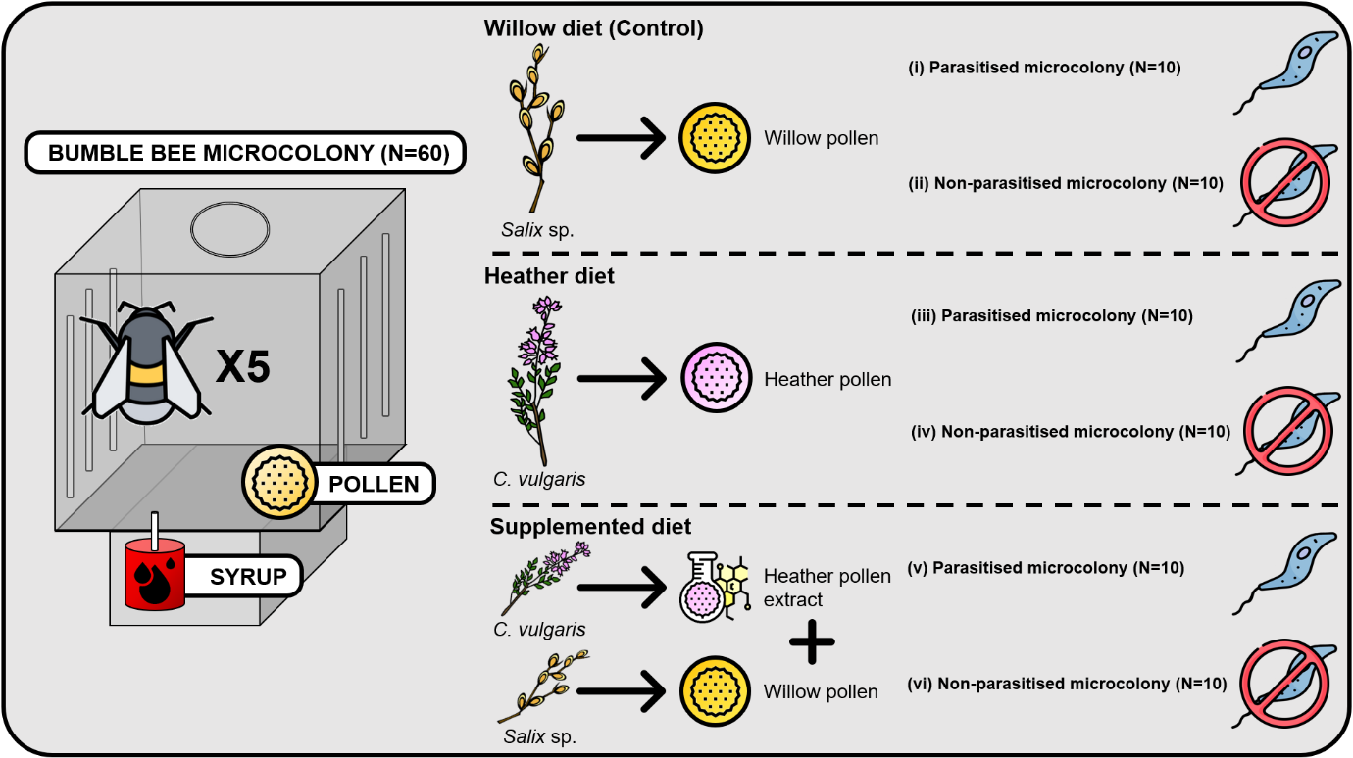
Figure 1. Bioassay design. Microcolonies initiated with five B. terrestris workers were fed for 35 days with one of three diets. For each diet, ten microcolonies contained parasitised individuals (Crithidia sp.), ten others were non-parasitised. Icon used for the figure: https://www.flaticon.com/. and author conception.
Diet preparation
Willow pollen batch (i.e., pollen loads from Apis mellifera L. 1758) was supplied by the commercial company Ruchers de Lorraine (Nancy, France) while heather pollen batch was obtained from a private beekeeper (Dittlo François, France, Gironde, Le Nizan). Although honey bee collected pollen loads may contain parasites, analysis of faeces of uninfected microcolonies fed with this pollen diet were parasite free. We then consider that no contamination occurred from the pollen batch. Pollen loads from the heather batch were hand-sorted based on the colour after microscopical identification to ensure monoflorality (800 g in total) (Sawyer & Pickard, 1981; Dafni et al., 2005). Each pollen batch was then homogenised and crushed before being used for the experiments. Half of the sorted heather batch served directly for the bioassays; the other half served for massive extraction of flavonoids. Flavonoids were extracted using a Soxhlet extraction for approximately 40 cycles with methanol as solvent, at 100°C. Extract was then vacuum filtered and evaporated to dryness (rotavapor IKA RV8). For flavonoid purification, extract was solubilized in water with a minimal amount of methanol, and placed in a separatory funnel with dichloromethane. The funnel was shaken and left to settle overnight before recovering the aqueous phase. The purified extract was then dried using rotary evaporator and dissolved in aqueous ethanol solution (1:1, v/v) before addition to the control diet to prepare a flavonoid-supplemented diet. Control and heather pollen diets were also supplemented with a similar amount of ethanol to avoid any bias (for details see Appendix A, Table S1).
Parasite inoculation
Multiple morphologically identical trypanosomes affect B. terrestris (Bartolomé et al., 2021). Although Crithidia bombi is by far the most abundant in wild populations (Shykoff & Schmid-Hempel, 1991; Popp et al., 2012), parasite identification will be limited to Crithidia sp. in this manuscript to avoid misinterpretation. Parasite inoculation was performed using Crithidia sp. reservoirs maintained in the laboratory (i.e., commercial colonies regularly renewed and repeatedly inoculated with contaminated faeces in order to ensure a turnover of the available Crithidia sp. pool). Faeces from a total of 45 infected workers were collected and pooled together to ensure multiple-strain inoculum (Gekière et al., 2022a). The inoculum was homogenised, brought to 1 mL with 0.9% NaCl solution, and purified by a triangulation method (Cole, 1970) adapted by Baron et al. (2014) and Martin et al. (2018). The concentration of Crithidia sp. cells was then estimated by counting with a Neubauer chamber, and the inoculum was diluted to 2,500 Crithidia sp. cells/µL with a 40% sugar solution. Workers allocated to the infected microcolonies were placed in individual Nicot® queen rearing cages and given 10µL of the inoculum (i.e., 25,000 Crithidia sp. cells; Logan et al., 2005) by letting them feed on the sugar solution in a glass microcapillary after a 5-hour starvation period. Workers allocated to uninfected microcolonies also underwent the same treatment (isolation, starvation) but with 10µL of sterile sugar solution.
Parameters evaluated
To investigate the impacts of pollen diet and parasite, several parameters in microcolonies were measured (Tasei & Aupinel, 2008), namely resource collection, reproductive success, stress response, and individual health through fat body content (i.e., immunocompetence proxy; Arrese & Soulages, 2010; Rosales, 2017; Vanderplanck et al., 2021) and parasite load measurements.

Resource collection was assessed by weighing every two days in each microcolony the syrup container, as well as the recovered pollen candy and the newly introduced one. These data were corrected for evaporation using controls, as well as divided by the total worker mass by microcolony to avoid bias due to worker activity. To evaluate the reproductive success, all microcolonies were dissected at the end of the experiment (Day 35) to weigh the total hatched brood mass, as well as the individual mass of each emerged male used as reference of viable offspring at the end of development (Goulson, 2010). Offspring masses were divided by the total worker mass by microcolony to avoid any bias due to worker care. Regarding stress response, we assessed worker mortality, larval ejection, pollen dilution (ratio between the collection of syrup and pollen) as well as pollen efficiency (ratio between offspring mass and pollen collection; Tasei & Aupinel, 2008) that highlights when a micro-colony needs to consume more pollen to produce offspring.

For the individual health parameters, fat body content was measured at the end of the bioassays on two males and two workers per microcolony (40 individuals per treatment) following Ellers (1996). The abdomens were cut and dehydrated in an incubator at 70°C for three days before being weighed. They were then placed for one day in 2mL of diethyl ether to solubilise lipids constituting the fat body. The abdomens were then washed twice with diethyl ether, and incubated at 70°C for seven days before being weighed. Fat body content was defined as the mass difference between dry abdomen before and after lipid solubilisation, divided by the dry abdomen mass prior to solubilisation. Moreover, in infected treatments, we repeatedly monitored the parasite load within microcolonies using the same marked worker along the bioassays. The first measurement was made three days post-inoculation (day 4) to enable Crithidia sp. to multiply and ensure its presence in the faeces (Logan et al., 2005). A total of seven further measurements were taken to establish the infection curve of Crithidia sp., namely on days 6, 8, 10, 12, 16, 20 and 35. Measurements were performed at larger intervals after day 12 because infection reached the plateau phase (Schmid-Hempel & Schmid-Hempel, 1993; Otterstatter & Thomson, 2006). In practice, the marked worker was held in a 50mL Falcon in the light until the faeces were expelled. Faeces were then collected in a 10µL microcapillary tube and diluted two to ten times with distilled water to enable rational cell counting. Parasite cells were then counted using a haemocytometer (Neubauer) under an inverted phase contrast microscope (400X magnification, Eclipse Ts2R, Nikon). Uninfected microcolonies faeces were checked to be free of parasites at the end of the experiment, and a marked worker was isolated at days 4, 6, 8, 10, 12, 16, 20 and 35 in each uninfected microcolony to induce the same stress as in infected treatments.
Data analysis and statistics
To detect a potential effect of pollen diet or parasite on resource collection, reproductive success, stress response, and individual health, mixed models were fitted for each parameter using diet, parasite and their interaction as fixed factors, and colony as random factor. Pollen collection, pollen efficacy, and pollen dilution (log-transformed data) were analysed using a Gaussian distribution (i.e., normality of residuals; shapiro.test function from the stats R-package v.4.1.0; R Core Team, 2021) (lmer function from the nlme R package v.3.1.160; Pinheiro et al., 2022). Total hatched offspring mass, emerged male mass, and fat body content (i.e., proportion data) were analysed using a Gamma distribution and a log link function (glmmTMB function from the glmmTMB R-package v.1.1.4; Brooks et al., 2017). For fat body content, values were square root-transformed and sex was added as crossed-fixed effect. For emerged male mass and fat body content, microcolony was nested within colony in the random factor to deal with pseudo-replication (i.e., several measures per microcolony).

For larval ejection, a binomial distribution (ejected larvae and total number of living offspring produced as bivariate response) was used after checking for overdispersion and zero inflation (testDispersion and testZeroInflation functions from DHARMa R-package v.0.4.6; Hartig, 2022). For worker mortality, a Cox proportional hazard (mixed-effect) model was run with individuals alive at the end of the 35-day treatment assigned as censored, and those who died as uncensored (coxme function from the coxme R-package v.2.2.18.1; Therneau, 2022). For these two parameters, diet, parasite and their interaction were also used as fixed factors and colony was included as a random factor.

The last parameter measured was the parasite load at different time points within infected microcolonies. As infection dynamics is a discrete time series, it was analysed using a generalised additive mixed-effect model (GAMM; Wood, 2006). Parasite loads were square root-transformed and fitted using a Gaussian distribution with a log link. Diet and day were set as fixed factors and microcolony nested within colony as random factors. The model assumptions were tested using diagnostic graphs and tests.

Contrasts were then performed on the models to determine whether the uninfected control differed from the infected control, and whether effects on uninfected or infected microcolonies differed among diets (emmeans function from the emmeans R-package v.1.8.2; Lenth, 2022). For fat body content, data were analysed separately for workers and males as a sex-significant effect was detected. Graphs and plots were all performed using the R-package ggplot2 v.3.4.0 (Wickham, 2016) except the one referring to the survival probability of the workers performed with the ggsurvplot function of the survminer R-package v.0.4.9 (Kassambara et al., 2021). All the statistical analyses were done using the R software v.4.1.0 (R Core Team, 2021). For all statistical analyses, p < 0.05 was used as a threshold for significance.
Results
Parasite impact
Comparison of microcolonies fed with control pollen between parasitised and non-parasitised treatments showed that Crithidia sp. infection did not impact the parameters related to resource collection (Fig 2A), reproductive success (Fig 2B-2C), or stress response (Fig 3A-C) (p > 0.05, Fig. 2 and 3). However, fat body content in newly emerged males was significantly higher with a mean that increased by 56% in infected microcolonies fed the control diet compared to uninfected ones fed the same diet (t = -3.828, p = 0.0012; Fig. 4B). The estimates (mean ± standard error) of our variables for each treatment are available in the appendices (Appendix B, Table S2)

Effect of heather pollen and its flavonoids on healthy bumble bees
Regarding resource collection, total pollen collection was significantly lower in microcolonies fed the supplemented diet compared to those fed the other diets (control vs supplemented: 43% less pollen collected, t = -5.672, p <0.001; heather vs supplemented: 33% less pollen collected, t = 3.924, p < 0.001; Fig. 2A). With regards to the reproductive success, microcolonies fed the supplemented and heather diets produced a significantly lower brood mass compared to microcolonies fed the control diet (control vs supplemented: brood mass 52% lower, t = 3.890, p < 0.001; control vs heather: brood mass 32% lower, t = 2.189, p = 0.0331; Fig. 2B), as well as significantly smaller emerged males (control vs supplemented: t = 2.350, p = 0.0192; control vs heather: t = 2.925, p = 0.0036; Fig. 2C)

In terms of stress responses, pollen dilution was significantly higher in microcolonies fed the supplemented diet compared to those fed the other diets (control vs supplemented: t = 2.282, p = 0.0268; heather vs supplemented: t = -3.191, p = 0.0025; Fig. 3A). Microcolonies fed the heather or supplemented diets also displayed a lower pollen efficacy than the microcolonies fed the control diet (control vs supplemented t = -2.741, p = 0.0085; control vs heather: t = -3.025, p = 0.0039; Fig. 3B). On the contrary, no significant difference was detected for larval ejection (p > 0.05) or for worker mortality (p < 0.05, Fig. 3C).

Regarding individual health, while no difference was detected in worker fat body content among diet treatments (p > 0.05; Fig. 4A), fat body content in newly emerged males was significantly higher in microcolonies fed the supplemented or heather diets compared to those fed the control diet (control vs supplemented: fat body content 62% higher, t = -3.891, p = 0.0012; control vs heather: fat body content 41% higher, t = 2.850, p = 0.0223; Fig. 4B).
Effect of heather pollen and its flavonoids on parasitised bumble bees
Similarly to previous results with uninfected microcolonies, total pollen collection was significantly lower in infected microcolonies fed the supplemented diet than in microcolonies fed the control diet (36% less pollen collected, t = -4.414, p < 0.001), but also in infected microcolonies fed heather diet compared to those fed the control diet (16% less pollen collected, t = -2.866, p = 0.0061) (Fig. 2A). Regarding the reproductive success, as observed in uninfected microcolonies, microcolonies fed the supplemented and heather diets produced a significantly lower brood mass compared to microcolonies fed the control diet (control vs supplemented: brood mass 51% lower, t = 3.784, p < 0.001; control vs heather: brood mass 41% lower, t = 3.551, p < 0.001; Fig. 2B). However, no significant difference was detected for the mass of newly emerged males among diet treatments (p < 0.05; Fig. 2C).

Regarding stress responses, pollen dilution was significantly higher in microcolonies fed the supplemented diet than in microcolonies fed the other diets (control vs supplemented: t = 2.111, p = 0.0398; heather vs supplemented: t = -2.120, p = 0.0390; Fig. 3A). Microcolonies fed the heather or supplemented diets also displayed a lower pollen efficacy than those fed the control diet (control vs supplemented: t = -3.684, p < 0.001; control vs heather: t = -4.904, p < 0.001; Fig. 3B). While no significant difference was detected for larval ejection (p > 0.05), the worker survival probability was significantly reduced in infected microcolonies fed the heather diet compared to those fed either the control or supplemented diets (heather vs control: t = -2.265, p = 0.0235; heather vs supplemented: t = -3.331, p < 0.001; Fig. 3C).

In terms of individual health, no difference was detected in fat body content of workers or newly emerged males among diet treatments (p > 0.05; Figs. 4A and 4B). Regarding the parasite load, the infection dynamic was more gradual in infected microcolonies fed the control diet compared to those fed the other diets which supported a parasite load peak around day 20 before a decrease up to the end of treatment (supplemented vs control: t = 2.893, p = 0.0126; heather vs control: t = 2.328, p = 0.0313; Fig. 4C).
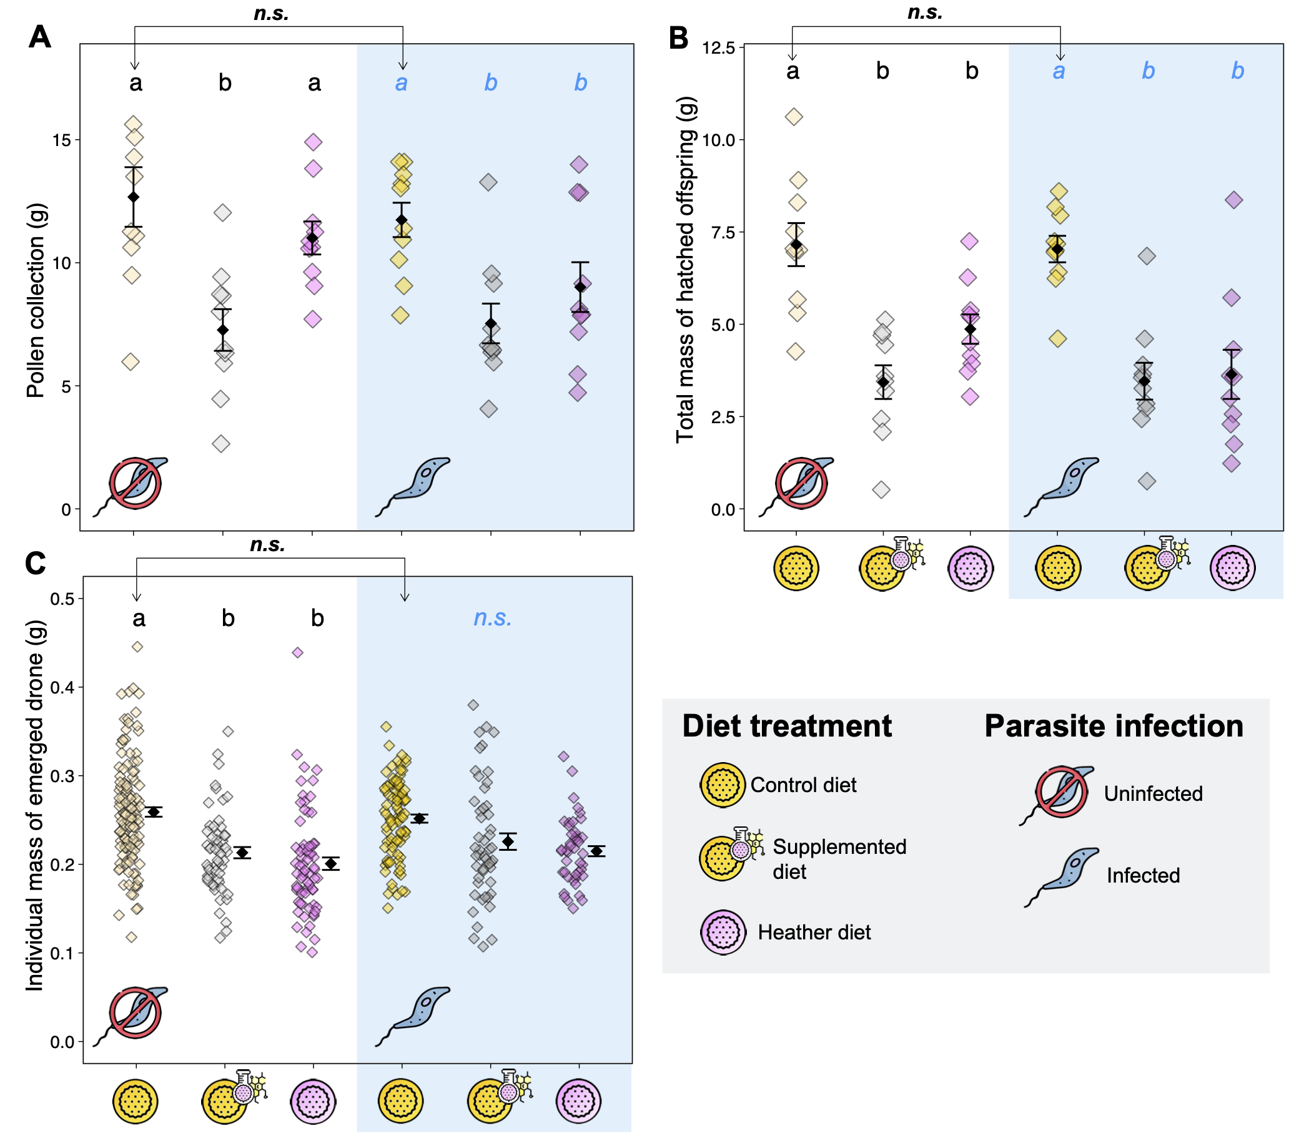
Figure 2. Resource collection and reproductive success. (A) Total mass of collected pollen; (B) Total mass of hatched offspring produced; and (C) Individual mass of emerged males. Each coloured data point represents a microcolony (in A and B) or an individual (in C), diamonds are mean values of each treatment, and error bars indicate the standard error. For (C), means and error bars have been shifted in the graph to improve readability. Letters indicate significance at p < 0.05 (pairwise comparisons within uninfected treatments in black, and pairwise comparisons within infected treatments in blue); n.s., non-significant. Arrows indicate the pairwise comparisons for the control diet between infection treatments (i.e., parasite effect). Symbol caption is in the grey zone.
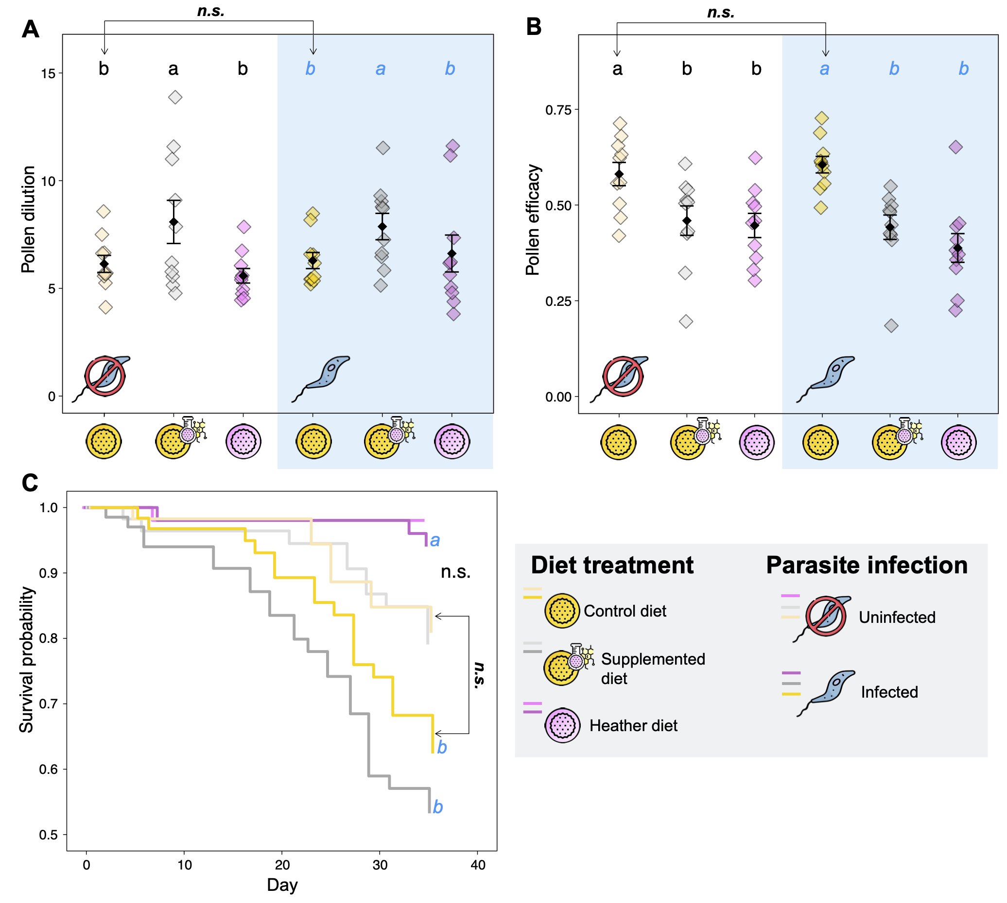
Figure 3. Stress responses. (A) Pollen dilution, defined as the ratio between syrup and pollen collection; (B) Pollen efficacy, defined as the ratio between total mass of hatched offspring and pollen collection; and (C) Worker survival probability over time. For (A) and (B), each coloured data point represents a microcolony, diamonds are mean values of each treatment, and error bars indicate the standard error. Letters indicate significance at p < 0.05 (pairwise comparisons within uninfected treatments in black, and pairwise comparisons within infected treatments in blue); n.s., non-significant. Arrows indicate the pairwise comparisons for the control diet between infection treatments (i.e., parasite effect). Symbol caption is in the grey zone.

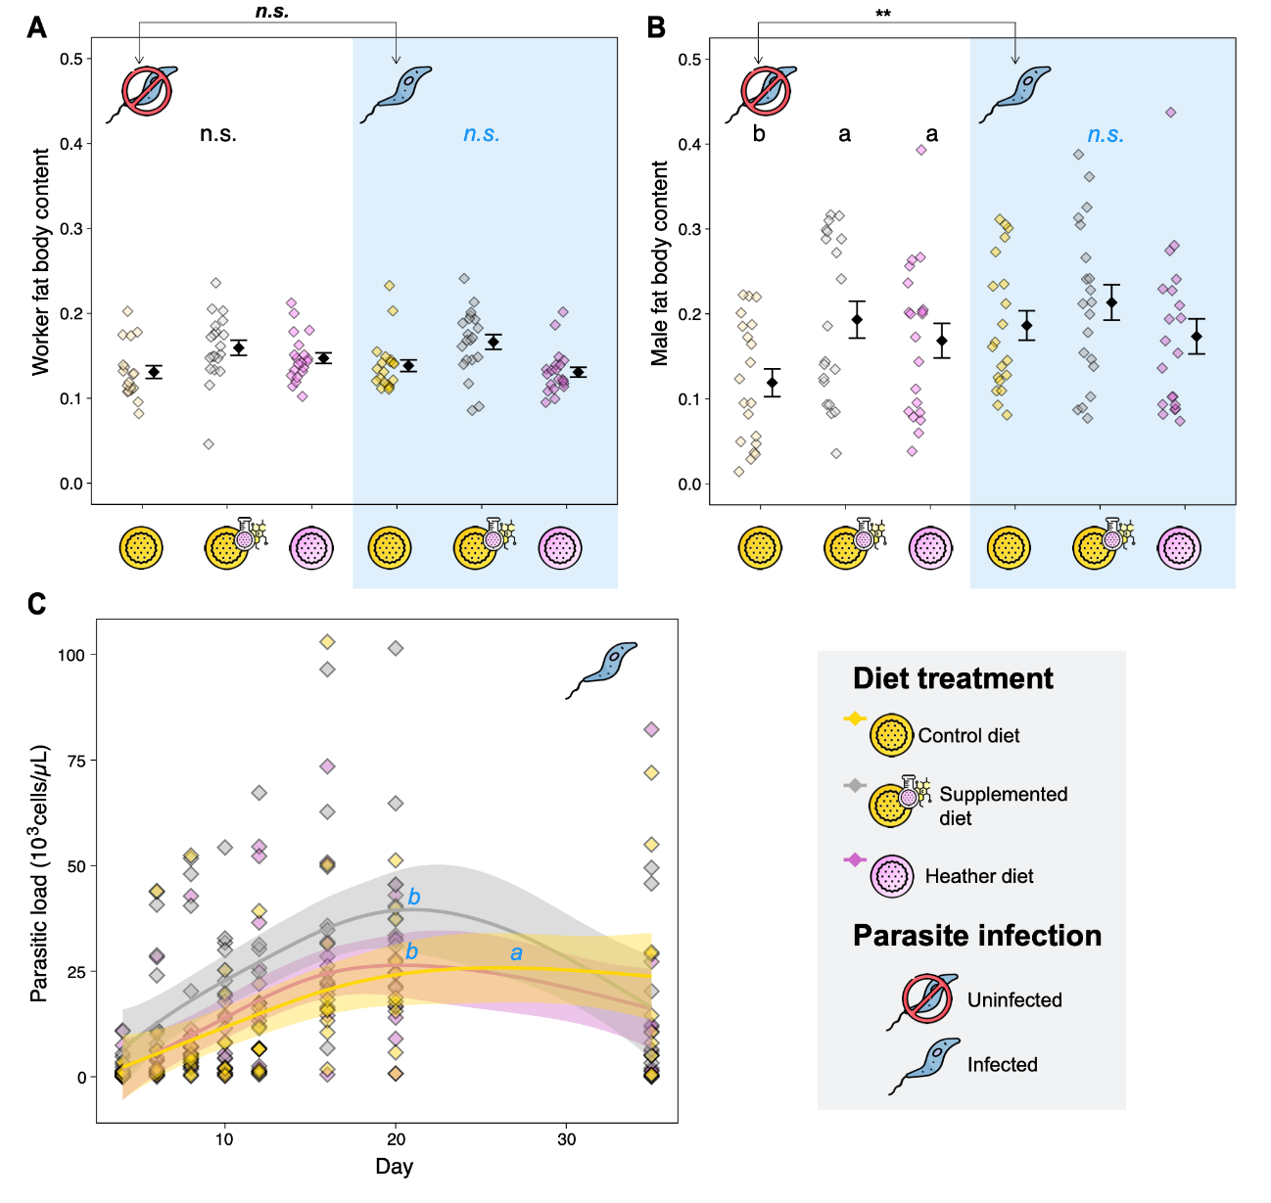
Figure 4. Health parameters. (A) Worker fat body content, and (B) Male fat body content; each coloured data point represents a microcolony, diamonds are mean values of each treatment, and error bars indicate the standard error. Means and error bars have been shifted in the graphs to improve readability. (C) Parasite load over time. Generalized additive mixed-effect models (in C) were used to fit smoothers to the data showing mean trends [±95 % confidence intervals, light coloured bands] over time. Here, each dot represents one data point (i.e., parasite load for the monitored worker for each time point and each microcolony). Letters indicate significance at p < 0.05 (pairwise comparisons within uninfected treatments in black, and pairwise comparisons within infected treatments in blue); n.s., non-significant; **, p < 0.01. Arrows indicate the pairwise comparisons for the control diet between infection treatments (i.e., parasite effect). Symbol caption is in the grey zone.

Discussion
Parasite effect on bumble bee
The parasite had no impact neither on larval ejection, total mass of offspring produced, nor on individual mass of newly emerged males. Such results suggest that infection is unlikely to reduce colony and offspring fitness, or dissemination success, which are related to individual size (Greenleaf et al., 2007; Amin et al., 2012). The limited effects of Crithidia sp. on the reproductive success of bumble bees herein observed are in line with the literature (Brown et al., 2003; Goulson et al., 2018; Gekière et al., 2022a). This absence of impacts on development performance and offspring fitness may stem from the fact that the parasite only infects the adult stage (i.e., Crithidia sp. does not develop in bumble bee larvae, Folly et al., 2017).

Besides our results showed that Crithidia sp. induced larger fat body content in males emerged in infected microcolonies compared to those that emerged in uninfected ones, whereas it has no impact on worker fat body content. We propose two rationales to explain such a Crithidia-induced difference in fat body content only in newly emerged males and not in workers. First, newly emerged males and workers were likely not inoculated at the same age. Indeed, workers developed in healthy colonies and were inoculated at the adult stage (most likely > 2 days old) for the establishment of infected microcolonies. However, males (most likely one day old) developed in infected microcolonies and ingested Crithidia sp. cells upon emergence resulting in the infection of up to 90% of them (Gekière et al., 2021, unpublished results). Second, while the difference in male fat body content between infected and uninfected microcolonies is unlikely to have arisen from a difference in brood care (i.e., no significant difference in pollen efficacy), we cannot rule out that infected workers displayed specific brood caring behaviour. For instance, they could have added peculiar nutrients or microorganisms to larval food from their hypopharyngeal and mandibular glands and/or stomach to prepare their offspring to face infection (e.g., addition of sterols, Svoboda et al., 1986). Such an increase in offspring fat body content through adapted larval feeding by workers could be interpreted as a trans-generational prophylactic behaviour. Indeed, enhanced fat body content has been assumed to correspond to a specific allocation of resources to counteract parasites by mounting an immune response (Brown et al., 2003). It would be interesting to test whether infected workers provide their larvae with specific central and specialised metabolites. We should however underline that the relationship between fat body content and immunity has become controversial since some results have been contradictory (e.g., Brown et al., 2000, Gekière et al., 2022a).

Although Crithidia sp. only showed mild effects in our experiment and in previous laboratory experiments (Brown et al., 2003; Goulson et al., 2018; Gekière et al., 2022a), it is important to keep in mind that interpretation of results observed in laboratory conditions must be interpreted with caution as controlled conditions are often not representative of natural constraints encountered in the field such as for instance, predation, flight, and foraging. For example, infection by Crithidia sp. has been shown to impair pollen foraging (Shykoff & Schmid-Hempel, 1991; Otterstatter et al., 2005; Gegear et al., 2006), but such effects cannot be fully comprehended under laboratory conditions.
Heather pollen quality: the case of flavonoids
Heather pollen harbours kaempferol flavonoids linked to one/two coumaroyl groups which are also linked to one/two hexosides (Gekière et al., in prep). Herein, we have shown that these heather flavonoids reduced the total offspring production, as indicated by a decreased pollen collection and a lower pollen efficacy, as well as a reduced mass of newly emerged males, thereby altering microcolony performance. Indeed, drone mass is known to impact flight distances, but also reproductive abilities, affecting the dissemination and reproductive success of bumble bee populations (Greenleaf et al., 2007; Amin et al., 2012). Such poor quality of heather pollen for the maintenance of buff-tailed bumble bee microcolonies has already been pinpointed (Vanderplanck et al., 2014). While it was partly attributed to its nutritional content (i.e., low concentration of amino acids and abundance of δ-7-avenasterol and δ-7-stigmasterol, Huang et al., 2011, Vanderplanck et al., 2014), our study demonstrated that specialised metabolites may also impact heather pollen quality, regardless of its nutritional content (i.e., central metabolites).

Both heather pollen and its flavonoids showed detrimental effects (i.e. reduction of offspring production, pollen efficacy). However, heather flavonoids seemed to induce a higher stress response than heather pollen as dilution behaviour was significantly higher in microcolonies fed the supplemented diet compared to those fed the control diet (i.e., mixing behaviour to mitigate unfavourable diet properties, Berenbaum & Johnson, 2015; Vanderplanck et al., 2018) while such a difference was not observed for microcolonies fed the heather diet. The reason for this discrepancy is not obvious, as both diets harbour the same flavonoids and should therefore lead to similar dilution behaviour. Two hypotheses could be proposed to explain this difference: (i) flavonoids were more bioavailable in the supplemented diets (outside pollen grains after the chemical extraction) and then more easily absorbed by the workers, which ultimately reduced the diet palatability (Wang et al., 2019); and (ii) as flavonoid extract was added to the control diet (i.e., willow pollen) that already contained flavonoids, the supplemented diet was richer in flavonoids than the other diets, reaching a threshold that ultimately reduced the diet palatability. Unfortunately, it is not possible to unravel these hypotheses without additional experiments. Another observation supporting the potential toxicity of heather flavonoids is the increase in fat body content in males emerging from microcolonies fed heather and supplemented diets compared to those emerging in microcolonies fed the control diet. Indeed, such an increase could be interpreted as a specific allocation of resources to the fat body for performing a detoxification activity (Li et al., 2019). In that way, flavonoid assimilation is known to induce the activation of defence mechanisms based on cytochrome P450 monooxygenase, a molecule that is highly active in the fat body (Scott et al., 1998). This increase in fat body content was not observed in workers, which could be explained by the different exposure to flavonoids during their life stages. Indeed, workers within microcolonies mainly fed on syrup, while males fed on pollen during their whole larval development and were then more exposed to specialised metabolites. Moreover, it is highly possible that sensitivity to pollen-specialised metabolites is higher in larvae than in adults, as already demonstrated in honey bees (Lucchetti et al., 2018).
The complex response of parasitised bumble bees to heather pollen and its flavonoids
Flavonoids were associated with an increase in parasite load, which has been also observed for other classes of specialised metabolites (Thorburn et al., 2015; Gekière et al., 2022a). Therefore, by contrast to our expectations based on previous studies (Baracchi et al., 2015, Koch et al., 2019), the detrimental effects of heather pollen flavonoids on bumble bees were not balanced by any therapeutic effect against the parasite Crithidia sp. These results suggest a potential additive effect between phytochemical and parasite stress as previously described (Thorburn et al., 2015), with the diet effect mostly overriding the parasite effect in bumble bees in the case of heather as already shown for the sunflower (Gekière et al., 2022a). The nutritional stress due to heather pollen feeding could then increase the effect of Crithidia sp. which could be more effective under stressful conditions (Brown et al., 2000; Brown et al., 2003).

We found that mortality in infected microcolonies was lower in microcolonies fed the heather diet compared to those fed the control diet. Although infection was not shown to have a significant impact on mortality in microcolonies fed the control diet, heather pollen could then increase host tolerance to the parasite but this effect is unlikely due to its flavonoid content as mortality in infected workers fed the supplemented diet did not significantly differ from those fed the control diet. Regarding fat body content in newly emerged males, males that emerged in microcolonies fed the heather or supplemented diets displayed higher fat body content than those that emerged in microcolonies fed the control diet, but this diet effect was not significant anymore in infected microcolonies, probably because, as discussed before, the parasitic stress also increased fat body content in microcolonies fed the control diet.
Conclusion
How heather pollen and its specialised metabolites impact the buff-tailed bumble bee, and how they modulate the interaction with its obligate gut parasite Crithidia sp. are complex questions given the diversity of specialised metabolites found in the floral resources of this species. Previous studies have found that heather nectar does not contain any flavonoids (Gekière et al., in prep) but protected the pollinator from its parasite Crithidia sp. through callunene activity (Koch et al., 2019). In this study, we found that the occurrence of flavonoids in heather pollen reduced its collection, as well as the bumble bee fitness. Moreover, heather pollen did not help to counteract the parasite but rather appeared to induce an additional stress that could potentially increase the parasite effect. Actually, our results complete the understanding of the bumble bee-heather-parasite relationship by underlining that heather pollen is not suitable for buff-tailed bumble bee performance and does not display any therapeutic effect. This study highlights the complexity of the plant-pollinator interaction by illustrating the distinct roles and effects of specialised metabolites found either in nectar or pollen. We strongly encourage the consideration of these two floral resources in future studies investigating the medicinal effects of plant species, especially when defining pollinator conservation strategies.
Acknowledgements
We would like to thank D. Evrard and L. Marin for their help in colony and microcolony maintenance, as well as the numerous people that helped with microcolony dissection. We are very grateful to the Laboratory of Cellular Biology (UMons) and the Laboratory of Therapeutic Chemistry and Pharmacognosy (UMons) for their advice and the access to the device needed for the microscope analyses and the diet preparation. We also thank François Dittlo for providing us with heather pollen, as well as the family of the first author (I., C., C., and C. Tourbez) for their help.
Funding
This study was funded by the ‘METAFLORE,2019–2023′ project, one ARC ‘Actions de Recherche Concertées’ project. C.T. PhD grant is funded by the University of Mons (UMONS). A.G. is supported by a F.R.S.-FNRS PhD grant ‘Aspirant’. The PhD grant of I.S. is supported by the ARC project METAFLORE.
Authors’ contributions
Conceptualization, M.V.; chemical analyses and extraction, I.S. and P.G.; bioassays, C.T., with help from A.M. and A.G.; resources, D.M. and P.G.; writing—original draft preparation, C.T., with help from A.G. and M.V.; supervision, A.G. and M.V.; funding acquisition, D.M., P.G. and M.V. All authors have read and agreed to the published version of the manuscript.
Conflict of interest disclosure
The authors declare that they comply with the PCI rule of having no financial conflicts of interest in relation to the content of the article.
Data, script, and code information availability
Datasets and R script are available on a Zenedo repository: https://doi.org/10.5281/zenodo.7804841

References
Amin, M. R., Bussière, L. F., & Goulson, D. (2012). Effects of male age and size on mating success in the bumblebee Bombus terrestris. Journal of insect behavior, 25(4), 362-374. https://doi.org/10.1007/s10905-011-9306-4
Arnold, S. E., Idrovo, M., Arias, L. J. L., Belmain, S. R., & Stevenson, P. C. (2014). Herbivore defence compounds occur in pollen and reduce bumblebee colony fitness. Journal of Chemical Ecology, 40(8), 878-881. https://doi.org/10.1007/s10886-014-0467-4
Arrese, E. L., & Soulages, J. L. (2010). Insect fat body: energy, metabolism, and regulation. Annual review of entomology, 55, 207-225. https://doi.org/10.1146/annurev-ento-112408-085356
Ballantyne, G., Baldock, K. C., & Willmer, P. G. (2015). Constructing more informative plant–pollinator networks: visitation and pollen deposition networks in a heathland plant community. Proceedings of the Royal Society B: Biological Sciences, 282(1814), 20151130. https://doi.org/10.1098/rspb.2015.1130
Baracchi, D., Brown, M. J., & Chittka, L. (2015). Behavioural evidence for self-medication in bumblebees?. F1000Research, 4. https://doi.org/10.12688/f1000research.6262.3
Baron, G. L., Raine, N. E., & Brown, M. J. (2014). Impact of chronic exposure to a pyrethroid pesticide on bumblebees and interactions with a trypanosome parasite. Journal of Applied Ecology, 51(2), 460-469. https://doi.org/10.1111/1365-2664.12205
Bartolomé, C., Jabal‐Uriel, C., Buendía‐Abad, M., Benito, M., Ornosa, C., De la Rúa, P., ... & Maside, X. (2021). Wide diversity of parasites in Bombus terrestris (Linnaeus, 1758) revealed by a high‐throughput sequencing approach. Environmental Microbiology, 23(1), 478-483. https://doi.org/10.1111/1462-2920.15336
Baude, M., Kunin, W. E., Boatman, N. D., Conyers, S., Davies, N., Gillespie, M. A., ... & Memmott, J. (2016). Historical nectar assessment reveals the fall and rise of floral resources in Britain. Nature, 530(7588), 85-88. https://doi.org/10.1038/nature16532
Berenbaum, M. R., & Johnson, R. M. (2015). Xenobiotic detoxification pathways in honey bees. Current opinion in insect science, 10, 51-58. https://doi.org/10.1016/j.cois.2015.03.005
Biller, O. M., Adler, L. S., Irwin, R. E., McAllister, C., & Palmer-Young, E. C. (2015). Possible synergistic effects of thymol and nicotine against Crithidia bombi parasitism in bumble bees. PLoS one, 10(12), e0144668. https://doi.org/10.1371/journal.pone.0144668
Brochu, K. K., van Dyke, M. T., Milano, N. J., Petersen, J. D., McArt, S. H., Nault, B. A., ... & Danforth, B. N. (2020). Pollen defenses negatively impact foraging and fitness in a generalist bee (Bombus impatiens: Apidae). Scientific reports, 10(1), 1-12. https://doi.org/10.1038/s41598-020-58274-2
Brooks, M. E., Kristensen, K., Van Benthem, K. J., Magnusson, A., Berg, C. W., Nielsen, A., ... & Bolker, B. M. (2017). glmmTMB balances speed and flexibility among packages for zero-inflated generalized linear mixed modeling. The R journal, 9(2), 378-400. https://doi.org/10.3929/ethz-b-000240890
Brown, M. J. F., Loosli, R., & Schmid‐Hempel, P. (2000). Condition‐dependent expression of virulence in a trypanosome infecting bumblebees. Oikos, 91(3), 421-427. https://doi.org/10.1034/j.1600-0706.2000.910302.x
Brown, M. J. F., Moret, Y., & Schmid-Hempel, P. (2003). Activation of host constitutive immune defence by an intestinal trypanosome parasite of bumble bees. Parasitology, 126(3), 253-260. DOI: https://doi.org/10.1017/S0031182002002755
Butchart, S. H., Walpole, M., Collen, B., Van Strien, A., Scharlemann, J. P., Almond, R. E., ... & Watson, R. (2010). Global biodiversity: indicators of recent declines. Science, 328(5982), 1164-1168. https://doi.org/10.1126/science.1187512
Campos, M. G., Bogdanov, S., de Almeida-Muradian, L. B., Szczesna, T., Mancebo, Y., Frigerio, C., & Ferreira, F. (2008). Pollen composition and standardisation of analytical methods. Journal of Apicultural Research, 47(2), 154-161. https://doi.org/10.1080/00218839.2008.11101443
Cole, R. J. (1970). The application of the “triangulation” method to the purification of Nosema spores from insect tissues. Journal of Invertebrate Pathology, 15(2), 193-195. https://doi.org/10.1016/0022-2011(70)90233-8
Dafni, A., Kevan, P. G., & Husband, B. C. (2005). Practical pollination biology. Practical pollination biology.
Descamps, C., Moquet, L., Migon, M., & Jacquemart, A. L. (2015). Diversity of the insect visitors on Calluna vulgaris (Ericaceae) in Southern France heathlands. Journal of Insect Science, 15(1), 130. https://doi.org/10.1093/jisesa/iev116
Descamps, C., Moquet, L., Migon, M., & Jacquemart, A. L. (2015). Diversity of the insect visitors on Calluna vulgaris (Ericaceae) in Southern France heathlands. Journal of Insect Science, 15(1), 130. https://doi.org/10.1093/jisesa/iev116
Detzel, A., & Wink, M. (1993). Attraction, deterrence or intoxication of bees (Apis mellifera) by plant allelochemicals. Chemoecology, 4, 8-18. https://doi.org/10.1007/BF01245891
Dicks, L. V., Breeze, T. D., Ngo, H. T., Senapathi, D., An, J., Aizen, M. A., ... & Potts, S. G. (2021). A global-scale expert assessment of drivers and risks associated with pollinator decline. Nature Ecology & Evolution, 5(10), 1453-1461. https://doi.org/10.1038/s41559-021-01534-9
Ellers, J. (1996). Fat and eggs: an alternative method to measure the trade-off between survival and reproduction in insect parasitoids. Netherlands Journal of Zoology, 46, 227-235.
Van Engelsdorp, D., Evans, J. D., Saegerman, C., Mullin, C., Haubruge, E., Nguyen, B. K., ... & Pettis, J. S. (2009). Colony collapse disorder: a descriptive study. PloS one, 4(8), e6481. https://doi.org/10.1371/journal.pone.0006481
Fauser, A., Sandrock, C., Neumann, P., & Sadd, B. M. (2017). Neonicotinoids override a parasite exposure impact on hibernation success of a key bumblebee pollinator. Ecological Entomology, 42(3), 306-314. https://doi.org/10.1111/een.12385
Fitch, G., Figueroa, L. L., Koch, H., Stevenson, P. C., & Adler, L. S. (2022). Understanding effects of floral products on bee parasites: mechanisms, synergism, and ecological complexity. International Journal for Parasitology: Parasites and Wildlife, 17, 244-256. https://doi.org/10.1016/j.ijppaw.2022.02.011
Folly, A. J., Koch, H., Stevenson, P. C., & Brown, M. J. (2017). Larvae act as a transient transmission hub for the prevalent bumblebee parasite Crithidia bombi. Journal of Invertebrate Pathology, 148, 81-85. https://doi.org/10.1016/j.jip.2017.06.001
Gegear, R. J., Otterstatter, M. C., & Thomson, J. D. (2006). Bumble-bee foragers infected by a gut parasite have an impaired ability to utilize floral information. Proceedings of the Royal Society B: Biological Sciences, 273(1590), 1073-1078. https://doi.org/10.1098/rspb.2005.3423
Gekière, A., Semay, I., Gérard, M., Michez, D., Gerbaux, P., & Vanderplanck, M. (2022a). Poison or Potion: Effects of Sunflower Phenolamides on Bumble Bees and Their Gut Parasite. Biology, 11(4), 545. https://doi.org/10.3390/biology11040545
Gekière, A., Michez, D., & Vanderplanck, M. (2022b). Bumble Bee Breeding on Artificial Pollen Substitutes. Journal of Economic Entomology, 115(5), 1423-1431. https://doi.org/10.1093/jee/toac126
Gekière, A., Semay, I., Michel, A., Tourbez, C., Gerbaux, P., Michez, D., Vanderplanck, M. Plant mediation: The delicate balance between herbivore deterrence and pollinator attraction. In preparation.
Gekière, A., Vanderplanck, M., & Michez, D. (2023). Trace metals with heavy consequences on bees: A comprehensive review. Science of The Total Environment, 165084. https://doi.org/10.1016/j.scitotenv.2023.165084
Goulson, D. (2010). Bumblebees: behaviour, ecology, and conservation. Oxford University Press on Demand.
Goulson, D., & Hughes, W. O. (2015). Mitigating the anthropogenic spread of bee parasites to protect wild pollinators. Biological Conservation, 191, 10-19. https://doi.org/10.1016/j.biocon.2015.06.023
Goulson, D., O'CONNOR, S. T. E. P. H., & Park, K. J. (2018). The impacts of predators and parasites on wild bumblebee colonies. Ecological Entomology, 43(2), 168-181. https://doi.org/10.1111/een.12482
Greenleaf, S. S., Williams, N. M., Winfree, R., & Kremen, C. (2007). Bee foraging ranges and their relationship to body size. Oecologia, 153(3), 589-596. https://doi.org/10.1007/s00442-007-0752-9
Hartig, F. (2022). DHARMa: residual diagnostics for hierarchical (multi-level/mixed) regression models. R package version 0.3, 3.
Hendriksma, H. P., Härtel, S., & Steffan-Dewenter, I. (2011). Testing pollen of single and stacked insect-resistant Bt-maize on in vitro reared honey bee larvae. PLoS One, 6(12), e28174. https://doi.org/10.1371/journal.pone.0028174
Huang, T., Jander, G., & de Vos, M. (2011). Non-protein amino acids in plant defense against insect herbivores: representative cases and opportunities for further functional analysis. Phytochemistry, 72(13), 1531-1537. https://doi.org/10.1016/j.phytochem.2011.03.019
Irwin, R. E., Cook, D., Richardson, L. L., Manson, J. S., & Gardner, D. R. (2014). Secondary compounds in floral rewards of toxic rangeland plants: impacts on pollinators. Journal of Agricultural and Food Chemistry, 62(30), 7335-7344. https://doi.org/10.1021/jf500521w
Johnson, R. M., Mao, W., Pollock, H. S., Niu, G., Schuler, M. A., & Berenbaum, M. R. (2012). Ecologically appropriate xenobiotics induce cytochrome P450s in Apis mellifera. PloS one, 7(2), e31051. https://doi.org/10.1371/journal.pone.0031051
Kassambara, A., Kosinski, M., Biecek, P., & Fabian, S. (2021). Survminer: Drawing Survival Curves Using Ggplot2. 2021. URL https://CRAN. R-project. org/package= survminer. R package version 0.4, 9.
Kleijn, D., & Raemakers, I. (2008). A retrospective analysis of pollen host plant use by stable and declining bumble bee species. Ecology, 89(7), 1811-1823. https://doi.org/10.1890/07-1275.1
Koch, H., Woodward, J., Langat, M. K., Brown, M. J., & Stevenson, P. C. (2019). Flagellum removal by a nectar metabolite inhibits infectivity of a bumblebee parasite. Current Biology, 29(20), 3494-3500. https://doi.org/10.1016/j.cub.2019.08.037
Lenth, R. (2022). emmeans: estimated marginal means, aka least-squares means. R package version 1.4. 7. 2020.
Li, J., Ou-Lee, T. M., Raba, R., Amundson, R. G., & Last, R. L. (1993). Arabidopsis flavonoid mutants are hypersensitive to UV-B irradiation. The Plant Cell, 5(2), 171-179. https://doi.org/10.1105/tpc.5.2.171
Li, S., Yu, X., & Feng, Q. (2019). Fat body biology in the last decade. Annual Review of Entomology, 64, 315-333. https://doi.org/10.1146/annurev-ento-011118-112007
Liao, L. H., Wu, W. Y., & Berenbaum, M. R. (2017a). Behavioral responses of honey bees (Apis mellifera) to natural and synthetic xenobiotics in food. Scientific Reports, 7(1), 15924. https://doi.org/10.1038/s41598-017-15066-5
Liao, L. H., Wu, W. Y., & Berenbaum, M. R. (2017b). Impacts of dietary phytochemicals in the presence and absence of pesticides on longevity of honey bees (Apis mellifera). Insects, 8(1), 22. https://doi.org/10.3390/insects8010022
Logan, A., Ruiz-González, M. X., & Brown, M. J. F. (2005). The impact of host starvation on parasite development and population dynamics in an intestinal trypanosome parasite of bumble bees. Parasitology, 130(6), 637-642. https://doi.org/10.1017/S0031182005007304
Lucchetti, M. A., Kilchenmann, V., Glauser, G., Praz, C., & Kast, C. (2018). Nursing protects honeybee larvae from secondary metabolites of pollen. Proceedings of the Royal Society B: Biological Sciences, 285(1875), 20172849. https://doi.org/10.1098/rspb.2017.2849
Mallinger, R. E., Gaines-Day, H. R., & Gratton, C. (2017). Do managed bees have negative effects on wild bees? A systematic review of the literature. PloS one, 12(12), e0189268. https://doi.org/10.1371/journal.pone.0189268
Manson, J. S., Otterstatter, M. C., & Thomson, J. D. (2010). Consumption of a nectar alkaloid reduces pathogen load in bumble bees. Oecologia, 162(1), 81-89. https://doi.org/10.1007/s00442-009-1431-9
Martin, C. D., Fountain, M. T., & Brown, M. J. (2018). Bumblebee olfactory learning affected by task allocation but not by a trypanosome parasite. Scientific reports, 8(1), 1-8. https://doi.org/10.1038/s41598-018-24007-9
McMenamin, A. J., & Genersch, E. (2015). Honey bee colony losses and associated viruses. Current Opinion in Insect Science, 8, 121-129. https://doi.org/10.1016/j.cois.2015.01.015
Meeus, I., Brown, M. J., De Graaf, D. C., & Smagghe, G. U. Y. (2011). Effects of invasive parasites on bumble bee declines. Conservation Biology, 25(4), 662-671. https://doi.org/10.1111/j.1523-1739.2011.01707.x
Moquet, L., Bacchetta, R., Laurent, E., & Jacquemart, A. L. (2017). Spatial and temporal variations in floral resource availability affect bumblebee communities in heathlands. Biodiversity and Conservation, 26(3), 687-702. https://doi.org/10.1007/s10531-016-1266-8
Naug, D. (2009). Nutritional stress due to habitat loss may explain recent honeybee colony collapses. Biological Conservation, 142(10), 2369-2372. https://doi.org/10.1016/j.biocon.2009.04.007
Nicolson, S. W., & Thornburg, R. W. (2007). Nectar chemistry. In Nectaries and nectar (pp. 215-264). Springer, Dordrecht. https://doi.org/10.1007/978-1-4020-5937-7_5
Onkokesung, N., Reichelt, M., van Doorn, A., Schuurink, R. C., van Loon, J. J., & Dicke, M. (2014). Modulation of flavonoid metabolites in Arabidopsis thaliana through overexpression of the MYB75 transcription factor: role of kaempferol-3, 7-dirhamnoside in resistance to the specialist insect herbivore Pieris brassicae. Journal of experimental botany, 65(8), 2203-2217. https://doi.org/10.1093/jxb/eru096
Onyilagha, J. C., Gruber, M. Y., Hallett, R. H., Holowachuk, J., Buckner, A., & Soroka, J. J. (2012). Constitutive flavonoids deter flea beetle insect feeding in Camelina sativa L. Biochemical Systematics and Ecology, 42, 128-133. https://doi.org/10.1016/j.bse.2011.12.021
Otterstatter, M. C., Gegear, R. J., Colla, S. R., & Thomson, J. D. (2005). Effects of parasitic mites and protozoa on the flower constancy and foraging rate of bumble bees. Behavioral Ecology and Sociobiology, 58(4), 383-389. https://doi.org/10.1007/s00265-005-0945-3
Otterstatter, M. C., & Thomson, J. D. (2006). Within-host dynamics of an intestinal pathogen of bumble bees. Parasitology, 133(6), 749-761. https://doi.org/10.1017/S003118200600120X
Palmer‐Young, E. C., Farrell, I. W., Adler, L. S., Milano, N. J., Egan, P. A., Junker, R. R., ... & Stevenson, P. C. (2019). Chemistry of floral rewards: intra‐and interspecific variability of nectar and pollen secondary metabolites across taxa. Ecological Monographs, 89(1), e01335. https://doi.org/10.1002/ecm.1335
Paris, L., El Alaoui, H., Delbac, F., & Diogon, M. (2018). Effects of the gut parasite Nosema ceranae on honey bee physiology and behavior. Current opinion in insect science, 26, 149-154. https://doi.org/10.1016/j.cois.2018.02.017
Di Pasquale, G., Salignon, M., Le Conte, Y., Belzunces, L. P., Decourtye, A., Kretzschmar, A., ... & Alaux, C. (2013). Influence of pollen nutrition on honey bee health: do pollen quality and diversity matter? PloS one, 8(8), e72016. https://doi.org/10.1371/journal.pone.0072016
Pinheiro, J., & Bates, D. (2022). R Core Team (2022) nlme: linear and nonlinear mixed effects models. R package version 3.1–160.
Popp, M., Erler, S., & Lattorff, H. M. G. (2012). Seasonal variability of prevalence and occurrence of multiple infections shape the population structure of Crithidia bombi, an intestinal parasite of bumblebees (B ombus spp.). MicrobiologyOpen, 1(4), 362-372. https://doi.org/10.1002/mbo3.35
Pusztahelyi, T., Holb, I. J., & Pócsi, I. (2015). Secondary metabolites in fungus-plant interactions. Frontiers in plant science, 6, 573. https://doi.org/10.3389/fpls.2015.00573
R Core Team (2021). R: A language and environment for statistical computing. R Foundation for Statistical Computing, Vienna, Austria. http://www. R-project. org/.
Regali, A., & Rasmont, P. (1995). Nouvelles méthodes de test pour l'évaluation du régime alimentaire chez des colonies orphelines de Bombus terrestris (L)(Hymenoptera, Apidae). Apidologie, 26(4), 273-281. https://doi.org/10.1051/apido:19950401
Richardson, L. L., Adler, L. S., Leonard, A. S., Andicoechea, J., Regan, K. H., Anthony, W. E., ... & Irwin, R. E. (2015). Secondary metabolites in floral nectar reduce parasite infections in bumblebees. Proceedings of the Royal Society B: Biological Sciences, 282(1803), 20142471. https://doi.org/10.1098/rspb.2014.2471
de Roode, J. C., & Hunter, M. D. (2019). Self-medication in insects: when altered behaviors of infected insects are a defense instead of a parasite manipulation. Current opinion in insect science, 33, 1-6. https://doi.org/10.1016/j.cois.2018.12.001
Rosales, C. (2017). Cellular and molecular mechanisms of insect immunity. Insect Physiology and Ecology. InTeach Publicaiton. CCBY, 179-212. https://dx.doi.org/10.5772/67107
Sánchez-Bayo, F., & Goka, K. (2014). Pesticide residues and bees–a risk assessment. PloS one, 9(4), e94482. https://doi.org/10.1371/journal.pone.0094482
Sawyer, R., & Pickard, R. S. (1981). Pollen identification for beekeepers. University College Cardiff Press.
Schmid-Hempel, P., & Schmid-Hempel, R. (1993). Transmission of a pathogen in Bombus terrestris, with a note on division of labour in social insects. Behavioral Ecology and Sociobiology, 33, 319-327. https://doi.org/10.1007/BF00172930
Schmid-Hempel, P. (1998). Parasites in social insects. Princeton University Press.
Schmid-Hempel, P. (2001). On the evolutionary ecology of host–parasite interactions: addressing the question with regard to bumblebees and their parasites. Naturwissenschaften, 88(4), 147-158. https://doi.org/10.1007/s001140100222
Scott, J. G., Liu, N., & Wen, Z. (1998). Insect cytochromes P450: diversity, insecticide resistance and tolerance to plant toxins. Comparative Biochemistry and Physiology Part C: Pharmacology, Toxicology and Endocrinology, 121(1-3), 147-155. https://doi.org/10.1016/S0742-8413(98)10035-X
Shykoff, J. A., & Schmid-Hempel, P. (1991). Incidence and effects of four parasites in natural populations of bumble bees in Switzerland. Apidologie, 22(2), 117-125. https://doi.org/10.1051/apido:19910204
Simmonds, M. S. (2003). Flavonoid–insect interactions: recent advances in our knowledge. Phytochemistry, 64(1), 21-30. https://doi.org/10.1016/S0031-9422(03)00293-0
Svoboda, J. A., Herbert Jr, E. W., Thompson, M. J., & Feldlaufer, M. F. (1986). Selective sterol transfer in the honey bee: Its significance and relationship to other hymenoptera. Lipids, 21(1), 97-101. https://doi.org/10.1007/BF02534310
Tasei, J. N., & Aupinel, P. (2008). Validation of a method using queenless Bombus terrestris micro-colonies for testing the nutritive value of commercial pollen mixes by comparison with queenright colonies. Journal of Economic Entomology, 101(6), 1737-1742. https://doi.org/10.1603/0022-0493-101.6.1737
Therneau, T. M. (2022). Mixed Effects Cox Models [R package coxme version 2.2-18.1].
Thorburn, L. P., Adler, L. S., Irwin, R. E., & Palmer-Young, E. C. (2015). Variable effects of nicotine, anabasine, and their interactions on parasitized bumble bees. F1000Research, 4.
Treutter, D. (2005). Significance of flavonoids in plant resistance and enhancement of their biosynthesis. Plant biology, 7(06), 581-591. https://doi.org/10.1055/s-2005-873009
Vanderplanck, M., Moerman, R., Rasmont, P., Lognay, G., Wathelet, B., Wattiez, R., & Michez, D. (2014). How does pollen chemistry impact development and feeding behaviour of polylectic bees?. PloS one, 9(1), e86209. https://doi.org/10.1371/journal.pone.0086209
Vanderplanck, M., Decleves, S., Roger, N., Decroo, C., Caulier, G., Glauser, G., ... & Michez, D. (2018). Is non‐host pollen suitable for generalist bumblebees?. Insect Science, 25(2), 259-272. https://doi.org/10.1111/1744-7917.12410
Vanderplanck, M., Michez, D., Albrecht, M., Attridge, E., Babin, A., Bottero, I., ... & Gérard, M. (2021). Monitoring bee health in European agro-ecosystems using wing morphology and fat bodies. One Ecosystem, 6, e63653. https://doi.org/10.3897/oneeco.6.e63653
Vaudo, A. D., Tooker, J. F., Patch, H. M., Biddinger, D. J., Coccia, M., Crone, M. K., ... & Grozinger, C. M. (2020). Pollen protein: lipid macronutrient ratios may guide broad patterns of bee species floral preferences. Insects, 11(2), 132. https://doi.org/10.3390/insects11020132
Wang, S. D., Liu, W., Xue, C. B., & Luo, W. C. (2010). The effects of luteolin on phenoloxidase and the growth of Spodoptera exigua (Hübner) larvae (Lepidoptera: Noctuidae). Journal of Pesticide Science, 35(4), 483-487. https://doi.org/10.1584/jpestics.G10-24
Wang, X. Y., Tang, J., Wu, T., Wu, D., & Huang, S. Q. (2019). Bumblebee rejection of toxic pollen facilitates pollen transfer. Current Biology, 29(8), 1401-1406. https://doi.org/10.1016/j.cub.2019.03.023
Weber, M. (2004). Alkaloids and Old Lace: Pollen Toxins Exclude Generalist Pollinators From Death Camas. https://doi.org/10.26076/dc24-fa2f
Wickham, H. (2016). Data analysis. In ggplot2 (pp. 189-201). Springer, Cham. https://doi.org/10.1007/978-3-319-24277-4_9
Wood, S. N. (2006). Generalized Additive Models: An Introduction with R.,(Chapman and Hall: CRC Press, Boca Raton, FL.).
Zaynab, M., Fatima, M., Abbas, S., Sharif, Y., Umair, M., Zafar, M. H., & Bahadar, K. (2018). Role of secondary metabolites in plant defense against pathogens. Microbial pathogenesis, 124, 198-202. https://doi.org/10.1016/j.micpath.2018.08.034

Appendix A – Supplemented diet
Total flavonoid content of heather bee pollen, as well as its associated dried extract, were analysed in triplicates by HPLC-MS/MS (triplicates of 20 – 40 mg) for quantification (expressed as quercetin equivalent, QE). Based on these analyses, the supplementation formula was established to have a similar amount of ethanol and willow pollen in candies for all diets, as well as flavonoid concentrations in the supplemented diet mimicking natural concentration found on average in bee pollen candies, namely 12.08 mg QE/heather candy on average (14.73 ± 1.69 mg QE/g for heather bee pollen) (Table S1). We found that heather bee pollen extract contained 40.63 ± 0.72 mg QE/g (209.79 g extract).
Table S1. Diet compositions.
Diets | Ethanol  (μL/g candy) | Pollen  (g/g candy) | Flavonoids  (mg/g candy)
Control diet  Heather pollen-supplemented diet  Heather diet | 17.02  19.80  20.50 | 0.68  0.67  0.82 | 11.89  11.85 ¹  12.08
¹ The concentration indicated for supplemented diets does not take into account the flavonoid concentration already present in the control diet (11.89 mg/g candy).

Appendix B – Variable estimates
Table S2. Mean ± standard error (SE) values of the variable used to describe parasite and diet effects.
Variable | Uninfected |  |  |  | Infected
 |  | Control | Supplemented | Heather | Control | Supplemented | Heather
Pollen collection | 12.7 ± 1.21 |  | 7.27 ± 0.85 | 11.0 ± 0.67 | 11.7 ± 0.70 | 7.53 ± 0.81 | 9.01 ± 1.01
Total mass of hatched offspring | 7.16 ± 0.58 |  | 3.43 ± 0.46 | 4.87 ± 0.40 | 7.04 ± 0.36 | 3.46 ± 0.50 | 3.64 ± X0.67
Individual mass of emerged drone | 0.259 ± 0.005 |  | 0.213 ± 0.006 | 0.201 ± 0.007 | 0.252 ± 0.005 | 0.226 ± 0.009 | 0.215 ± 0.006
Pollen dilution | 6.14 ± 0.40 |  | 8.08 ± 1.00 | 5.58 ± 0.34 | 6.29 ± 0.37 | 7.87 ± 0.61 | 6.62 ± 0.86
Pollen efficacy | 0.581 ± 0.030 |  | 0.459 ± 0.038 | 0.447 ± 0.032 | 0.605 ± 0.022 | 0.442 ± 0.032 | 0.388 ± 0.037
Larval ejection | 0.984 ± 0.006 |  | 0.970 ± 0.010 | 0.999 ± 0.001 | 0.969 ± 0.007 | 0.889 ± 0.053 | 0.990 ± 0.007
Worker fat body content | 0.131 ± 0.008 |  | 0.159 ± 0.009 | 0.147 ± 0.006 | 0.138 ± 0.007 | 0.166 ± 0.009 | 0.131 ± 0.006
Male fat body content | 0.119 ± 0.016 |  | 0.193 ± 0.022 | 0.168 ± 0.020 | 0.186 ± 0.017 | 0.213 ± 0.021 | 0.173 ± 0.021

