THE LARGE AND CENTRAL Caligo martia EYESPOT MAY REDUCE FATAL ATTACKS BY BIRDS: A CASE STUDY SUPPORTS THE DEFLECTION HYPOTHESIS IN NATURE

Running title: Caligo martia eyespots support the deflection hypothesis.

Cristiano Agra Iserhard^{1,}*; Shimene Torve Malta²; Carla Maria Penz³; Brenda Barbon Fraga²; Camila Abel da Costa²; Taiane Schwantz¹; Kauane Maiara Bordin⁴

¹ Programa de Pós-Graduação em Biodiversidade Animal, Departamento de Ecologia, Zoologia e Genética, Instituto de Biologia, Universidade Federal de Pelotas, Rio Grande do Sul, Brazil
² Departamento de Ecologia, Zoologia e Genética, Instituto de Biologia, Universidade Federal de Pelotas, Rio Grande do Sul, Brazil
³ Department of Biological Sciences, University of New Orleans, Louisiana, USA and Florida Museum of Natural History, Florida, USA
⁴ Programa de Pós-Graduação em Ecologia, Universidade Federal do Rio Grande do Sul, Rio Grande do Sul, Brazil

* Corresponding author: cristianoiserhard@gmail.com

Acknowledgements
We thank our colleagues who helped in the elaboration and construction of the models, mainly Daniel Carvalho. We thank Rafael Antunes Dias who provided a species list of insectivorous birds in the studied Restinga Forests. We are in debt to two anonymous reviewers who improved a lot in the early versions of this study. CAI and KMB are members of the National Institute for Science and Technology (INCT) in Ecology, Evolution and Biodiversity Conservation, supported by MCTIC/CNPq (proc. 465610/2014-5) and FAPEG. This study is dedicated to Carlos Eduardo Guimarães Pinheiro (1955-2023), a true naturalist whose passion for the evolution of butterfly-bird interactions took the field into new heights.

Abstract
Many animals have colorations that resemble eyes, but the functions of such eyespots are debated. Caligo martia (Godart, 1824) butterflies have large ventral hind wing eyespots, and we aimed to test whether these eyespots act to deflect or to thwart bird attacks through intimidation in a natural community in a Restinga Forest in austral South America. We used four types of paper facsimiles: unmanipulated C. martia (with eyespots, WE), facsimiles with UV enhanced eyespots (UV), camouflaged facsimiles lacking eyespots (CM), and light-coloured facsimiles that were not camouflaged and lacked eyespots (NC). Two experiments were performed: Experiment 1 used facsimiles in a natural resting position, and in Experiment 2 facsimiles were positioned with the wings open, with ventral wing surfaces and body exposed to viewers. In both experiments facsimiles were placed in two forest sites, organized in 50 blocks with four models each, and checked for predator attacks every 24 h for five consecutive days. While WE and UV facsimiles were mostly attacked in non-vital areas (wings), most bird attacks on CM were directed at vital body areas. Notably, CM facsimiles had lower attack probability than WE, UV and NC. Our results indicate that C. martia eyespots appear to have a deflection function. Eyespots did not appear to reduce attack rates, suggesting that local bird species were not intimidated. Both eyespots and camouflage can be considered efficient functional traits in defence against predation in forest environments, and experiments focusing on local predators and prey are key to our understanding of wing pattern evolution in Lepidoptera.

Keywords: Butterfly facsimiles, Defence strategy, Eye-mimicry, Intimidation, Neotropics, Restinga Forest
Introduction
Many animal species use eyespots as a defence against predators, and they have evolved independently in various groups of insects, such as Lepidoptera, Hemiptera, Coleoptera and Orthoptera (Stevens, 2005). Butterfly eyespots are characterised by a roughly circular pattern on the wing, with at least two concentric rings or with a single colour disc and a central pupil (Monteiro, 2008) imitating a natural vertebrate eye (Blut et al., 2012; Mukherjee & Kodandaramaiah, 2015) that can be detected by birds. As eye contact is expected to have a strong impact in determining an attack in vertebrate predators, eyespots are considered an important functional trait in the anti-predator strategies of diurnal insects (Shih et al., 2019), being also characterised as ‘eye-mimicry’ (Olofsson et al., 2010). Mimicry is defined as a convergent resemblance of one species to another (or part of another, such as eyes), and this resemblance may encompass morphology, chemistry, sounds, and behaviour (see Quicke (2017) for a review), all of which are important within the context of predator-prey interactions (Endler, 1978; Pinheiro et al., 2016). It involves at least three groups of organisms: models, mimics, and operators, where models are the organisms that have their characteristics imitated by mimics, and the operators are potential predators that receive the signal emitted by the first two (Endler, 1981). From the perspective of predator-prey interactions, the main difference between crypsis vs. eye-mimicry, is that in the first the operator does not detect the potential prey and thus does not make any decision, while in the case of eye-mimicry, the operator is deceived (Endler, 1981), and in some cases both responses by the predator may be acting together (Sargent, 1978).
Nymphalid butterflies, especially those in the subfamily Satyrinae, often have eyespots on their wings, which possibly evolved 85-90 million years ago (Oliver et al., 2014). The Nymphalidae Ground Plan describes eyespots as a part of the “border ocelli system” (Nijhout, 1990, 2001), and they may be modified or lost individually in different species. This allows for a wide diversity of patterns, as well as the ability to evolve various types of camouflage or mimicry with precision (Nijhout, 1994). Indeed, the role of eyespots as an anti-predator defence is well documented in Lepidoptera (see Stevens (2005) for a review). Two hypotheses have been proposed (Blest, 1957; Poulton, 1890): (i) deflection, in which the eyespots would serve as “targets” to deflect the attack of predators to a non-vital region of the body, and (ii) intimidation, in which the eyespots would startle predators in an attempt to avoid an attack.
Several experimental studies have investigated the role of eyespots in predator-prey interactions, demonstrating that their function may vary depending on the species. Examples of butterfly species where eyespots seem to deflect predator attacks from the body include the Neotropical Junonia evarete (Cramer, 1779) (Pinheiro et al., 2014) (Nymphalidae, Nymphalinae), Eurasian Lopinga achine (Scopoli, 1763) (Olofsson et al., 2010), and Afrotropical Bicyclus anynana (Butler, 1879) (Prudic et al., 2015) (both Nymphalidae, Satyrinae). On the other hand, some works indicate that the number and size of eyespots may intimidate potential avian predators (Ho et al., 2015; Merilaita & Stevens, 2011; Olofsson et al., 2015). In a controlled experiment, models of the Neotropical Caligo martia (Godart, 1824) (Nymphalidae, Satyrinae) with intact and disfigured eyespots were presented on a computer monitor with the wings open (exposing the ventral surface) to European great tits (Parus major, Paridae), which preferably avoided images with intact eyespots (De Bona et al., 2015). This example is particularly important in the context of our work, which examines the reaction of natural predators to the same butterfly species used by De Bona et al. (2015).
Moths in the genus Catocala (Noctuidae) have cryptic forewings with conspicuous hindwings that are exposed when disturbed at rest (Sargent, 1978), evidencing a startle device (deimatic display) (Sargent, 1973; Schlenoff, 1985). It is noteworthy that the deimatic display may occur as a secondary defence strategy against small birds in species that lack typical eyespots, like Papilio machaon Linnaeus, 1758 (Papilionidae) (Olofsson et al., 2012) or in butterflies showing deflection marks such as the conspicuous white marginal patches in the hindwing like species of Pierella (Nymphalidae, Satyrinae) (Hill & Vaca, 2004). Although Catocala species constitute classic examples of the intimidation function of hindwing colour patterns (Sargent, 1978), there is limited evidence that butterfly eyespots intimidate potential predators (see Vallin et al. (2007)). Finally, in addition to functioning in predator-prey interactions, butterfly eyespots have also been demonstrated to play a role in courtship behaviour and are thus potentially influenced simultaneously by natural and sexual selection (Crees et al., 2021; Huq et al., 2019; Lyytinen et al., 2003; Oliver et al., 2009; Robertson & Monteiro, 2005). Thus, it is important to evaluate natural avian predator responses when confronting eyespots to properly assess the use of these structures in butterfly-predator interactions. The two hypotheses (intimidation and deflection) may be acting together, being not mutually exclusive, because distinct bird species may react differently to eyespots depending on their size or experience (Vallin et al., 2007).
Species of the genus Caligo (Nymphalidae, Satyrinae, Brassolini) live in the understory of Neotropical forests and have crepuscular habits (DeVries, 1987). All Caligo species have a large, centralised eyespot on the hindwing ventral surface (Crees et al., 2021; Penz & Mohammadi, 2013) that resembles a vertebrate species’ eye (De Bona et al., 2015; Stevens, 2005). These butterflies are known to forage and sit on the side of tree trunks during the day. Their eyespots are quite visible against the grey and brown shades of the wing surface which usually match the background (CAI, pers. obs.) and can thus be considered a form of camouflage. To our knowledge, no experimental study has attempted to evaluate how local predators respond to Caligo eyespots. Given their size and conspicuousness, are they intimidating to potential predators? Or do they function as targets that draw predator attacks away from vital areas of the body?
Accordingly, we aimed to assess whether the ventral eyespots of Caligo martia (Godart, 1824) function as predicted by intimidation and/or deflection hypotheses. To do so, we performed two field experiments with paper butterfly facsimiles (Figure 1): (i) with eyespots, (ii) with eyespots enhanced with UV ink, (iii) a camouflaged facsimiles lacking eyespots and (iv) facsimiles with light wing coloration and lacking eyespots. In the first experiment facsimiles were placed in C. martia natural day-resting position, allowing us to compare predator attacks on different types of facsimiles. Under the intimidation hypothesis only, we would predict that facsimiles with eyespots (i and ii) would startle predators and thus be avoided, while those lacking eyespots would be attacked (iii and iv). In contrast, if the deflection hypothesis applies exclusively, we would predict that predators would use eyespots as targets of attack (i and ii) and facsimiles lacking eyespots (iii and iv) would sustain fewer beak marks from predators. To complement the first experiment, in the second experiment we used the four facsimiles with the full ventral surface exposed and quantified the predation attempts on the wings or body of different facsimile types. Again, the intimidation hypothesis only would lead to a prediction that facsimiles lacking eyespots would show a larger number of predation attempts, and that facsimiles would be preferably attacked on the body (thus enhancing probability of prey capture) than on the wings. If only the deflection hypothesis were at play, the opposite could be predicted; that is, facsimiles with eyespot “targets” would show a larger number of beak marks, and be more often attacked on the wings than the body. As it is often the case in studies performed in the field, the results of our experiments were more complex than the predictions outlined above, underscoring the intricacies of nature. Thus, we discuss our findings within the context of the intimidation and deflection hypotheses and consider the possibility that both could be at play. Finally, we also discuss how local predators responded to wing background colour of facsimiles that lacked eyespots.

Material and methods
Study area
Our study was carried out in two areas of Restinga Forest in the Southern Coastal Plain of Rio Grande do Sul, municipality of Capão do Leão: (1) the Horto Botânico Irmão Teodoro Luís (31°48'58” S; 52°25'55” W), and (2) an adjacent area (31°48'54.9" S; 52°25'42.1" W), approximately 300 meters apart. The climate is humid subtropical with hot summers and four well-defined seasons, according to Köppen's classification (Kottek et al. 2006). The annual means of temperature and relative humidity for the region are 17.8 °C and 80.7%, respectively, with precipitation of ca. 1366 mm per year (EMBRAPA, 2010). The Restinga Forest environments in southern Brazil consist of vegetation patches over sandy deposits, commonly composed of a high density of short plants (up to 12 meters) with emerging tree species, and where three strata can be identified: arboreal, shrubby, and herbaceous (Scherer et al., 2009), forming a well-structured forested environment. This region is part of the Pampa Biome, with vegetation characterized as Pioneer Formations and influenced by the Atlantic Forest (IBGE, 2012). Insectivorous birds present in the area that are large enough to prey on C. martia include Tolmomyias sulphurescens (Hartert & Goodson, 1917) (14-15 g), Myiarchus swainsoni Cabanis & Heine, 1859 (21-29 g), Pitangus sulphuratus (Linnaeus, 1766) (53-71 g), Myiodynastes maculatus (Statius Muller, 1776) (43 g), Tyrannus melancholicus Vieillot, 1819 (39 g), Tyrannus savana Daudin, 1802 (28-32 g), Empidonomus varius (Vieillot, 1818) (25 g), Lathrotriccus euleri (Cabanis, 1868) (10-11 g) (all in the family Tyrannidae), and Trogon surrucura Vieillot, 1817 (56-78 g) (Trogonidae) (Rafael Antunes Dias, pers. obs.; note variation in body mass in grams (g)).
Sampling design
We used natural-size, facsimile models of C. martia (facsimiles hereafter) with eyespot about 1 cm in diameter, which is a common butterfly species in the Restinga Forest region (Gallo, 2018). The software Adobe Photoshop® was used to manipulate collection specimen photographs and produce four colour morphs: (i) with unmanipulated eyespots (WE, Figure 1a); (ii) with the lighter ring of the eyespots enhanced with ultraviolet ink (UV, Figure 1b and Supplementary Information Figure S1); (iii) without eyespots, corresponding to camouflage (CM, Figure 1c); and (iv) without eyespots and with lighter coloration, not camouflaged (NC, Figure 1d). All facsimiles were laser-printed in white sulfite paper and hand-cut. To visualize marks produced by predators, a thin layer of Acrilex modeling clay (black 520©) was placed on all Caligo facsimiles as described below. Experimental facsimiles were attached to tree trunks with wood glue (Figure 2).

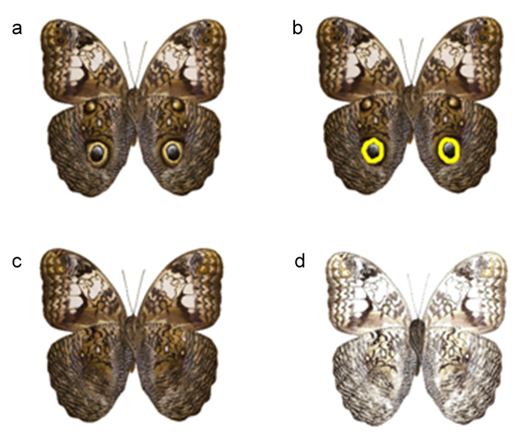
NC
CM
UV
WE
Figure 1: Facsimiles used in the experiments: a) with original eyespots (WE); b) eyespots enhanced with ultraviolet paint (UV); c) eyespots removed, original background colour (CM); d) eyespots removed, lighter background colour (NC).

The study included two experiments carried out between March and June 2019. Each experiment was composed of 50 blocks that included the four different facsimiles (a total of 200 facsimiles per experiment). The four facsimiles were randomly placed, and at least 30 cm apart from each other within individual trees (Howe et al., 2009) (Figure 2). Although Caligo butterflies do not naturally aggregate when resting during the day, grouping the four facsimiles would potentially attract the attention of foraging birds, thus increasing the chance that our facsimiles would be sampled, as the predators could visualise all facsimiles before selecting one for predation (Barnett et al., 2016). Sample blocks were set 20 meters apart and along a linear transect inside the two study sites, covering approximately 30 hectares. Facsimiles remained in the field during five consecutive days, and predation attempts were recorded at 24 h, 48 h, 72 h, 96 h and 120 h (Barnett et al., 2016). The clay of every attacked facsimile was remodelled in the field to account for all consecutive days of sampling. If the attack destroyed a facsimile, we replaced it with an equivalent one to complete the sampling period. The total sampling effort was 1000 observations during the five-day sampling period.
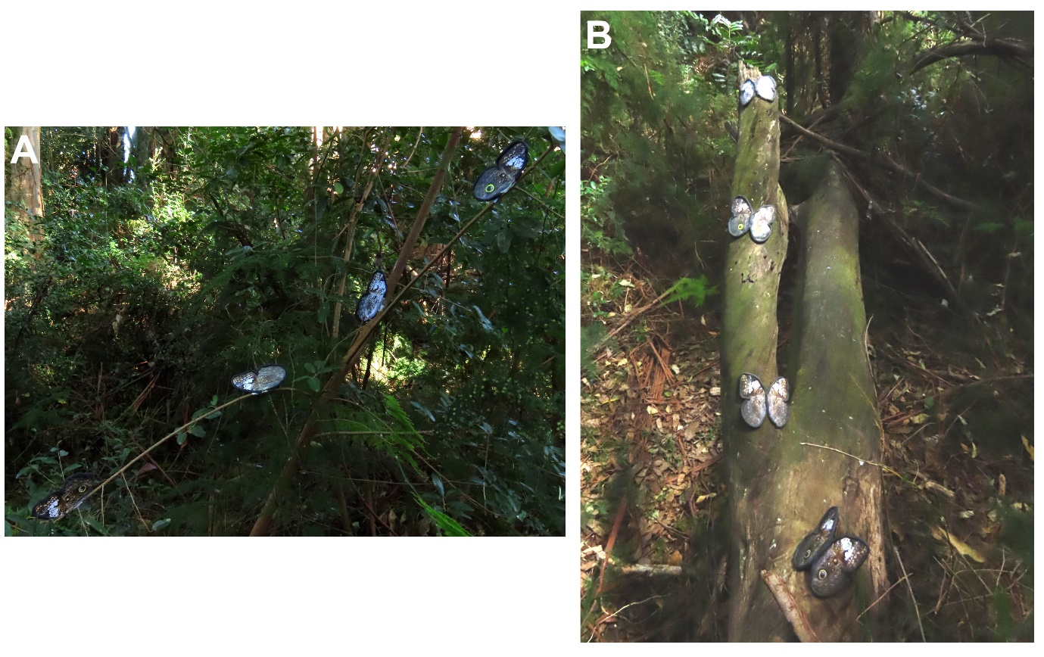
Figure 2: Arrangement of facsimiles within a block under the distinct experiments. A) Experiment 1 and B) Experiment 2.

In the first experiment, facsimiles were placed to resemble the natural day-resting position of a Caligo butterfly, and modelling clay was laid on the border of the wings (Figure 2A). The exclusion of the body in the first experiment allowed us to focus exclusively on the effect of eyespots (or lack thereof) in a standardised manner by limiting predators’ choice/potential attacks to the wings themselves. As such, the analyses related to the first experiment focused on the beak marks left by bird predators on the wings of the facsimiles, which in most cases occurred near and/or at the eyespot location. In the second experiment, the facsimiles included a body and were presented with the full ventral surface exposed so that potential predators could view all four wings (Figure 2B). In this case, the birds would be able to attack the body of these facsimiles just as easily as they would the wings, thus complementing the first experiment. Modelling clay was placed on the border of the wings and on the body, which allowed us to compare the predator attacks on different body parts, i.e., wings or body. Despite the un-natural position of Caligo in our second experiment, it was an efficient way to expose the body fully to a potential predator attack. Finally, we also note that an ongoing experiment at the same Restinga forest with another facsimile butterfly with several marginal eyespots on the wings (a small-brown Satyrini) suggests that local birds do not direct their attack to the butterfly head or body (after 1000 observations, only two attacks were made on the body, CAI unpublished data).
In both experiments, our response variable was attacks by birds, recorded as absence or presence of distinct “V-shaped” beak marks, depending on the bird, made by predators regardless of the number of marks on a facsimile (Saporito et al., 2007) (Figure 3). Each time the facsimiles were checked in the field, beak marks were removed by reshaping the modelling clay. This allowed us to use the same facsimiles for five consecutive days, and to account for repeated predation events (see Brodie (1993) for additional details).

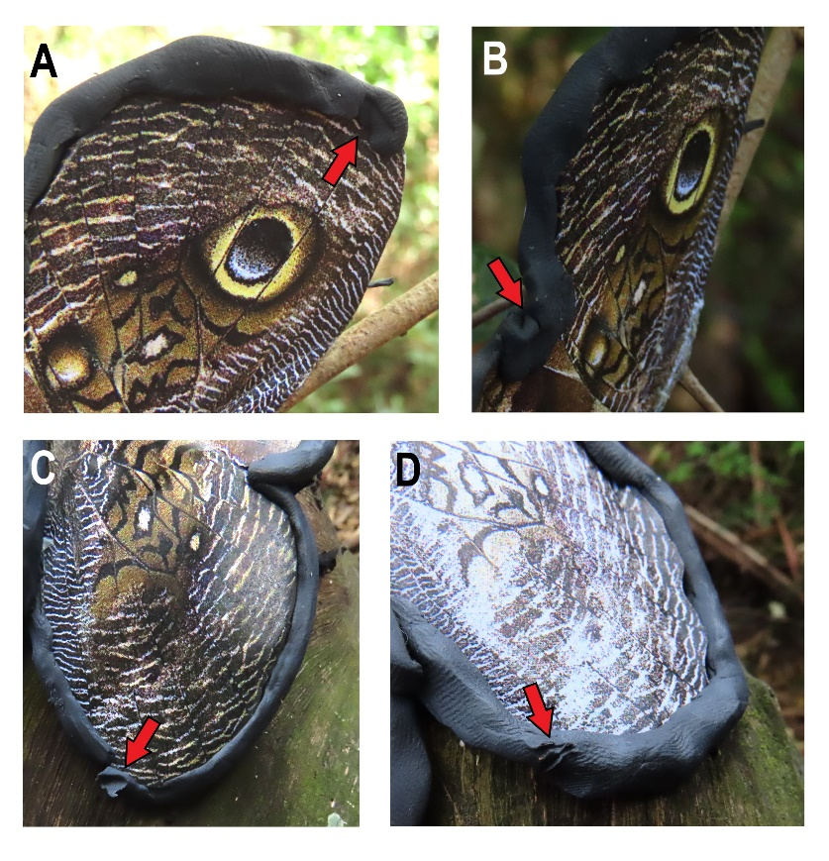
Figure 3: Beak marks (indicated by the red arrows) on the modelling clay placed in the facsimiles Caligo martia butterflies. A) and B) beak marks near the original eyespot in the Experiment 1; C) beak mark in the facsimile without eyespot (camouflage) in Experiment 2; D) beak marks in the facsimile without eyespots and with lighter coloration in Experiment 2.

Data analysis
In the first experiment, to assess the effect of butterfly colour pattern on the occurrence of predation, we fitted generalised linear mixed models (GLMM). The response variable followed a binomial distribution (i.e., presence or absence of beak marks), with a complementary clog-log link, to reduce any asymmetrical 0-1 values in the samples (Zuur et al., 2009); see Supplementary Information (Figure S2) for a schematic representation of the study. In order to achieve the principle of independence between variables, we considered each block as a random effect on GLMMs. In the second experiment, to obtain the predation probability per facsimiles, we fitted GLMMs (binomial distribution, logit link, block as random effect) for each facsimile. All analyses were conducted in the R environment for statistical computing (R Core Team, 2023), by using functions from lme4 and MuMIn packages (Bartón, 2020; Bates et al., 2022).

Results
Considering both experiments combined, we observed a higher number of beak marks on facsimiles that had eyespots (WE plus UV, N=80) than on facsimiles that lacked eyespots (CM plus NC, N=53) (Table 1). Nonetheless, each of our experiments uncovered different aspects of the predator responses to the facsimiles.
In the first experiment, we registered a total of 94 beak marks on the wings (Table 1). Camouflaged facsimiles (CM) showed the lowest number of beak marks while the light-coloured facsimiles that were not camouflaged (NC) had the highest. The two facsimiles with eyespots (WE and UV) had a similar number of attacks by birds and incurred an almost identical attack rate as NC. The calculated predation probabilities through GLMM statistically categorise the facsimiles as CM<WE=UV=NC (Figure 4, Table 2).

Table 1: Number of beak marks recorded for each facsimile in Experiment 1 (E1) and Experiment 2 (E2). Abbreviations: WE, facsimile with original eyespots; UV, eyespots enhanced with ultraviolet paint; CM, eyespots removed, original background color; NC, lighter background color.

Facsimile | E1 | E2 |  |  | Grand Total
 |  | Body | Wing | Total
WE | 27 | 4 | 11 | 15 | 42
UV | 27 | 4 | 7 | 11 | 38
CM | 11 | 2 | 1 | 3 | 14
NC | 29 | 7 | 3 | 10 | 39
Grand Total | 94 | 17 | 22 | 39 | 133

Table 2: Results of the fixed effects of the generalised linear mixed model (GLMM) that evaluated the differences on the probability of predation among four different butterfly facsimiles in Experiment 1 (E1) and Experiment 2 (E2). The explained variance for fixed (R2m) and fixed + random (R2c) effects is also shown. SE = standard error; WE = facsimiles with unmanipulated eyespots; UV = facsimiles with eyespot lighter ring enhanced with ultraviolet ink; CM = facsimiles without eyespots and unmanipulated background colour (camouflaged); and NC = facsimiles without eyespots and with lighter background coloration (not camouflaged). Note that for Experiment 2 all the results shown are wings in relation to the body.

Experiment 1
Facsimile | Estimate | SE | z value | p value | R2m | R2c
Intercept: WE | -2.369 | 0.23 | -10.19 | <2e-16 | 0.07 | 0.28
Facsimile CM | -0.956 | 0.35 | -2.661 | 0.007
Facsimile UV | -0.002 | 0.27 | -0.007 | 0.994
Facsimile NC | 0.064 | 0.27 | 0.24 | 0.81
Experiment 2
Facsimile | Estimate | SE | z value | p value | R2m | R2c
NC:wing | -5.9 | 2.5 | -2.3 | 0.02 | 0.003 | 0.9
CM:wing | -0.7 | 1.2 | -0.5 | 0.5 | 0.003 | 0.003
WE:wing | 3.5 | 1.8 | 1.9 | 0.05 | 0.03 | 0.96
UV:wing | 2.2 | 1.5 | 1.4 | 0.14 | 0.01 | 0.9

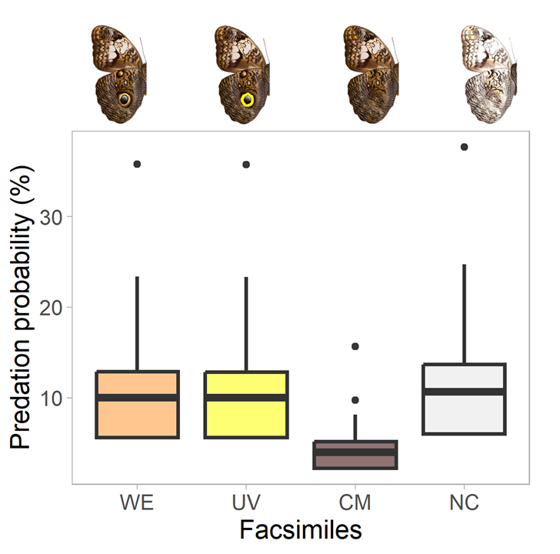
Figure 4: Predation probabilities for the four facsimiles in Experiment 1. Black horizontal lines indicate the median estimated values, the box shows the 25th and 75th percentile, and the black points represent outlier values. Abbreviations: WE, facsimile with original eyespots; UV, eyespots enhanced with ultraviolet paint; CM, eyespots removed, original background colour; NC, lighter background colour.

In the second experiment we analysed potential trends and differences in predation between wings and body (Table 1, Figure 5a and Figure 5b). Among the four facsimiles, WE and NC showed the most distinct predation patterns between wings and body. While WE facsimiles had a higher proportion of beak marks on their wings, NC had a higher predation probability on the body (Figure 5a, Figure 5b i and iv, Table 2). Both WE and UV facsimiles showed a higher proportion of beak marks on the wings than on the body, and the reverse was the case for facsimiles that lacked eyespots. Similar to the first experiment, fewer beak marks were observed in the CM facsimile (Figure 5a), and despite the few bird attacks, the trend for this facsimile fits that of NC, that is, a higher number of attacks on the body than on the wings (Figure 5, Figure 5b iv). Furthermore, this experiment showed that the facsimile that best matched the real appearance of C. martia (WE) showed the highest number of beak marks (wing and body combined; Table 1, Figure 5b i), and also that facsimiles with eyespots were mostly attacked on the wings while those that lacked eyespots were mostly attacked on the body (Figure 5b iv).

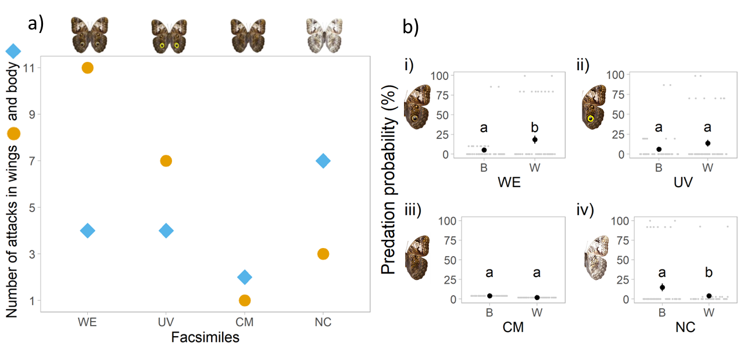
Figure 5: Predation probability at wings and body across different Caligo martia butterfly facsimiles. a) Number of attacks on wings (circles) and body (diamonds) for the four facsimiles in the Experiment 2. b) Comparisons of predation probability at wings (W) or body (B) across the facsimiles. Different letters show statistical differences among the predation probability, while equal letters show no statistical differences. Abbreviations and figures in panel b: (i) WE, facsimile with original eyespots; (ii) UV, eyespots enhanced with ultraviolet paint; (iii) CM, eyespots removed, original background colour; (iv) NC, lighter background colour.

Discussion
Given their particularly large size and resemblance to vertebrate eyes, we asked whether the ventral eyespots of Caligo martia function as predicted by the intimidation or by the deflection hypotheses. The life-size facsimiles used in the two complementary experiments were exposed to at least nine species of native insectivorous birds (see Materials and Methods and Figure 2). Despite the limitations of experiments that use artificial models, this study is the first empirical test of the defensive function of Caligo eyespots in nature, suggesting that their single, large, central eyespot most likely functions within the context of deflection rather than intimidation in our studied community.
The intimidation hypothesis predicts that eyespots frighten potential predators, thus preventing an attack (Blest, 1957; Poulton, 1890). To test if vertebrate eye-mimicry intimidated predators, De Bona et al. (2015) used Caligo martia images with intact and disfigured eyespots in a controlled experiment. Facsimiles with the wings open (as in our Figure 2b) were presented on a computer monitor to European great tits (Parus major, Paridae), which preferably avoided images with intact eyespots. Unlike the experimental design by De Bona et al. (2015), which presents a Neotropical butterfly presented to an European bird in the laboratory, our study exposed C. martia facsimiles to native predators in the field and our results indicated that local insectivorous birds attacked the large and conspicuous eyespots in the C. martia. Interestingly, Vallin et al. (2007) observed that the response to eyespot size (and prey size) varied between two Parus species of different body sizes. As we did not have direct observations of birds interacting with butterfly facsimiles, we cannot assess whether all bird species present in our study site had the same reaction to C. martia eyespots (see Methods for variation in size). Given that this butterfly is very common (CAI, pers. obs.), mature adult birds in our study area likely had prior experience with it. Yet, if they were intimidated by C. martia eyespots, we would have expected few beak marks on facsimiles that faithfully represented this butterfly species, which was not the case.
The deflection hypothesis predicts that eyespots function as “targets” that drive predator attacks away from vital areas of the prey’s body. As most species in the tribe Brassolini (Satyrinae), C. martia has a large eyespot below hindwing vein CuA1 (Penz & Mohammadi, 2013). This region of the wing (tornus) has been historically recognized as a prime location for predator attacks (Carpenter, 1933, 1937, 1942; Collenette & Talbot, 1928) and it has been demonstrated to tear easily (DeVries, 2002, 2003; Hill & Vaca, 2004). Several studies have provided evidence in support of the deflection hypothesis (Olofsson et al., 2010; Stevens, Stubbins, et al., 2008; Vallin et al., 2011). In the Neotropical region in particular, Pinheiro et al. (2014) showed that birds attacked butterflies’ eyespots through field observation of beak-marks on Junonia evarete, and also found a higher frequency of beak-marks on females than males. Furthermore, wing tears involving eyespots were more frequent than expected by chance, which suggests that birds were indeed using eyespots as “targets” for attacks. The results of our Experiment 1 agree with findings by Pinheiro et al. (2014) and the predictions of the deflection hypothesis (see Introduction), given that C. martia facsimiles with eyespots had a higher predation probability than the camouflaged facsimile that lacked eyespots. Moreover, in the European region, Olofsson et al. (2010) found that ultraviolet light influenced predators, observing that bird attacks on Lopinga achine (Scopoli, 1763) (Nymphalidae) were directed to the marginal eyespots of the wings only in a low UV intensity environment. We did not find an influence of UV reflectance in our study, as facsimiles with eyespots and those with UV enhanced eyespots were attacked at a similar frequency (Table 1, Figure 4). Although some studies reported the importance of UV light to visual tests performed with birds (Ho et al., 2015; Olofsson et al., 2010), our results showed that UV did not have a primordial function in the decision-making by the local bird predators within the microhabitat where the experiments were performed. It is nonetheless possible that UV light might be important within the context of mate selection (Huq et al., 2019; Robertson & Monteiro, 2005), as are the size and central position of the wing eyespot as suggested by Crees et al. (2021). Finally, although the presence of large eyespots might increase detectability by predators as compared to the camouflaged facsimile, our results show that, once detected, eyespots may deflect the attack away from the body. We note, however, that in Experiment 1 facsimiles did not have modelling clay on the body, which prevents us from comparing bird attacks to the body vs. wings in a natural resting position.
The two facsimiles that lacked eyespots (Figure 1c, d) were perceived differently by the local birds. Not surprisingly, the camouflaged facsimile with normal Caligo wing background colour showed fewer beak marks than the light-coloured facsimile. Camouflage has been widely recognized as an effective means of protection against predation in many animal groups (see Quicke (2017) for a review), and it is likely that our dark-coloured facsimiles lacking eyespots were less noticeable to birds by being similar to the background of the Restinga Forest interior. Furthermore, predation probabilities were similar for the light-coloured facsimile and each of the facsimiles with eyespots. There are two possible explanations for this finding. First, our light-coloured facsimile showed some resemblance to the white Morpho epistrophus catenaria Perry, 1811 (Nymphalidae) that coexists with C. martia in our area (Gallo 2018) and is commonly attacked by birds (CAI pers. obs.). This Morpho species nonetheless has a series of dark eyespots that are likely noticeable to birds. Second, and most likely, the highly visible light-coloured facsimile possibly drew the attention of local predators for being a novel pattern (Benson, 1972).
The association between a conspicuous eyespot and a camouflaged background pattern suggests the existence of an optimisation of two defence strategies in the same organism to avoid predation, since there is a chance of damage by predators when the prey attracts their attention (Kang et al., 2017; Stevens, 2005). Nonetheless, losing part of the wings would be an advantage compared to having vital parts attacked because, when camouflaged organisms are detected, the attempt of predation can be fatal. In the case of C. martia, these two features can promote both defence strategies depending on the distance and detection capacity of predators, potentially increasing survivorship (Stevens, Hardman, et al., 2008). It seems possible that when bird predators come close enough to identify the eyespot and the camouflaged wing pattern is not sufficient, they might indeed direct their attack to the attractive eyespot “target”.
We observed less than half as many predator attacks on facsimiles positioned with the wings open (Experiment 2, 39 beak marks) than on facsimiles in normal resting position (Experiment 1, 94 beak marks). We attribute this to the un-natural position of the facsimiles, as the two experiments were performed in the same area and time frame, or to the intimidation to some bird species that may recognise the shape of the facsimiles as a large vertebrate face. According to Vallin et al. (2007), intimidation or deflection depend on the avian predator size and experience, in which juveniles and small bird species perceive the central and large eyespot as a threat and avoid attempting predation. On the other hand, adult and larger bird species attack the butterflies directly in the eyespot, allowing escape. The studies of Ho et al. (2015) and De Bona et al. (2015) corroborate the results found in Experiment 2, and these findings may demonstrate that both predation avoidance strategies can work at the same time. Keeping in mind that our study was carried out in nature with artificial butterflies, the results of Experiment 2 nonetheless showed that facsimiles with eyespots were preferentially attacked on the wings, while those lacking eyespots were generally attacked on the body (Figure 5). Even though facsimiles in Experiment 1 did not have a body covered by modelling clay, results from this experiment support the deflective function of C. martia’s eyespots. Using chickens as experimental predators, Mukherjee & Kodandaramaiah (2015) found that eyespot “pairedness” decreased the number of attacks on facsimiles of Junonia almana (Linnaeus, 1758) (Nymphalidae, Nymphalinae). The discrepancy between their results and those of our Experiment 2 is likely due to differences in the sensory system of the experimental birds. Visually oriented predators have the ability to recognize the shape of their potential prey, underscoring the importance of using local butterfly and predator species in experimental studies. Experiments carried out in nature and accounting for habitat type, environmental conditions (Lyytinen et al., 2003; Stevens, Hardman, et al., 2008), and the availability of natural predators (Pinheiro et al., 2014) are expected to produce more reliable evidence of the use of eyespots as a defence against predation.
Most experiments that aim to test the intimidation and deflection hypotheses are performed in controlled conditions, use captive predators that are not always sympatric with the focal butterflies (e.g., great tits, chickens), or use facsimiles that do not resemble living insects. It is, therefore, not surprising that there is no consensus on the influence of eyespot size and number on the effectiveness of anti-predator defence (Ho et al., 2015; Stevens & Ruxton, 2014). Although the deflection hypothesis is usually associated with small and numerous eyespots at the edge of the wing (Ho et al., 2015; Kodandaramaiah, 2011; Stevens, 2005), our results generally supported this hypothesis even though the ventral eyespots of C. martia are large, highly conspicuous, and potentially intimidating (see also Vallin et al. (2007)). We note, however, that the experimental design did not allow us to assess how each individual bird species in our study site reacted to Caligo eyespots. When studying potential functions of butterfly eyespots, experimental biologists should avoid making broad generalisations based on narrow sets of conditions. We are aware of a possible bias inherent to the use of artificial facsimiles in nature and recognize limitations of Experiment 1 a posteriori (lack of modelling clay on the body). Nonetheless, our experiments highlight the importance of evaluating the role and use of functional traits in nature and focusing on local communities that interact in both ecological and evolutionary time. In this way, we aimed to improve the knowledge of anti-predator strategies as a proxy to a much larger goal: to comprehend the complex interactions that maintain the biodiversity of a megadiverse region such as the Neotropics.

Authors’ contributions
CAI: Conceptualization; Data curation; Investigation; Funding Acquisition, Supervision; Writing.
STM, BBF, and CAC: Conceptualization; Data curation; Investigation; Writing.
CMP: Investigation; Writing.
TS: Investigation; Writing.
KMB: Investigation; Analyses; Writing.

Data availability statement
The processed data and R codes used to conduct all analyses are available at https://doi.org/10.5281/zenodo.10116939.

Conflicts of interest
The authors declare no conflict of interests in this work.

References
Barnett, J. B., Scott-Samuel, N. E., & Cuthill, I. C. (2016). Aposematism: Balancing salience and camouflage. Biology Letters, 12(8). https://doi.org/10.1098/RSBL.2016.0335
Bartón, K. (2020). Package MuMIn: Multi-model inference. https://cran.r-project.org/web/packages/MuMIn/MuMIn.pdf
Bates, D., Maechler, M., Bolker, B., Walker, S., Christensen, R., Singmann, H., Dai, B., Scheipl, F., Grothendieck, G., Green, P., Fox, J., Bauer, A., & KrivitskyP. (2022). lme4: Linear Mixed-Effects Models using “Eigen” and S4. https://cran.r-project.org/web/packages/lme4/lme4.pdf
Benson, W. W. (1972). Natural Selection for Müllerian Mimicry in Heliconius erato in Costa Rica. Science, 176(4037), 936–939. https://doi.org/10.1126/SCIENCE.176.4037.936
Blest, A. (1957). The function of eyespot patterns in the Lepidoptera. Behaviour, 11, 209–256.
Blut, C., Wilbrandt, J., Fels, D., Girgel, E. I., & Lunau, K. (2012). The ‘sparkle’ in fake eyes – the protective effect of mimic eyespots in lepidoptera. Entomologia Experimentalis et Applicata, 143(3), 231–244. https://doi.org/10.1111/J.1570-7458.2012.01260.X
Brodie, E. D. (1993). Differential avoidance of coral snake banded patterns by free-ranging avian predators in Costa Rica. Evolution, 47(1), 227–235. https://doi.org/10.1111/J.1558-5646.1993.TB01212.X
Carpenter, G. D. H. (1933). Attacks of birds on butterflies. Transactions of the Royal Entomological Society of London, 81(1), 21–26. https://doi.org/10.1111/J.1365-2311.1933.TB00394.X
Carpenter, G. D. H. (1937). Further Evidence that Birds do attack and eat Butterflies. Proceedings of the Zoological Society of London, A107(3), 223–247. https://doi.org/10.1111/J.1096-3642.1937.TB00807.X
Carpenter, G. D. H. (1942). Observations and experiments in Africa by the late C. F. M. Swynnerton on wild birds eating butterflies and the preference shown. Proceedings of the Linnean Society of London, 154(1), 10–46. https://doi.org/10.1111/J.1095-8312.1942.TB00293.X
Collenette, C. L., & Talbot, G. (1928). Observations on the bionomics of the Lepidoptera of Mato Grosso, Brazil. Transactions of the Royal Entomological Society of London, 76, 392–416.
Crees, L. D., DeVries, P., & Penz, C. M. (2021). Do Hind Wing Eyespots of Caligo Butterflies Function in Both Mating Behavior and Antipredator Defense? (Lepidoptera, Nymphalidae). Annals of the Entomological Society of America, 114(3), 329–337. https://doi.org/10.1093/AESA/SAAA050
De Bona, S., Valkonen, J. K., López-Sepulcre, A., & Mappes, J. (2015). Predator mimicry, not conspicuousness, explains the efficacy of butterfly eyespots. Proceedings of the Royal Society B: Biological Sciences, 282(1806). https://doi.org/10.1098/RSPB.2015.0202
DeVries, P. (1987). The butterflies of Costa Rica and their natural history, Volume1: Papilionidae, Pieridae, Nymphalidae. Princeton University Press.
DeVries, P. (2002). Differential Wing Toughness in Distasteful and Palatable Butterflies: Direct Evidence Supports Unpalatable Theory 1. Biotropica, 34(1), 176–181.
DeVries, P. (2003). Tough models versus weak mimics: New horizons in evolving bad taste. Journal of the Lepidopterists’ Society, 57, 235–238.
EMBRAPA. (2010). Normais Climatológicos. Estação Agroclimatológica de Pelotas (Capão do Leão). In Http://agromet.cpact.embrapa.br/estacao/normais.html (p. Acess at 4th November 2020).
Endler, J. A. (1978). A Predator’s View of Animal Color Patterns. Evolutionary Biology, 319–364. https://doi.org/10.1007/978-1-4615-6956-5_5
Endler, J. A. (1981). An overview of the relationships between mimicry and crypsis. Biological Journal of the Linnean Society, 16(1), 25–31. https://doi.org/10.1111/J.1095-8312.1981.TB01840.X
Gallo, M. (2018). Efeito indireto do pastejo exercido pelo gado sobre a diversidade de borboletas frugívoras em matas de Restinga no extremo sul do Brasil (Indirect effect of cattle grazing on the diversity of fruit-feeding butterflies in Restinga forests in southern Brazi [Master thesis]. Universidade Federal de Pelotas, Brazil.
Hill, R. I., & Vaca, J. F. (2004). Differential Wing Strength in Pierella Butterflies (Nymphalidae, Satyrinae) Supports the Deflection Hypothesis. Biotropica, 36(3), 362–370. https://doi.org/10.1111/j.1744-7429.2004.tb00328.x
Ho, S., Schachat, S. R., Piel, W. H., & Monteiro, A. (2015). Attack risk for butterflies changes with eyespot number and size. Royal Society Open Science, 3(1). https://doi.org/10.1098/RSOS.150614
Howe, A., Lövei, G. L., & Nachman, G. (2009). Dummy caterpillars as a simple method to assess predation rates on invertebrates in a tropical agroecosystem. Entomologia Experimentalis et Applicata, 131(3), 325–329. https://doi.org/10.1111/J.1570-7458.2009.00860.X
Huq, M., Bhardwaj, S., & Monteiro, A. (2019). Male Bicyclus anynana Butterflies Choose Females on the Basis of Their Ventral UV-Reflective Eyespot Centers. Journal of Insect Science, 19(1). https://doi.org/10.1093/JISESA/IEZ014
IBGE, I. B. de G. e E. (2012). Manual Técnico da Vegetação Brasileira. 2ª edição revista e ampliada. Sistema Fitogeográfico. Inventário das Formações Florestais e Campestres. Técnicas e Manejo de Coleções Botânicas. Procedimentos para Mapeamentos. In Instituto Brasileiro de Geografia e Estatística—IBGE. https://doi.org/ISSN 0101-4234
Kang, C., Zahiri, R., & Sherratt, T. N. (2017). Body size affects the evolution of hidden colour signals in moths. Proceedings of the Royal Society B: Biological Sciences, 284(1861), 20171287. https://doi.org/10.1098/rspb.2017.1287
Kodandaramaiah, U. (2011). The evolutionary significance of butterfly eyespots. Behavioral Ecology, 22(6), 1264–1271. https://doi.org/10.1093/BEHECO/ARR123
Lyytinen, A., Brakefieid, P. M., & Mappes, J. (2003). Significance of butterfly eyespots as an anti-predator device in ground-based and aerial attacks. Oikos, 100(2), 373–379. https://doi.org/10.1034/J.1600-0706.2003.11935.X
Merilaita, S., & Stevens, M. (2011). Crypsis through background matching. In S. Merilaita & M. Stevens (Eds.), Animal Camouflage: Mechanisms and Function (pp. 17–33). Cambridge University Press.
Monteiro, A. (2008). Alternative models for the evolution of eyespots and of serial homology on lepidopteran wings. BioEssays, 30(4), 358–366. https://doi.org/10.1002/BIES.20733
Mukherjee, R., & Kodandaramaiah, U. (2015). What makes eyespots intimidating-the importance of pairedness Evolutionary ecology and behaviour. BMC Evolutionary Biology, 15(1), 1–10. https://doi.org/10.1186/S12862-015-0307-3/FIGURES/5
Nijhout, H. F. (1990). A comprehensive model for colour pattern formation in butterflies. In Proc. R. Soc. Land. B (Vol. 239, pp. 81–113). https://royalsocietypublishing.org/
Nijhout, H. F. (1994). Symmetry systems and compartments in Lepidopteran wings: The evolution of a patterning mechanism. Development, 1994(Supplement), 225–233. https://doi.org/10.1242/DEV.1994.SUPPLEMENT.225
Nijhout, H. F. (2001). Elements of butterfly wing patterns. Journal of Experimental Zoology, 291(3), 213–225. https://doi.org/10.1002/JEZ.1099
Oliver, J. C., Beaulieu, J. M., Gall, L. F., Piel, W. H., & Monteiro, A. (2014). Nymphalid eyespot serial homologues originate as a few individualized modules. Proceedings of the Royal Society B: Biological Sciences, 281(1787). https://doi.org/10.1098/rspb.2013.3262
Oliver, J. C., Robertson, K. A., & Nia Monteiro, A. (2009). Accommodating natural and sexual selection in butterfly wing pattern evolution. Proceedings of the Royal Society B, 276, 2369–2375. https://doi.org/10.1098/rspb.2009.0182
Olofsson, M., Eriksson, S., Jakobsson, S., & Wiklund, C. (2012). Deimatic Display in the European Swallowtail Butterfly as a Secondary Defence against Attacks from Great Tits. PLOS ONE, 7(10), e47092. https://doi.org/10.1371/journal.pone.0047092
Olofsson, M., Vallin, A., Jakobsson, S., & Wiklund, C. (2010). Marginal eyespots on butterfly wings deflect bird attacks under low light intensities with UV wavelengths. PloS One, 5(5). https://doi.org/10.1371/JOURNAL.PONE.0010798
Olofsson, M., Wiklund, C., & Favati, A. (2015). On the deterring effect of a butterfly’s eyespot in juvenile and sub-adult chickens. Current Zoology, 61(4), 749–757. https://doi.org/10.1093/czoolo/61.4.749
Penz, C. M., & Mohammadi, N. (2013). Wing pattern diversity in Brassolini butterflies (Nymphalidae, Satyrinae). Biota Neotropica, 13(3), 154–180. https://doi.org/10.1590/S1676-06032013000300020
Pinheiro, C. E. G., Antezana, M. A., & Machado, L. P. (2014). Evidence for the Deflective Function of Eyespots in Wild Junonia evarete Cramer (Lepidoptera, Nymphalidae). Neotropical Entomology, 43, 39–47. https://doi.org/10.1007/s13744-013-0176-7
Pinheiro, C. E. G., Freitas, A. V. L., Campos, V. C., Devries, P. J., & Penz, C. M. (2016). Both palatable and unpalatable butterflies use bright colors to signal difficulty of capture to predators. Neotropical Entomology, 45, 107–113. https://doi.org/10.1007/s13744-015-0359-5
Poulton, E. B. (1890). The colours of animals, their meaning and use, especially considered in the case of insects. D. Appleton and Company. https://doi.org/10.5962/bhl.title.11353
Prudic, K. L., Stoehr, A. M., Wasik, B. R., & Monteiro, A. (2015). Eyespots deflect predator attack increasing fitness and promoting the evolution of phenotypic plasticity. Proceedings of the Royal Society B: Biological Sciences, 282(1798). https://doi.org/10.1098/RSPB.2014.1531
Quicke, D. L. J. (2017). Mimicry, crypsis, masquerade and other adaptive resemblances. Wiley-Blackwell. https://www.wiley.com/en-us/Mimicry%2C+Crypsis%2C+Masquerade+and+other+Adaptive+Resemblances-p-9781118931530
R Core Team. (2023). R: A language and environment for statistical computing. R Foundation for Statistical Computing, Vienna, Austria. https://www.r-project.org/
Robertson, K. A., & Monteiro, A. (2005). Female Bicyclus anynana butterflies choose males on the basis of their dorsal UV-reflective eyespot pupils. Proceedings of the Royal Society B, 272, 1541–1546. https://doi.org/10.1098/rspb.2005.3142
Saporito, R. A., Zuercher, R., Roberts, M., Gerow, K. G., & Donnelly, M. A. (2007). Experimental Evidence for Aposematism in the Dendrobatid Poison Frog Oophaga pumilio. Copeia, 4, 1006–1011. https://doi.org/DOI: 10.1643/0045-8511(2007)7[1006:EEFAIT]2.0.CO;2
Sargent, T. D. (1973). Studies on the Catocala (Noctuidae) of southern New England. IV. A preliminary analysis of beak-damaged specimens, with discussion of anomaly as a potential anti-predator function of hindwing diversity. Journal of Lepidopteran Society, 27, 175–192.
Sargent, T. D. (1978). On the maintenance of stability in hindwing diversity among moths of the genus Catocala (Lepidoptera: Noctuide). Evolution, 32(2), 424–434. https://doi.org/10.1111/J.1558-5646.1978.TB00657.X
Scherer, A., Maraschin-Silva, F., & Rios de Moura Baptista, L. (2009). Estrutura do componente arbóreo em remanescentes florestais nas restingas sul brasileiras. Revista Brasileira de Biociências, 7(4), 354–363.
Schlenoff, D. (1985). The startle responses of blue jays to Catocala (Lepidoptera: Noctuidae) prey models. Animal Behaviour, 33, 1057–1067.
Shih, C., Wang, Y., & Ren, D. (2019). Camouflage mimicry or eyespot warning. In D. Ren, C. Shih, T. Gao, Y. Wang, & Y. Yao (Eds.), Rhythms of Insect Evolution: Evidence from the Jurassic and Cretaceous in Northern China (pp. 651–664). Wiley-Blackwell.
Stevens, M. (2005). The role of eyespots as anti-predator mechanisms, principally demonstrated in the Lepidoptera. Biological Reviews, 80(4), 573–588. https://doi.org/10.1017/S1464793105006810
Stevens, M., Hardman, C. J., & Stubbins, C. L. (2008). Conspicuousness, not eye mimicry, makes ”eyespots” effective antipredator signals. Behavioral Ecology, 19(3), 524–531. https://doi.org/10.1093/beheco/arm162
Stevens, M., & Ruxton, G. D. (2014). Do animal eyespots really mimic eyes? Current Zoology, 60(1), 26–36. https://doi.org/10.1093/CZOOLO/60.1.26
Stevens, M., Stubbins, C. L., & Hardman, C. J. (2008). The anti-predator function of “eyespots” on camouflaged and conspicuous prey. Behav Ecol Sociobiol, 62. https://doi.org/10.1007/s00265-008-0607-3
Vallin, A., Dimitrova, M., Kodandaramaiah, U., & Merilaita, S. (2011). Deflective effect and the effect of prey detectability on anti-predator function of eyespots. Behav Ecol Sociobiol, 65, 1629–1636. https://doi.org/10.1007/s00265-011-1173-7
Vallin, A., Jakobsson, S., & Wiklund, C. (2007). “An eye for an eye?”-on the generality of the intimidating quality of eyespots in a butterfly and a hawkmoth. Behav Ecol Sociobiol, 61, 1419–1424. https://doi.org/10.1007/s00265-007-0374-6
Zuur, A., Ieno, E., Walker, N., Saveliev, A., & Smith, G. (2009). Mixed Effects Models and extensions in ecology with R. Springer. https://doi.org/DOI:10.1007/978-0-387-87458-6

Supplementary Information

Figure S1: Facsimile with the lighter ring of the eyespots enhanced with ultraviolet light.
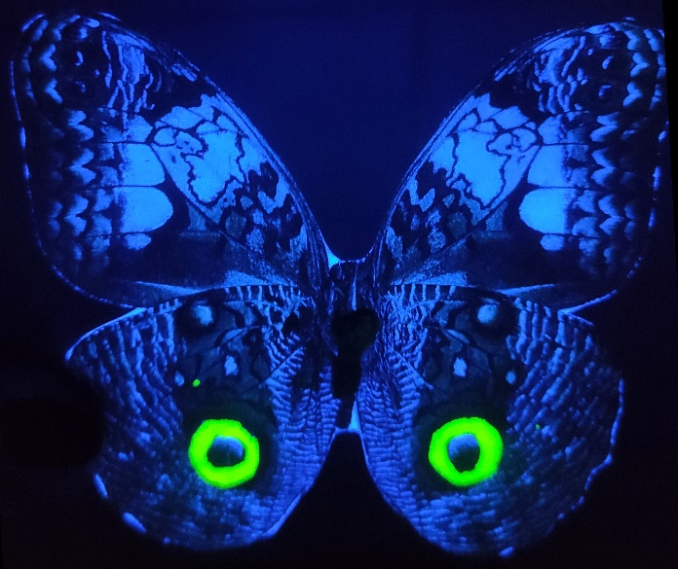

Figure S2: Scheme explaining data analysis, from the main question, dataset, issues, and developed model.
